USER’S GUIDE
Table of Contents
Introduction 3
Home Page 4
Highway Project Info Center 5
SYP Project Info 6
Kentucky Highway Plan Information 7
Construction and Change Order information 9
MARS/eMARS Budget Summary, Detailed Encumbrance and Expenditure info 10
Detailed Encumbrance information 12
Detailed Expenditure information 13
Pre-construction information and status 14
Kentucky Highway Project Budget and Expenditure Information 15
Non-Kentucky Highway Plan Budget and Expenditure Information 16
Active Construction Projects 17
Construction Contracts (KYTC Only) 19
Document Information (KYTC Only) 20
Status Reports 22
- District Status Reports by page 22
- Status Reports by Page (Status Book view) 22
Subject Matter Expert Tracking Reports 24
a. Project Management 24
- Letting Review Report - including Bridging KY projects 24
- Cost Per Mile 24
- Current Estimates 24
- Potential Closeouts-Inactive 24
- Potential Closeouts-Active 24
b. Program Management 24
- Federal Projects End 24
- Updated Letting Date 24
c. Highway Design 25
- Design Executive Summary 25
- Plan Processing Status 25
d. Environmental 25
- Environmental Permits Status 25
- Environmental Mitigation-Letting 25
- Environmental Mitigation-Awarded 25
Project Review Meeting Materials 25
- 18 Month Letting Schedule by District 25
- 4000 Project List 25
- Potential Closeouts 25
- Federal Projects End Dates (condensed) 25
- Highway Projects with 10% or Less Remaining in Budget 25
eMARS Project Budget Info (KYTC Only) 37
- eMARS Budget Info (Excel Spreadsheet) 38
- eMARS Advantage 39
- Projects with 10% of Budget Remaining 40
- State/Federal projects with No Activity in the Last 365 Days 41
TC-10 Viewer 42
PM Dashboard 46
- Overview Tab 48
- Design Tab 51
- Environmental Permits Tab 52
- Right of Way Tab 53
- Utilities Tab 55
- Vendors Assigned Tab 56
MISC 57
Aviation 58
LPA 60
Federal Aid Fund Report (KYTC Only) 62
Division of Program Management 62
Bridging Kentucky Projects 63
Glossary of Data Terms 68
eMARS Document Types APPENDIX

INTRODUCTION
This manual focuses primarily on information retrieval and explanation of the report results. The ability to report information entered into a database is a very important component of a database application. Program Management and Enterprise Data recognizes this need to extract database information, view it on a computer monitor, save it as an alternative format, and print it out for hard copy review and dissemination. In an effort to assist a variety of user capabilities, Program Management originally developed the Project Managers Toolbox to assist all users achieve their needs. The Office of Information Technology Enterprise Data Branch along with Program Management now maintain the PM ToolBox and all of its functions.

The Project Managers Toolbox contains financial information for all the Six-Year Plan projects that have a valid item number with phases that have been authorized and Non-Six Year Plan projects that are active in eMARS. This information is updated nightly from eMARS, the Commonwealth’s budget system, so users will have the latest information concerning their projects.
The Division of Program Management and the OIT Enterprise Data Branch, welcomes questions, comments, and suggestions concerning the Project Managers Toolbox, and our goal is to provide updates and enhancements to meet the needs of various user groups.

HOME PAGE
https://pmtoolbox.kytc.ky.gov/
The homepage contains a menu to navigate to different reports, a welcome message, today’s Road Fund Cash Balance and contacts for issues concerning the functionality of the PM toolbox.
Menu Contents:
- Highway Project Info  - eMARS Project Budget Info (KYTC Only)  - TC-10 Viewer | - PM DashBoard (KYTC Only)  - Misc  - Bridging Ky Projects

Highway Project Info Center: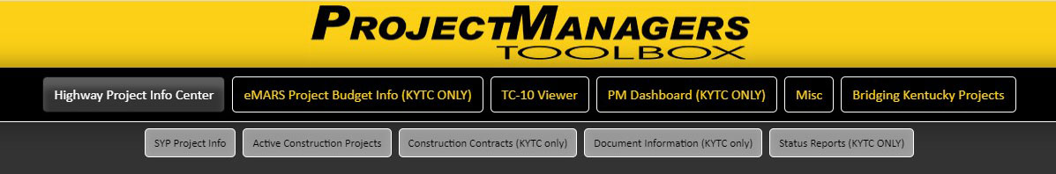
- SYP Project Info
1. Kentucky Highway Plan Project information
2. Kentucky Highway Project Budget and Expenditure Information
3. NON- Kentucky Highway Plan Project information
- Active Construction Projects
Select Construction Projects by Highway District, County, or Construction ID
- Construction Contracts (KYTC Only)
- Document Information (KYTC Only)
- Status Reports (KYTC Only)

SYP Project Info
For information from the Kentucky Highway Plan, it must be associated with a valid Item number, Authorized project phases or have an active eMARS budget to return any data.
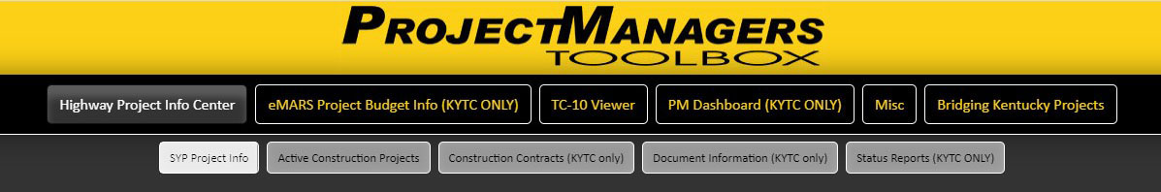
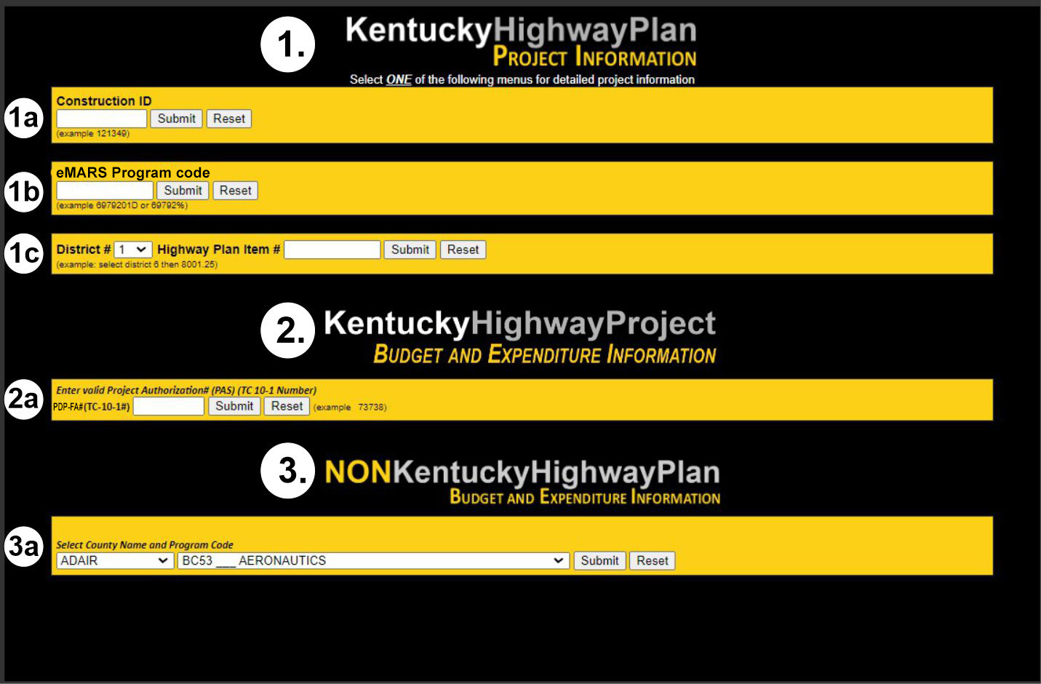
1. For Kentucky Highway Plan Information, enter valid data elements into one of these menus:
(1a.) Construction ID (example 121349)
(1b.) Program code, aka eMARS or TC-10 - 1 number (example 6979201D) this field can also accept
a wildcard key (example 69792%)
(1c.) District # and Six-Year Plan item number (example select district 6 then 8001.25)
When entering any of these three values, you will receive the same SYP project information data
format.
2. For Kentucky Highway Project Budget and Expenditure Information select:
(2a.) Project Authorization number, aka PDP-FA or TC10 -1 number (example 73738)
By entering an Authorization number, this menu will display Highway projects that have an active
eMARS budget associated.
3. For Non-Kentucky Highway Plan Budget and Expenditure Information select:
(3a.) County Name and Program Code
This field needs a valid County and related Program Code to display data.
Kentucky Highway Plan Information
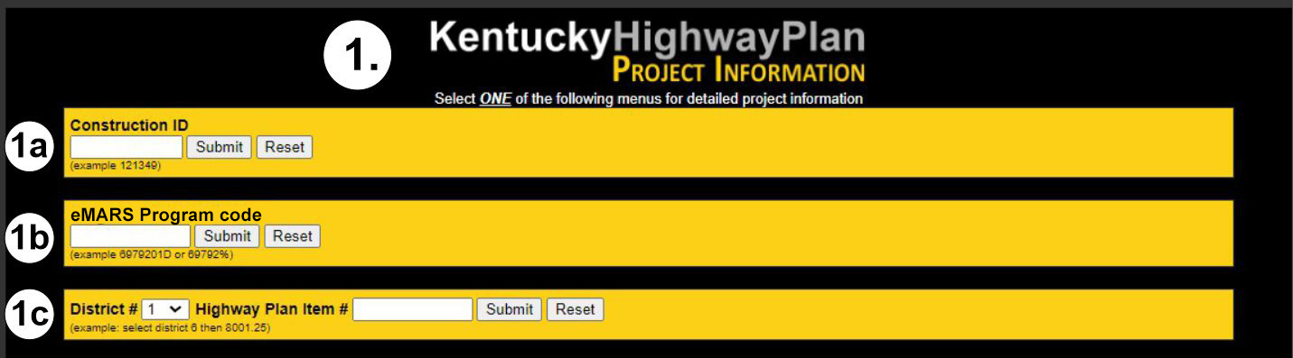
After selecting from any of the Highway Plan Project menus in the top section of the screen, you will be taken to a lookup screen that displays a tabular summary of that specific project’s information. It contains various links in dropdown menus located at the top of the screen to reveal more details about the identified project.
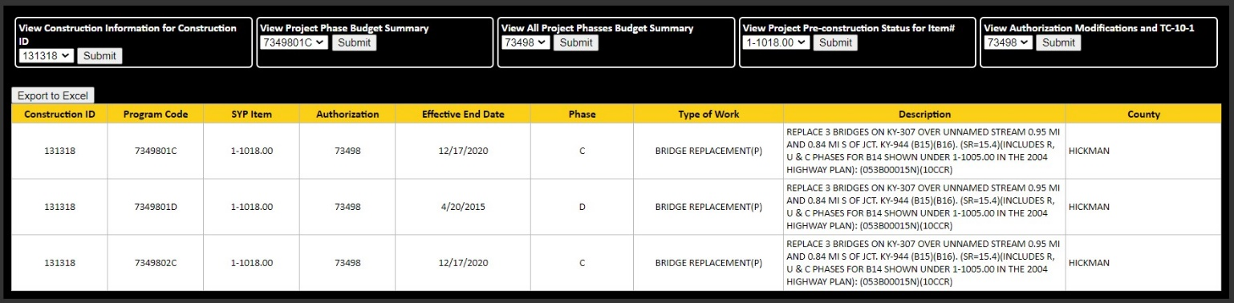
This table is exportable to Excel
On this screen lookup values include:
- Construction ID  - eMARS Program Code | - Authorization number  - SYP Item number
Other summarized data includes:
- Effective End Date  - Phase  - Type of Work | - Description  - County

The menus located at the top take you to four different reports:
A. Construction and Change Order information
Select a Construction ID to view related project information.
B./C. MARS/eMARS Budget Summary, Detailed Encumbrance and Expenditure info
Select an eMARS Program Code to view the specific Project phase budget summary.
Select the Authorization number to view the budget summary for all associated phases.
NOTE: It must be a valid SYP Item number or Program Code that is active in eMARS to be reported here.
D. Pre-construction information and status
Select a SYP Item number to see the Preconstruction status, Current Phase information and Highway
Plan Phase Info
E. Authorization Modifications and TC-10-1
Select the Authorization number to view all associated modifications made. From that screen you can
view the TC-10-1 Document related to the selected Mod chosen.

A. Construction and Change Order information
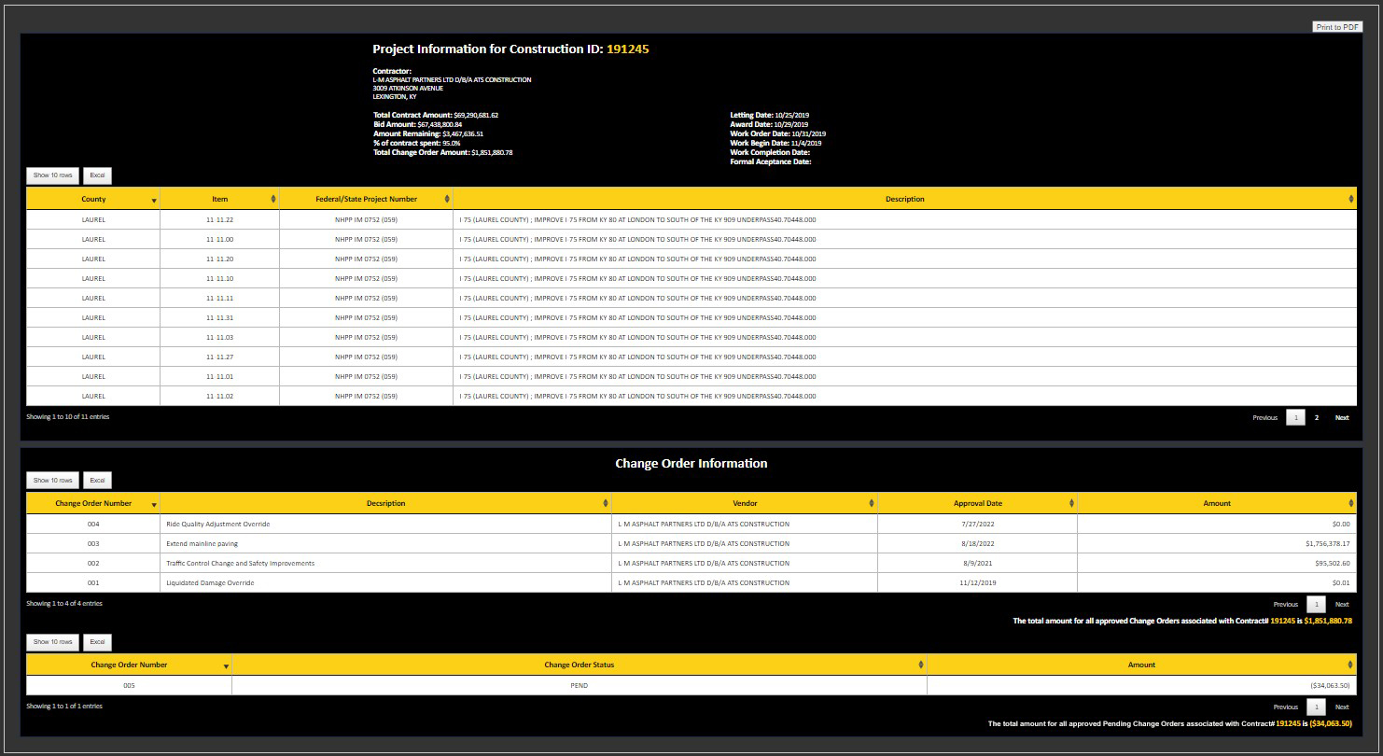
By selecting the Construction ID on the Lookup screen, you can access relative Construction, Change Order and Pending Change Order information. This screen is entirely printable to PDF or if needed. Each table is exportable to Excel (separately) and the headers can be sorted.
Construction information includes:
- Contractor Name and Address  - Total Contract amount (dollars)  - Bid Amount (dollars)  - Amount Remaining (dollars)  - % Of contract amount spent  - Total Change Order amount (dollars) | - Letting Date  - Award Date  - Work Order Date  - Work Begin Date  - Work Completion Date  - Formal Acceptance Date

Tabular data containing; County location, SYP Item Number, Federal/State Project Number and Project Description.
Change Order Information is tabular formatted data that is exportable to Excel which includes:
- Change Order Number  - Description  - Vendor | - Approval Date  - Amount (dollars)  - Total Amount (dollars)

Pending Change Order Information is tabular formatted data that is exportable to Excel which includes:
- (Pending) Change Order Number  - Change Order Status | - Amount (dollars)  - Total Amount (dollars)

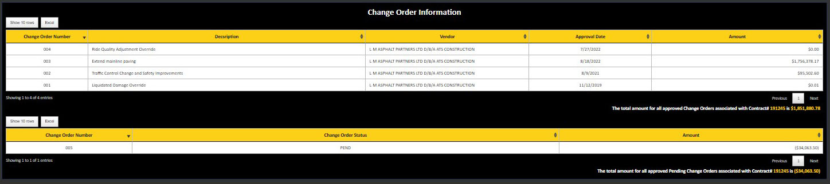

B./C. MARS/eMARS Budget Summary, Detailed Encumbrance and Expenditure info
This screen contains a project’s budget summary. There are also menus located at the top of the screen that drill into Project Authorization information, Current Encumbrance information and Detailed Expenditure information. Two options on the lookup screen allow you see B.) a single eMARS program code budget or C.) all eMARS program codes associated with and Authorization number.
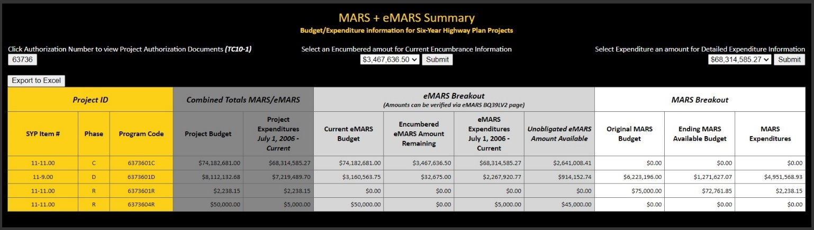
As a rule, only valid SYP Item numbers and Program Codes that are active in EMARS will be reported. The budget information displayed on this screen does not include ineligible funding line(s).
However, the expenditure amounts will include transactions referencing ineligible funding line(s). Amounts on the summary screen can be verified on the eMARS BQ39LV2 page.
The table on this screen is exportable to excel and is split into four color coded sections for easy reading are as follows:
- Project ID
SYP Item#
Phase
Program Code (emars)
The first five digits indicate the eMARS number (TC-10 number), the next two digits indicate
the sequence number and the last character indicates the phase of the project.
- Combined MARS/EMARS Totals
Project Budget
Project Expenditures July 1, 2006 – Current
- eMARS Breakout
Current eMARS Budget
Ky Custom Budget Formula: Adopted + Amendments;
excludes Ineligible Funding Line (INEL52) amounts
Encumbered eMARS Amount Remaining
This amount represents sum of eMARS funding line Expense Actuals:
Encumbrance amounts as shown on the eMARS BQ39LV2 page.
eMARS Expenditures
Formula: Accrued Expenses + Cash Expenses; includes Ineligible Funding Line (INEL52)
amounts.
Unobligated eMARS Amount Available
Formula: Current Budget minus Encumbered minus Accrued Expenses minus Cash Expenses;
excludes Ineligible Funding Line (INEL52) amounts.
- MARS Breakout
Original MARS Budget
Ending MARS Available Budget
MARS Expenditures

The menus located at the top of the screen gives you the ability to drill into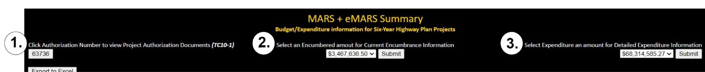
1. Authorization modifications and TC-10 documentation
Click Authorization Number to view Project Authorization Modifications and TC-10-1 Document
2. Detailed Encumbrance information
Select an Encumbered amount for Current Encumbrance Information
3. Detailed Expenditure information
Select and Expenditure amount for Detailed Expenditure information

1. Authorization modifications and TC-10 documentation (see TC-10 Viewer on page 42)
2. Detailed Encumbrance information
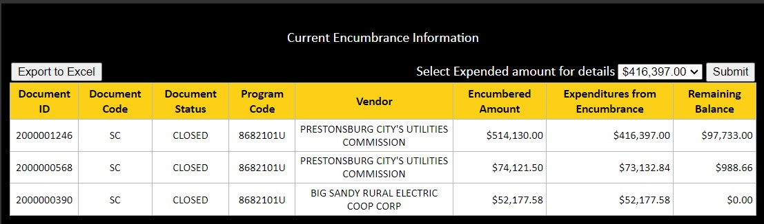
This screen displays the total encumbered amount remaining in the corresponding program code’s project/phase. The menu at the top drills into the total expenditures from the selected encumbrance.
The table is exportable to Excel and contains:
- Document ID  - Document Code  - Document Status  - Program Code (eMARS) | - Vendor  - Encumbered Amount  - Expenditures from Encumbrance  - Remaining Balance

The table generated on this screen is exportable to Excel and contains:
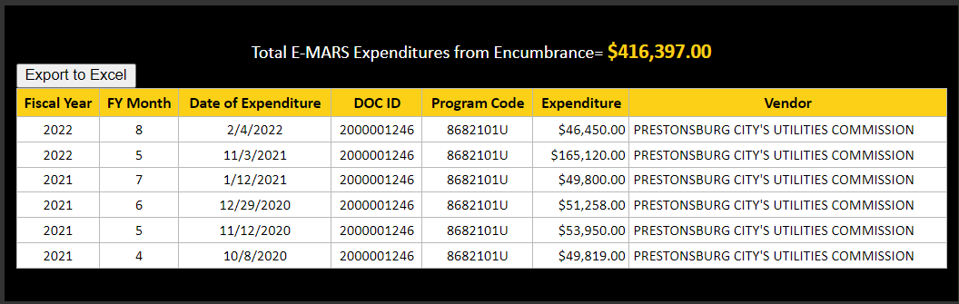
- Fiscal Year
- Fiscal Year Month
- Date of Expenditure
- Document ID
- Program Code
- Expenditure
The total of expenditures from encumbrances should always equal the value selected from Current Encumbrance Information screen
- Vendor
3. Detailed Expenditure information
The summed detail amounts should always total the amount shown on this summary screen.
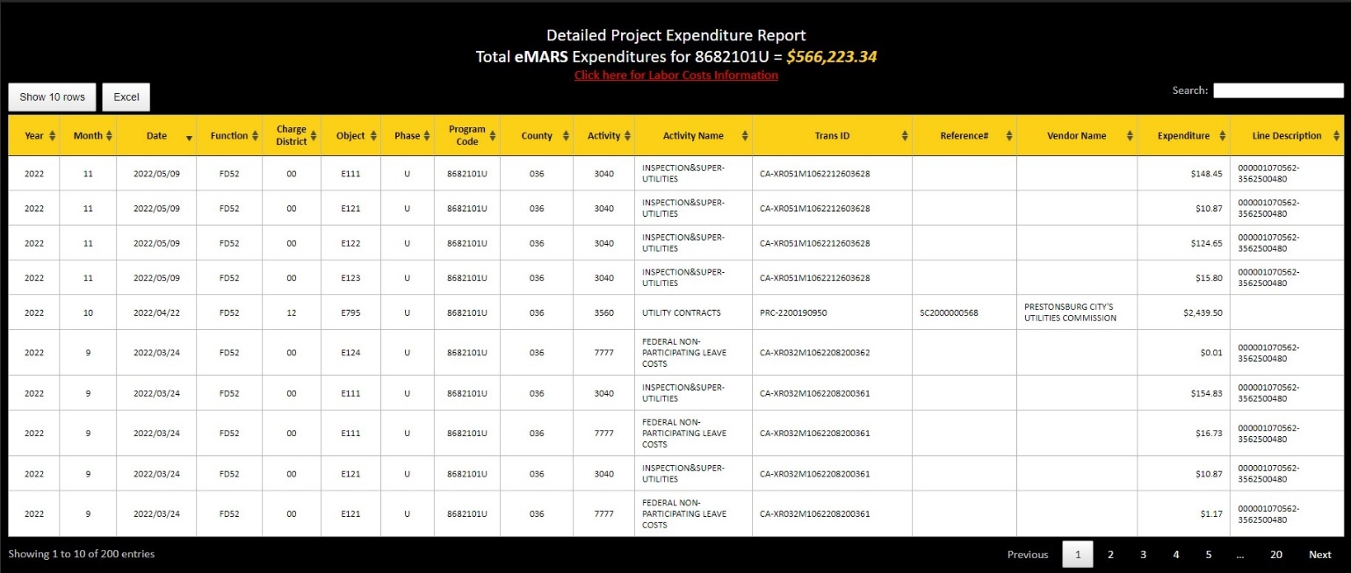
This table is exportable to Excel and the headers can be sorted. It contains:
- Year (Fiscal Year)  - Month (based on Fiscal Year)  - PBU  - Charge District  - Object  - Phase  - Program Code  - County | - Date  - Activity (ACT) Code  - Activity Name  - Trans ID  - Reference #  - Vendor Name  - Expenditure  - Line Description
Labor cost information
The Commonwealth pays employees on a semi-monthly basis with a scheduled pay day on the 15th and 30th of each month. The two monthly pay periods are from the 1st to the 15th of the month and the 16th through the last day of the month. Paycheck distribution is delayed by one pay period to allow for system processing. For example, work performed during the 1st to the 15th day of the month is paid to the employee on the 30th of the month. Accordingly, the cost accounting charges for labor costs posting in eMARS to operating accounts and highway projects are also delayed by approximately one pay period.
A good rule of measure is that the cost accounting charges for the pay period ending on the 15th of the month will post to eMARS by the 25th and those for the pay period ending on the last day of the month will post to eMARS by the 10th of the following month.
D. Pre-construction Information and Status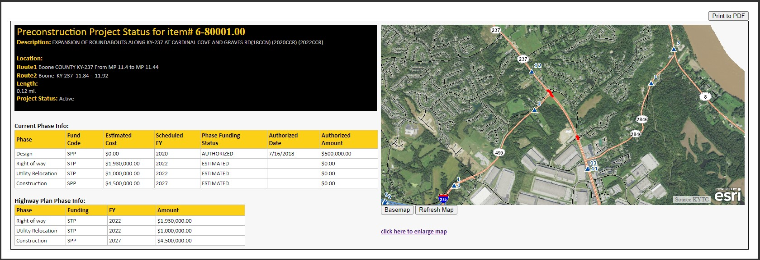
This screen is printable to PDF.
When selecting the Highway Plan Item number on the lookup screen you will retrieve Preconstruction (Precon) information and status. Information displayed includes:
- Description
Description of project form Preconstruction.
- Location
County, Route, Begin Mile Point and End Mile Point. (Route2 is listed if project covers 2 routes or 2 counties)
- Length
Total length of project in miles
- Project Status
Current status of project in Preconstruction (Active, Inactive)
- Current Phase Info
Phase, Fund Code, Current Estimated Cost, Scheduled Fiscal Year, Status of Phase Funding, Authorized Date and Authorized Amount currently in preconstruction.
- Highway Plan Phase Info
Phase, Fund Type, Fiscal Year, and Amount in current approved Highway Plan.
- Project Location Map
Displays a GIS base maps with route numbers and mile points shown. Also, the project location is linked to aerial photography and USGS quad sheets and provides the user zoom-in and zoom-out features along with pan around features of the project area.
E. Authorization Modifications and TC-10-1 (See TC-10 Viewer on page 42)

2. Kentucky Highway Project Budget and Expenditure Information 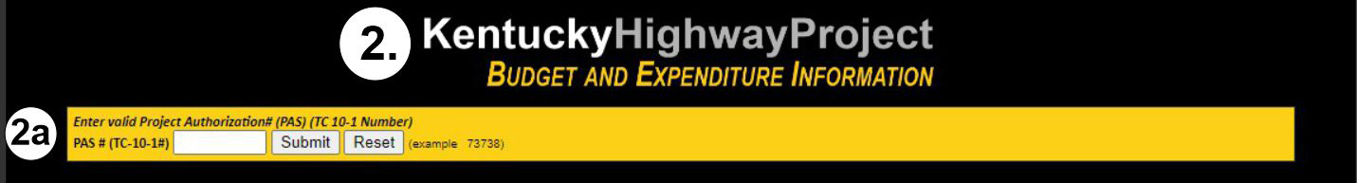
(2a.) Project Authorization number, aka PAS or TC10 -1 number, PDP-FA number
When entering the Authorization (PAS, TC-10, PDP-FA) number you can view the budget
summary of any associated Highway project that has an active e-MARS budget. This financial
data is pulled from MARS and eMARS.
MARS + eMARS Summary Budget and Expenditure Information for Highway Projects
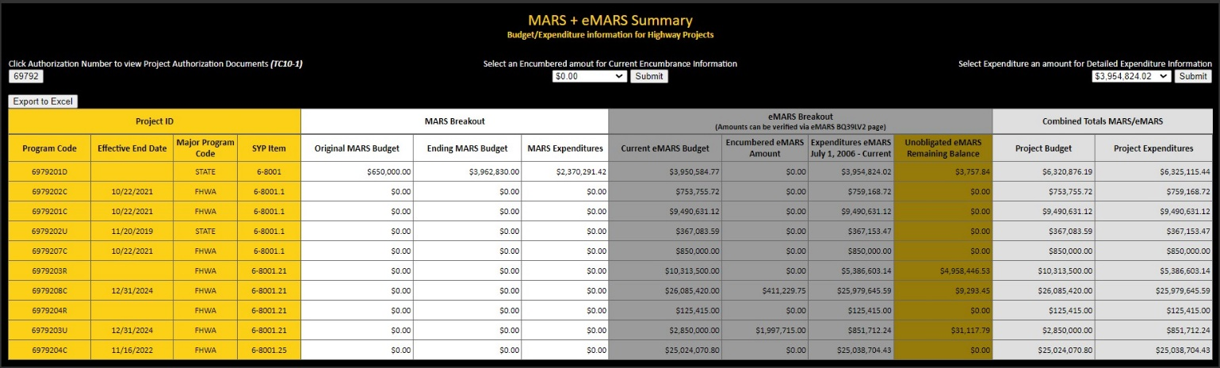
This screen is very similar to the previous MARS/eMARS Budget Summary screen shown on page 10.
It performs the same way. The links go to the same drilldown encumbrance, expenditure and project authorization screens as the other. The difference is within the Project ID section, there is no Phase column. The project phase is indicated with the last character of the Program Code. This table is exportable to Excel.
We have included two additional columns in this section:
- Effective End Date
- Major Program Code

3. Non-Kentucky Highway Plan Budget and Expenditure Information
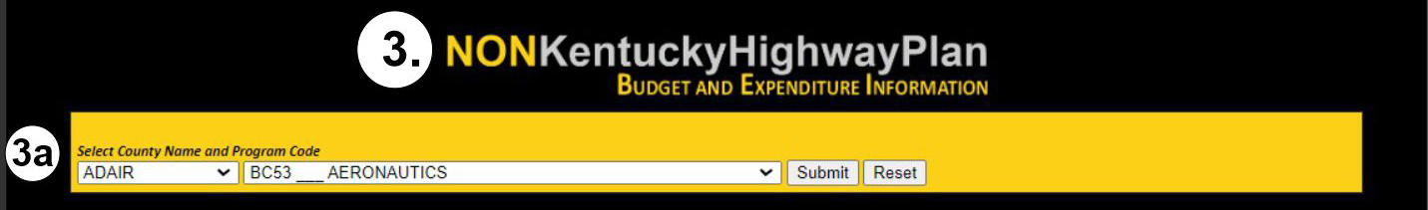
(3a.) County Name and Program Code: This field needs a valid County and related Program Code to display data. 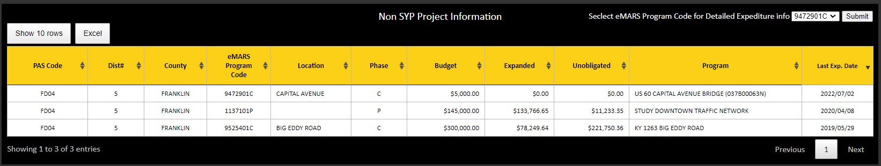
When selecting combination of PDP-FA Program Code and County name you can view relative project information on NON-Highway Plan projects. There is a dropdown menu located at the top of the screen on the right. When you select an eMARS program code, the query will take you to a related detailed expenditure report.
The table on this screen is exportable to Excel and contains:
- PDP-FA Program Code  - District  - County  - eMARS Program Code  - Location (Road Name)  - Phase | - Budget  - Expenditure Amount (dollars)  - Unobligated Amount (dollars)  - Program  - Last Expenditure Date

Active Construction Projects
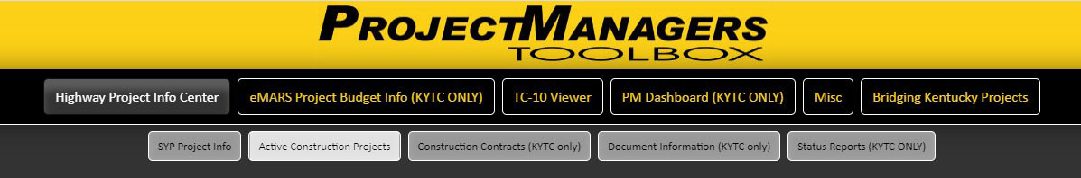
The second tab under The Highway Project Info Center is Active Construction Projects. This tab opens a menu screen with three different selections that drill to active construction project details.
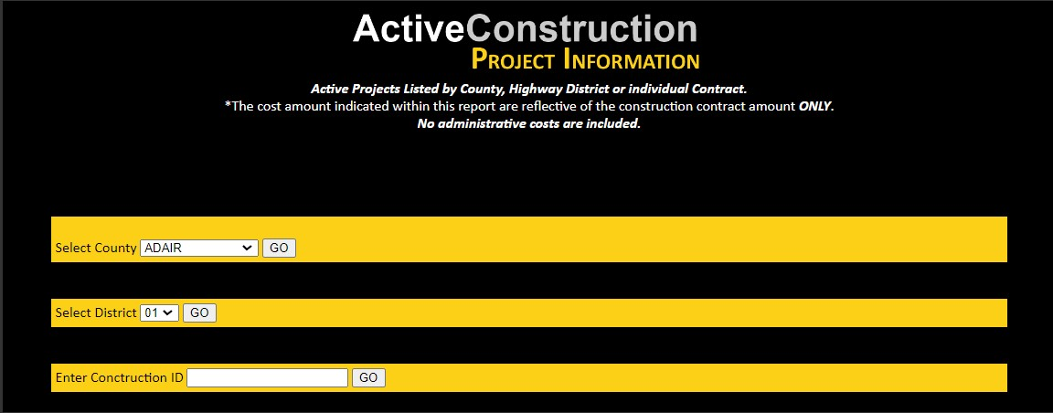
- Select County
Shows all active construction projects and summarized info within the selected county.
- Select District
Shows all active construction projects and summarized info within the selected Highway district.
- Enter Construction ID
Takes you directly to the same Construction and Change Order information screen as shown in the Highway Plan Project Information section. (See Page 9 for details)
NOTE: This screen includes SYP and NON-SYP projects.
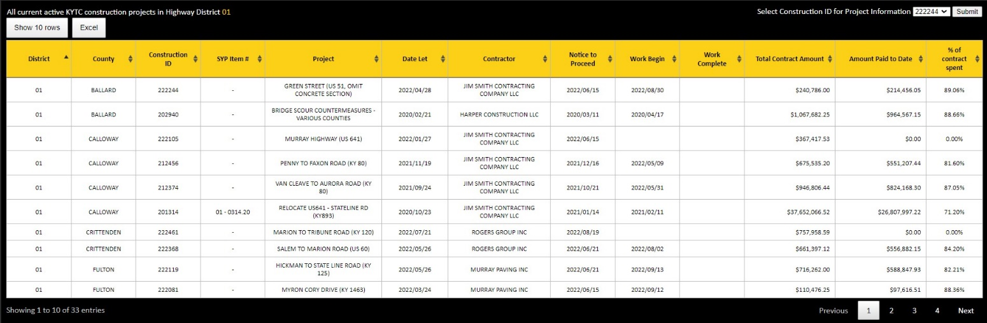
The construction summary screens are very similar in content, with differences being one is queried by County and the other by Highway District. There is a drill down menu on the top right-hand side with the Construction ID that drills to same Construction and Change Order information screen as shown in the Highway Plan Project Information section. (See Page 9 for details)
The table on this screen is exportable to Excel and the headers can be sorted. It includes:
- District  - County  - Construction ID  - SYP Item  - Project Description  - Letting (date)  - Contractor Name | - Notice to Proceed (date)  - Work Begins (date)  - Work Complete (date)  - Total Contract amount (dollars)  - Amount Paid to date (dollars)  - % Of contract amount spent

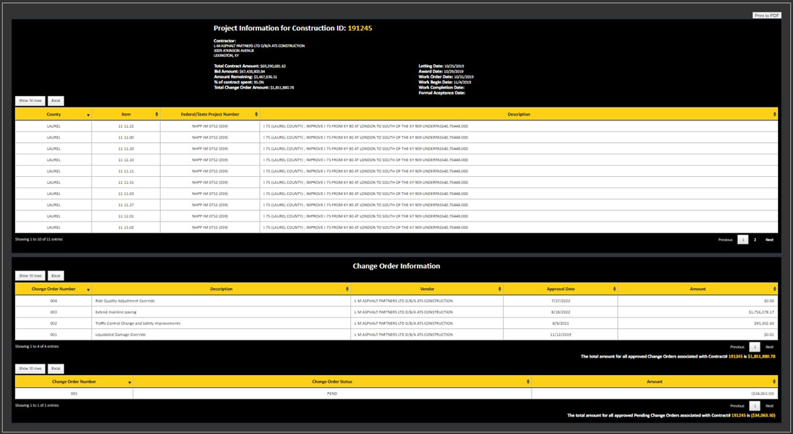
Entering Construction ID returns this screen. The details are the same as shown on page 9.

Construction Contracts (KYTC Only)
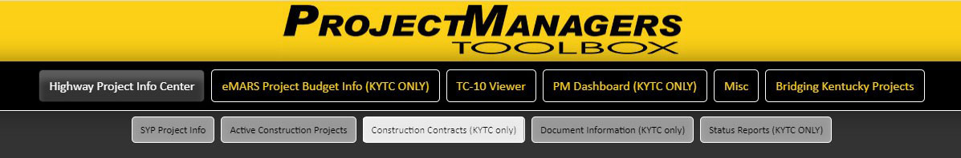
This screen can only be accessed by KYTC employees that are connected to our network within our firewall. It is not intended for external use. The table can be exported to Excel.
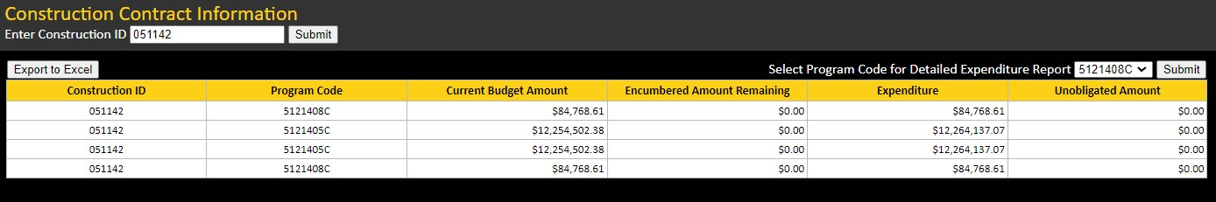
It was developed specifically for the Division of Construction to retrieve budget and expenditure information by eMARS Program Code. It only reflects the construction projects that are active in eMARS. When you enter a construction ID it displays a table containing:
- Construction ID  - Program Code  - Current Budget Amount (dollars) | - Encumbered Amount Remaining (dollars)  - Expenditure (dollars)  - Unobligated Amount (dollars)
When selecting the Expended amount in the dropdown menu you will get the Detailed Expenditure Information as shown in the Highway Information Center. (See page 12 for details.)
Document Information (KYTC Only)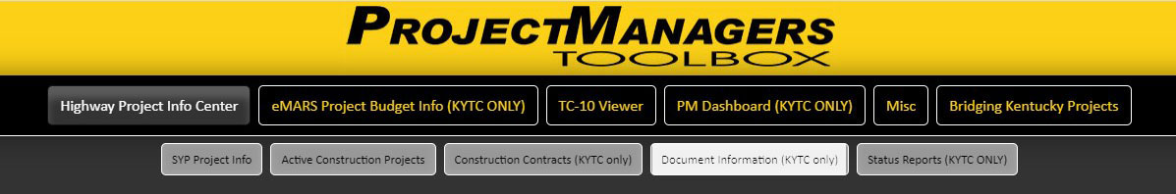
This screen displays some of the Highway project’s document record information that was previously shown in the “Doc Viewer” application. Doc Viewer is no longer supported. 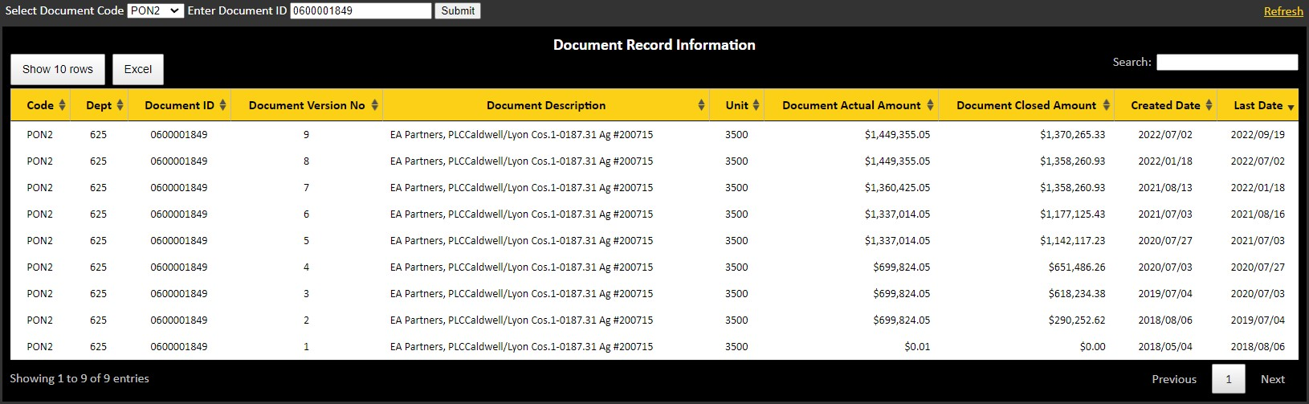
This screen can only be accessed by KYTC employees that are connected to our network within our firewall. It is not intended for external use.
When selecting the Document Code in conjunction with the Document ID, the query will return data in a tabular format, a summary of all the specified document records available. This table is exportable to Excel and includes:
- Document Code  - Department Code  - Document ID  - Document Version Number  - Document Description | - Document Unit Code  - Document Actual Amount (dollars)  - Document Closed Amount (dollars)  - Created Date  - Last Date

Status Reports (KYTC Only)
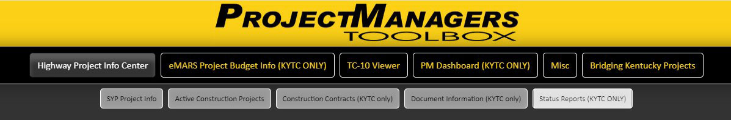
This tab contains internal working documents and is intended for internal (KYTC use only).
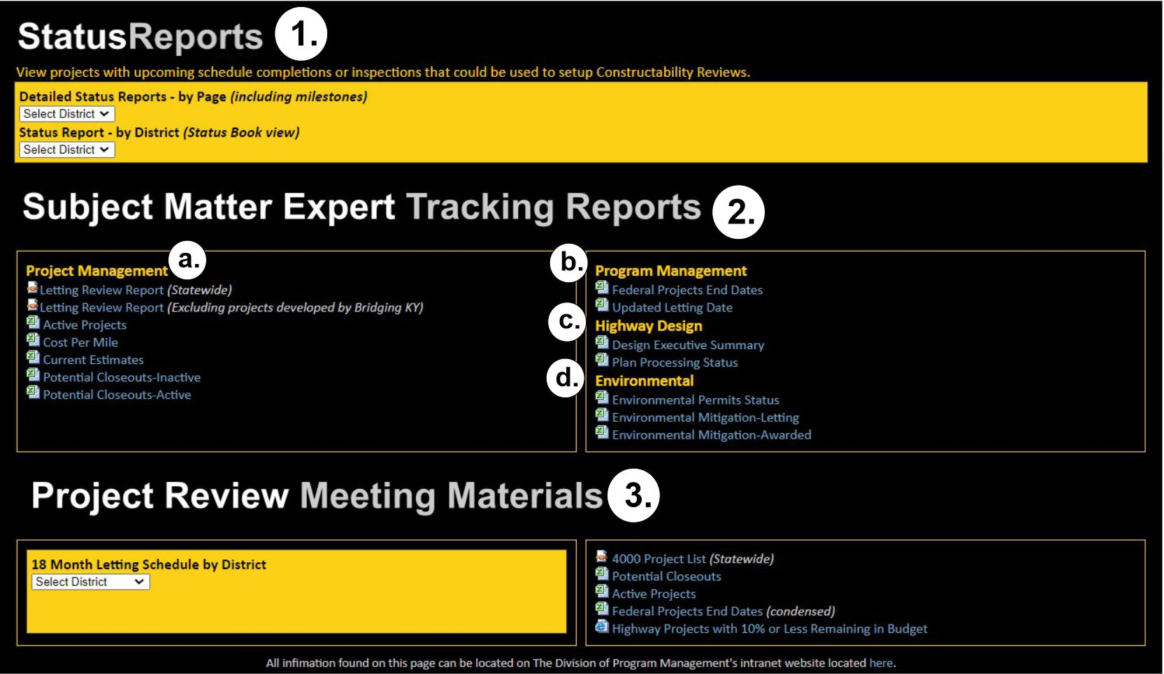
The Status Report screen contains links that can be found on The Division of Program Management’s Intranet webpage https://intranet.kytc.ky.gov/org/DPM/Pages/Status-Reports.aspx
Links found on this screen include:
- Status Reports
View projects with upcoming schedule completions or inspections that could be used to setup Constructability Reviews. Data sources include eMARS, PDP, KROWDS and EATS
- District Status Reports by page Including milestones updated monthly (see Fig.1 page 23)
- Status Reports by Page Status Book view updated daily (see Fig.2 page 24)

Fig. 1:
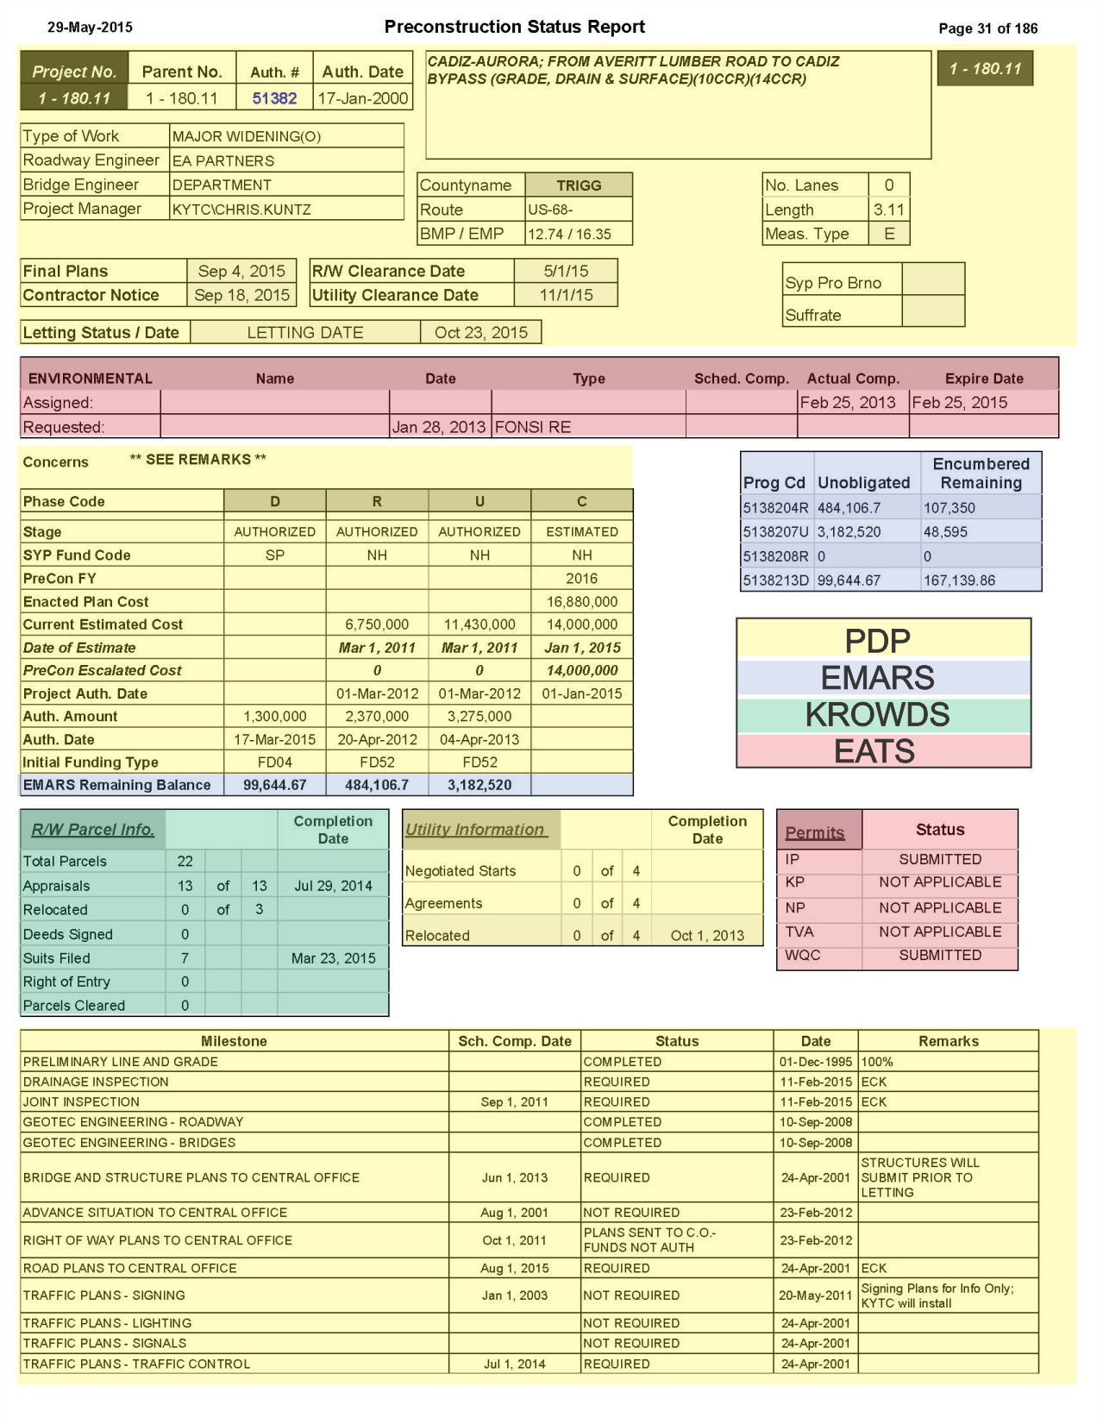
Fig. 2: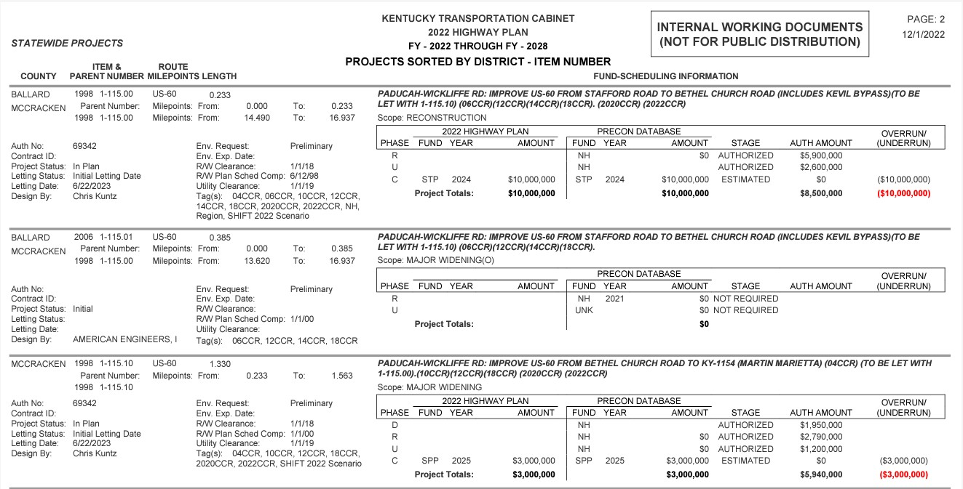
- Subject Matter Expert Tracking Reports
a. Project Management
- Letting Review Report -Statewide letting schedule including Bridging KY projects
- Letting Review Report - Statewide letting schedule Excluding projects by Bridging KY.
(see Fig. 3 page 26)
- Active Projects – Monitor and track status of all active Highway Plan projects filtered on
Highway District (see Fig. 4 pages 26)
- Cost Per Mile - Estimating phase cost per mile. (see Fig. 5 pages 27)
- Current Estimates - Current projects with Estimates revision date. Used to keep project
estimates up to date. (see Fig. 6 page 28)
- Potential Closeouts-Inactive - List of potential closeouts that are inactive in PRECON but
still open in eMARS. (see Fig. 7 pages 29)
- Potential Closeouts-Active - List of potential closeouts ACTIVE in PRECON
(see Fig. 7 page 29)
b. Program Management
- Federal Projects End Dates - FHWA list of projects with Federal eMARS end date to help
view upcoming and expired ends dates. (see Fig. 8 page 29)
- Updated Letting Date - Projects that have had a letting date revised within the past 15 days
(see Fig. 9 page 30)
c. Highway Design
- Design Executive Summary​ - Track the DES submittal and approval status. Projects will
populate on report based on PL&G Inspection minutes approval. (see Fig. 10 pages 30-31)
- Plan Processing Status - Monitor and track final plans status by Plan Processing branch.
Red fields note overdue check prints and/or final plans. ​(see Fig. 11 page 31)
d. Environmental
- Environmental Permits Status - This report can be used to track the status of the
environmental permits. RED fields notes upcoming permit expirations.
(see Fig. 12 Page 32)
- Environmental Mitigation-Letting - List of projects containing mitigation details for
upcoming letting schedule. (see Fig. 13 Page 33)
- Environmental Mitigation-Awarded​​ - List of projects containing mitigation details for
upcoming letting schedule. (see Fig. 14 Pages 33-34)
- Project Review Meeting Materials
- 18 Month Letting Schedule by District - Letting schedules for the next 18 months
(see Fig. 15 Page 34)
- 4000 Project List – List of projects with the letting date of 4000 (Statewide)
(see Fig. 16 Page 35)
- Potential Closeouts - List of potential closeouts that are inactive in PRECON but still open in
eMARS (see Fig. 17 Page 35)
- Federal Projects End Dates​ (condensed) - FHWA list of projects with Federal eMARS end date
to help view upcoming and expired ends dates. Same as above
- Highway Projects with 10% or Less Remaining in Budget – (See Page 40)

Fig. 3: Letting Review Report
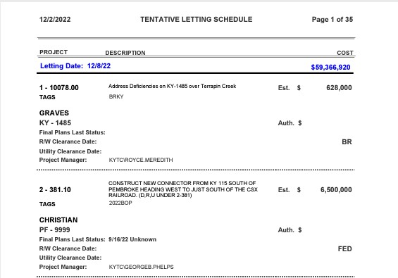
Fig. 4: Active Projects Report
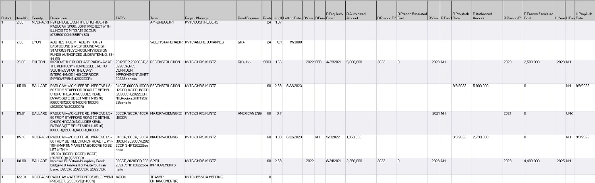
All Columns are not shown in this illustration. This report includes the following:

- Highway District  - Highway Plan Item No.  - County  - Project Description  - TAGS  - Project Type  - Project Manager  - Road Engineer  - Route  - Project Length  - Letting Date  - D Year  - D Fund  - D Proj Auth Date  - D Authorized Amount  - D Precon FY  - D Precon Escalated Cost | - R Year  - R Fund  - R Proj Auth Date  - R Authorized Amount  - R Precon FY  - R Precon Escalated Cost  - U Year  - U Fund  - U Proj Auth Date  - U Authorized Amount  - U Precon FY  - U Precon Escalated Cost  - C Year  - C Fund  - C Proj Auth Date  - C Authorized Amount  - C Precon FY  - C Precon Escalated Cost
Fig.5: Cost Per Mile Report
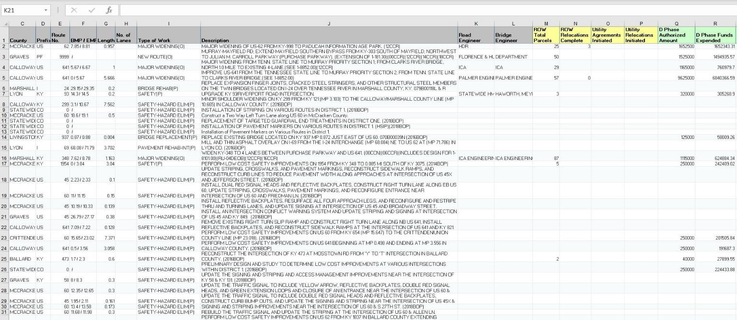
All Columns are not shown in this illustration. This report includes the following:
- District  - Item No.  - County  - Prefix  - RouteNo.  - BMP / EMP  - Length  - No. of Lanes  - Type of Work  - Description  - Road Engineer  - Bridge Engineer  - ROW Total Parcels | - ROW Relocations Complete  - Utility Agreements Initiated  - Utility Relocations Initiated  - D Phase Authorized Amount  - D Phase Funds Expended  - ROW Phase Authorized Amount  - ROW Phase Funds Expended  - U Phase Authorized Amount  - U Phase Funds Expended  - C Phase Authorized Amount  - C Phase Funds Expended  - Award Amount  - Award Date

Fig. 6: Current Estimates Report
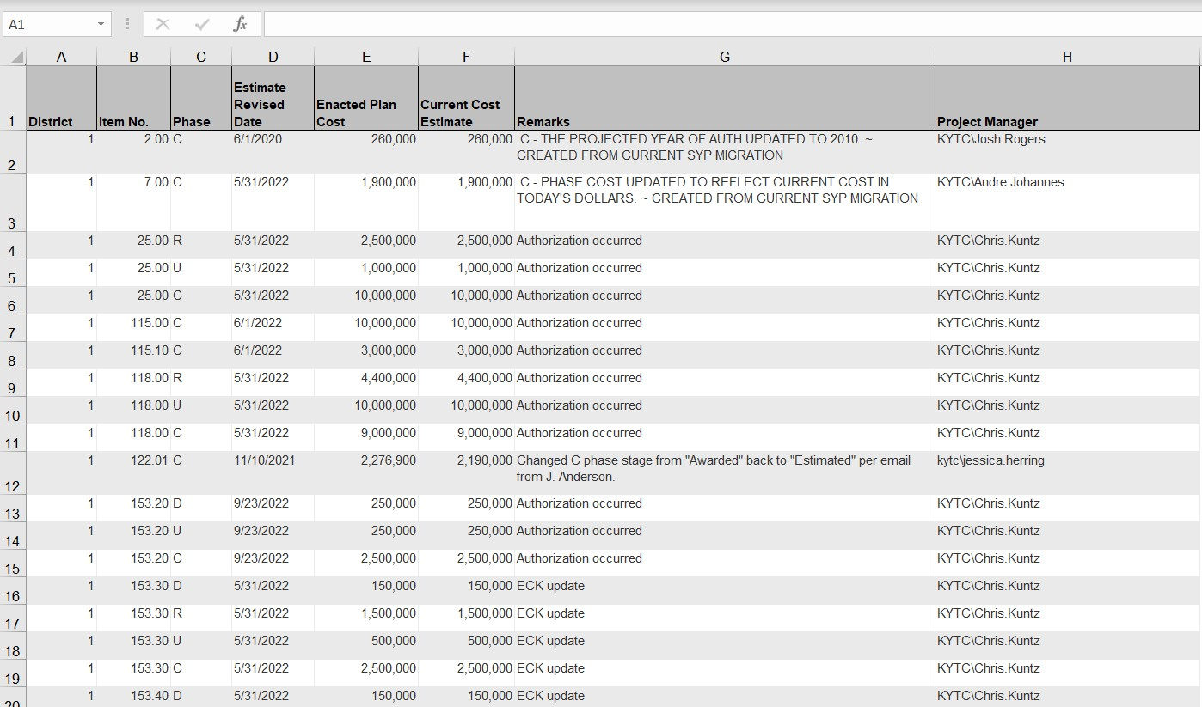

Fig. 7: Potential Closeouts-Active/Inactive Report
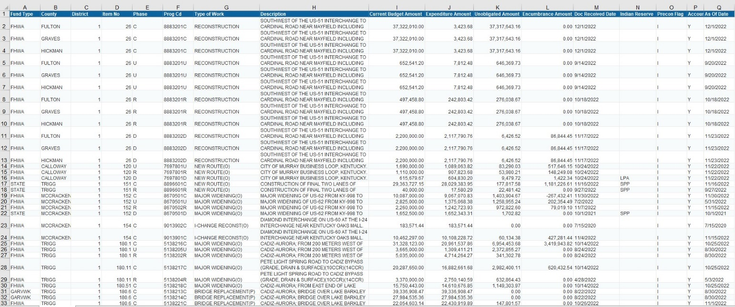
Both Active and Inactive reports contain the same columns with the difference being in the “Precon Flag” Column. A = Active I = Inactive. These tables include the following data:
- Fund Type  - County  - District  - Item No  - Phase  - Prog Cd  - Type of Work  - Description | - Current Budget Amount  - Expenditure Amount  - Unobligated Amount  - Encumbrance Amount  - Doc Received Date  - Indian Reserve  - Precon Flag  - Accounting Flag (Project Active Flag)  - As Of Date
Fig. 8: Federal Projects End Dates
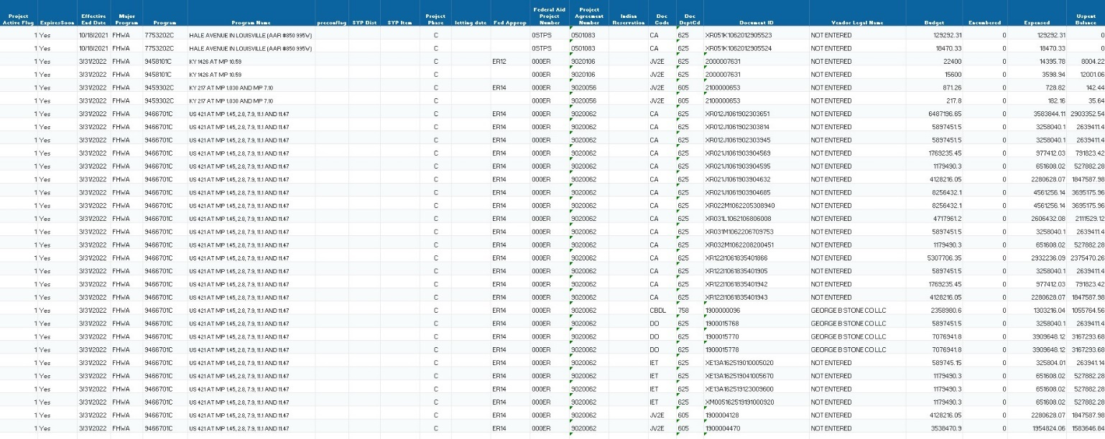
This table includes the following data:
- Project Active Flag  - ExpiresSoon  - Effective End Date  - Major Program  - Program (eMARS ProgramCode)  - Program Name  - preconflag  - SYP Dist  - SYP Item  - Project Phase  - letting date | - Fed Approp  - Federal Aid Project Number  - Project Agreement Number  - Indian Reservation  - Doc Code  - Doc DeptCd  - Document ID  - Vendor Legal Name  - Budget  - Encumbered  - Expensed  - Uspent Balance

Fig. 9: Updated Letting Date Report
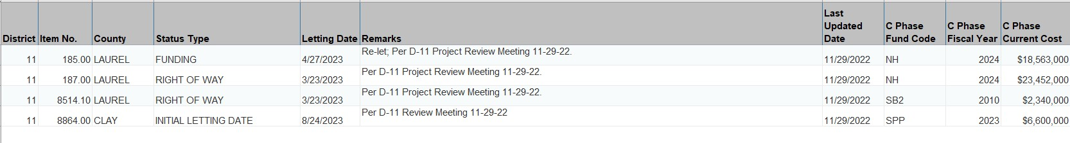

Fig. 10: Design Executive Summary
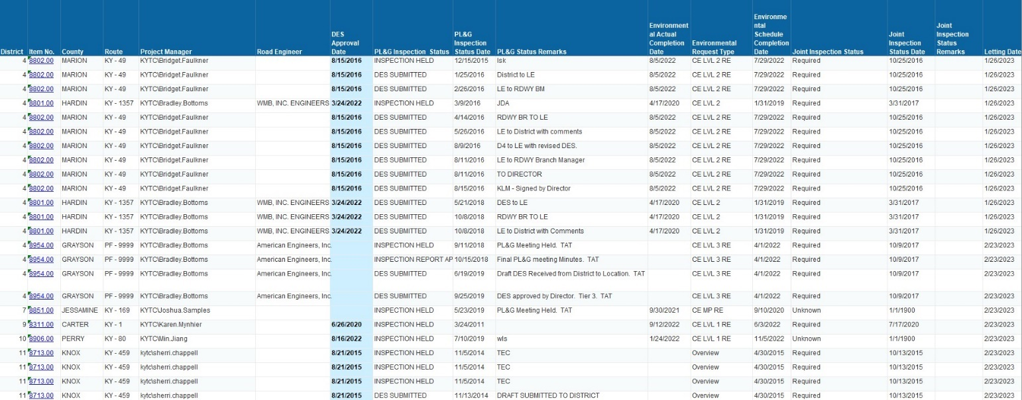
This table includes the following data:
- District Item No.  - County  - Route  - Project Manager  - Road Engineer  - DES Approval Date  - PL&G Inspection Status  - PL&G Inspection Status Date  - PL&G Status Remarks | - Environmental Actual Completion Date  - Environmental Request Type  - Environmental Schedule Completion Date  - Joint Inspection Status  - Joint Inspection Status Date  - Joint Inspection Status Remarks  - Letting Date
Fig. 11: Plan Processing Status
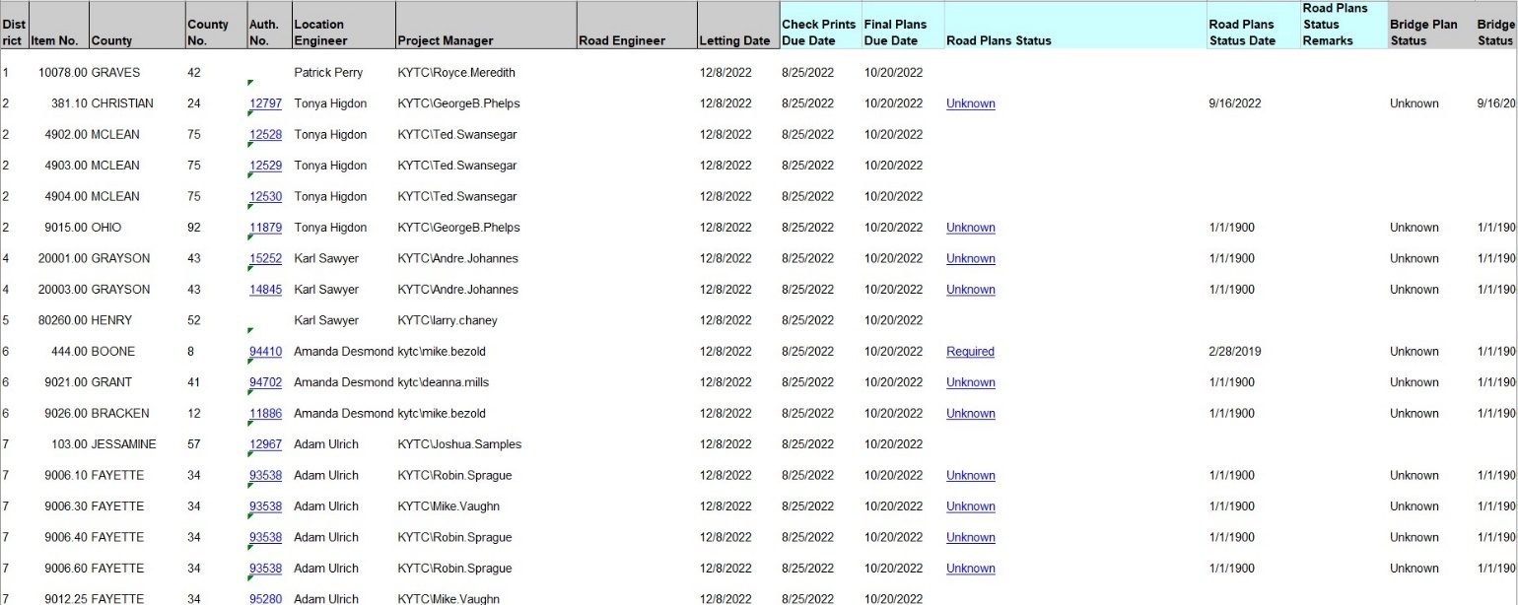
Not all columns are shown in this illustration. Data in this table includes:
- District  - Item No.  - County  - County No.  - Auth. No. – Drilldown link to Budget Summary Screen  - Location Engineer  - Project Manager  - Road Engineer  - Letting Date  - Check Prints Due Date  - Final Plans Due Date  - Road Plans Status – Drilldown link to Detailed Report | - Road Plans Status Date  - Road Plans Status Remarks  - Bridge Plan Status  - Bridge Plans Status Date  - Bridge Plans Status Remarks  - Lighting Status  - Lighting Status Date  - Lighting Status Remarks  - Signal Status  - Signal Status Date  - Signal Status Remarks  - Signing Status  - Signing Status Date  - Signing Status Remarks

Fig. 12: Environmental Permits Status
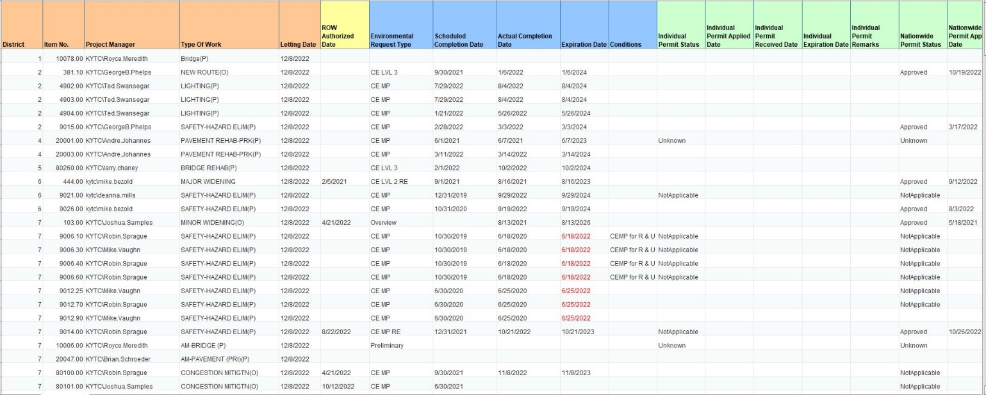
This illustration does not show all columns included. Data in this table includes:
- District Item No.  - Project Manager  - Type Of Work  - Letting Date  - ROW Authorized Date  - Environmental Request Type  - Scheduled Completion Date  - Actual Completion Date  - Expiration Date  - Conditions  - Individual Permit Status  - Individual Permit Applied Date  - Individual Permit Received Date  - Individual Expiration Date | - Individual Permit Remarks  - Nationwide Permit Status  - Nationwide Permit Applied Date  - Nationwide Permit Received Date  - Nationwide Expiration Date  - Nationwide Permit Remarks  - Water Quality Certification Status  - Water Quality Certification Applied Date  - Water Quality Certification Received Date  - Water Quality Certification Expiration Date  - Water Quality Certification Remarks

Fig. 13: Environmental Mitigation-Letting
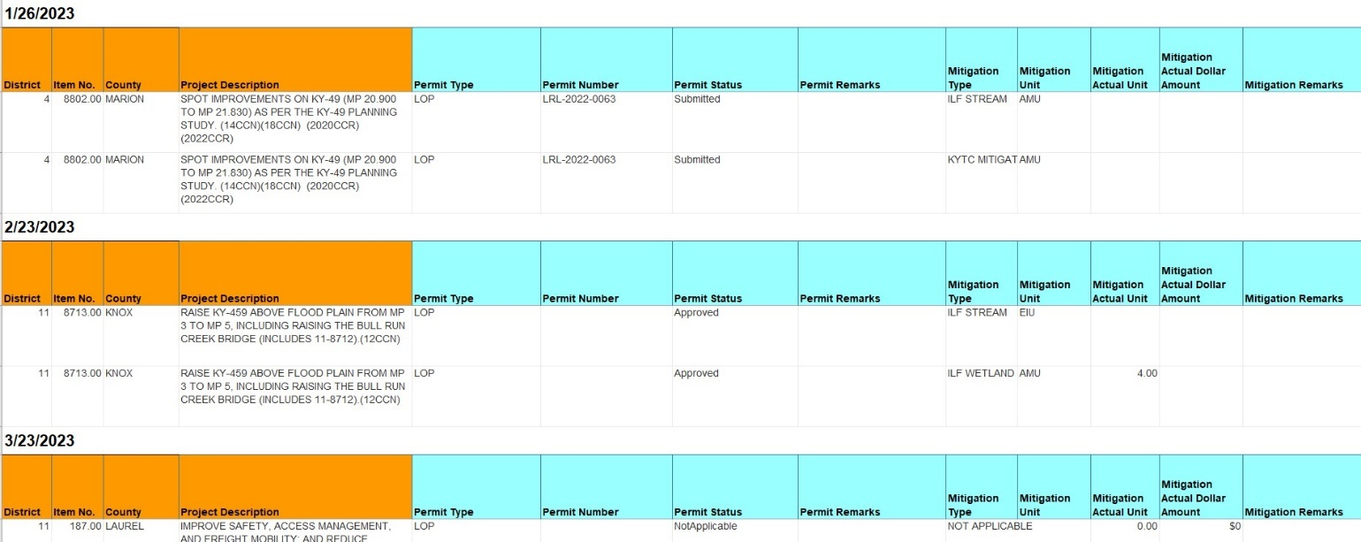
The data in this table is grouped by date and contains:
- District Item No.  - County  - Project Description  - Permit Type  - Permit Number  - Permit Status | - Mitigation Type  - Permit Remarks  - Mitigation Unit  - Mitigation Actual Unit  - Mitigation Actual Dollar Amount  - Mitigation Remarks
Fig. 14: Environmental Mitigation-Awarded
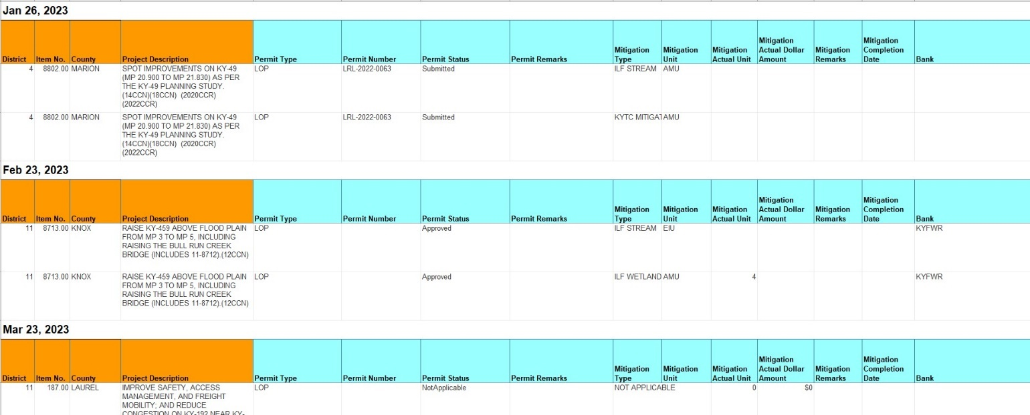
The data in this table is grouped by date and contains:
- District Item No.  - County  - Project Description  - Permit Type  - Permit Number  - Permit Status  - Permit Remarks | - Mitigation Type  - Mitigation Unit  - Mitigation Actual Unit  - Mitigation Actual Dollar Amount  - Mitigation Remarks  - Mitigation Completion Date  - Bank

Fig. 15: 18 Month Letting Schedule by District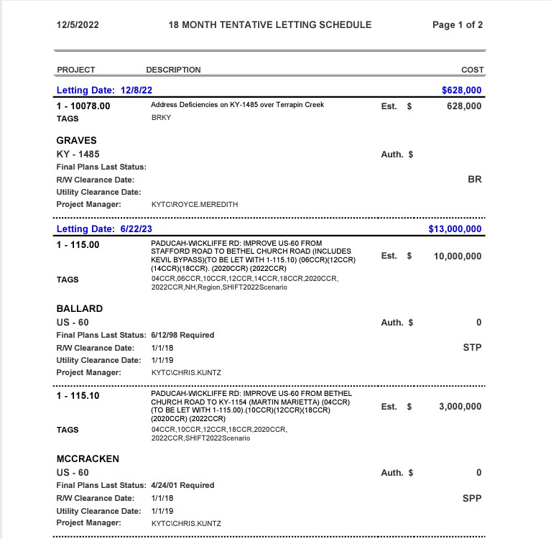

Fig. 16: 4000 Project List
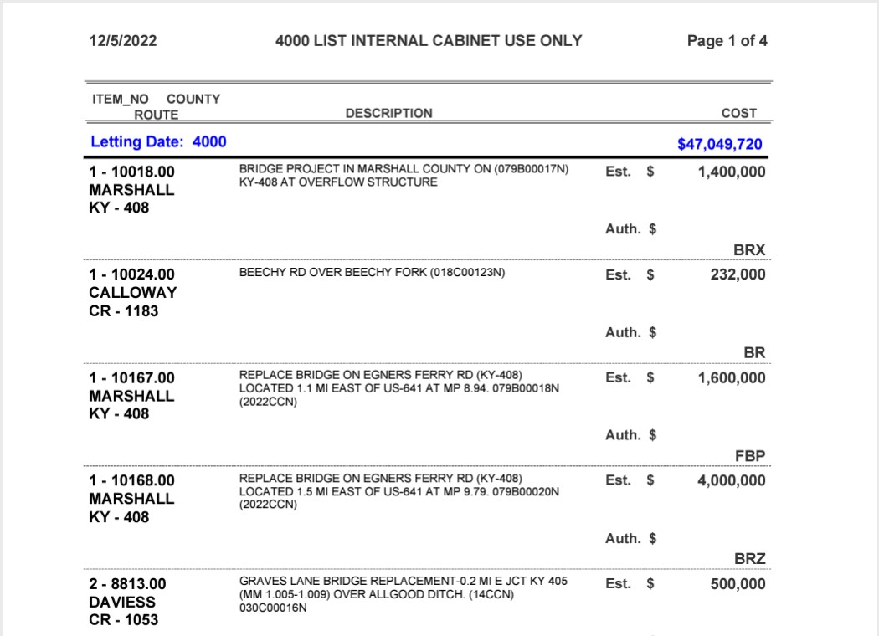
Fig 17: Potential Closeouts
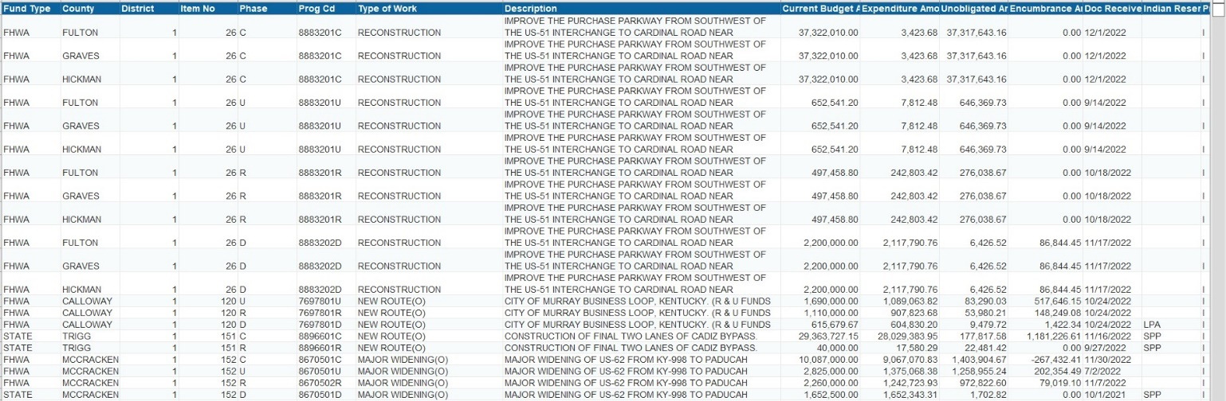
Not all columns are shown in this illustration. Data in this table includes:
- Fund Type  - County  - District  - Item No  - Phase  - Prog Cd  - Type of Work  - Description | - Current Budget Amount  - Expenditure Amount  - Unobligated Amount  - Encumbrance Amount  - Doc Received Date  - Indian Reserve  - Precon Flag  - Accounting Flag (Project Active Flag)  - As Of Date

eMARS Project Budget Info (KYTC Only)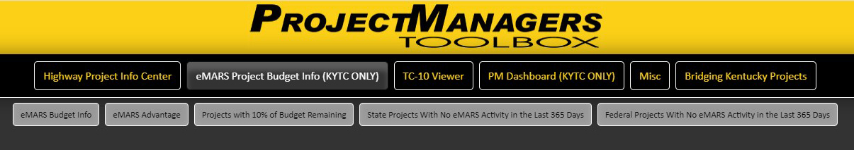
This tab contains internal working documents and is intended for internal (KYTC use only).
- eMARS Budget Info (Excel Spreadsheet)
- eMARS Advantage
- Projects with 10% of Budget Remaining
- State Projects with No Activity in the Last 365 Days
- Federal Projects with No Activity in the Last 365 Days

eMARS Budget Info: (Excel Spreadsheet)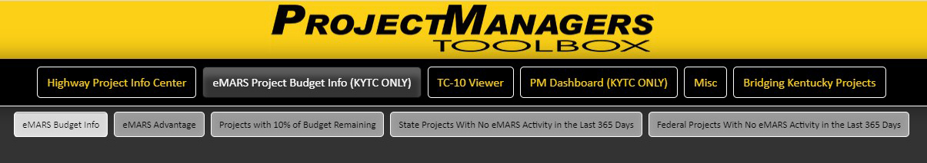
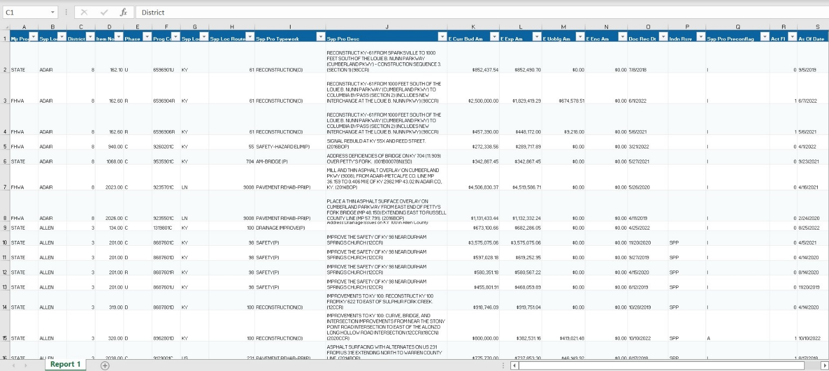
This tab opens to an Excel file that contains the current budget status of all Highway Plan projects as recorded within eMARS. The data is sorted by program code. The Excel spreadsheet is a tool to quickly find project information via Excel column filters. Columns include:
- Mjr Prog Cd – Major Program Code  - Syp Loc Countyname – County Name  - District – Highway District  - Item No – Highway Plan Item Number  - Phase – Project Phase  - Prog Cd – eMARS Program Code  - Syp Loc Prefix – Route Location Prefix  - Syp Loc Routeno – Route Location Number  - Syp Pro Typework – Project Type of Work  - Syp Pro Desc – Project Description  - E Curr Bud Am – eMARS Current Budget Amount (dollars)  - E Exp Am – eMARS Expended Amount (dollars) | - E Uoblg Am – eMARS Unobligated Amount (dollars)  - E Enc Am – eMARS Encumbered Amount (dollars)  - Doc Rec Dt – Document Recorded Date  - Indn Rsrv – ex: DB10, DB8, DB9, LPA, ROW, SPP  - Syp Pro Preconflag – indicates if a project is active or inactive in the Precon phases  - I = Inactive A = Active  - Act Fl – indicates if a project is active or inactive in eMARS 0 = Inactive 1 = Active  - As Of Date – Ending date
eMARS Advantage 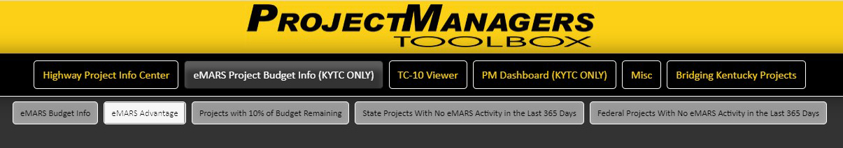
This tab provides users direct access to the CGI Advantage (eMARS) application. Proper credentials are required for login. https://emars311.ky.gov/webapp/finprdonline3111d1/Advantage
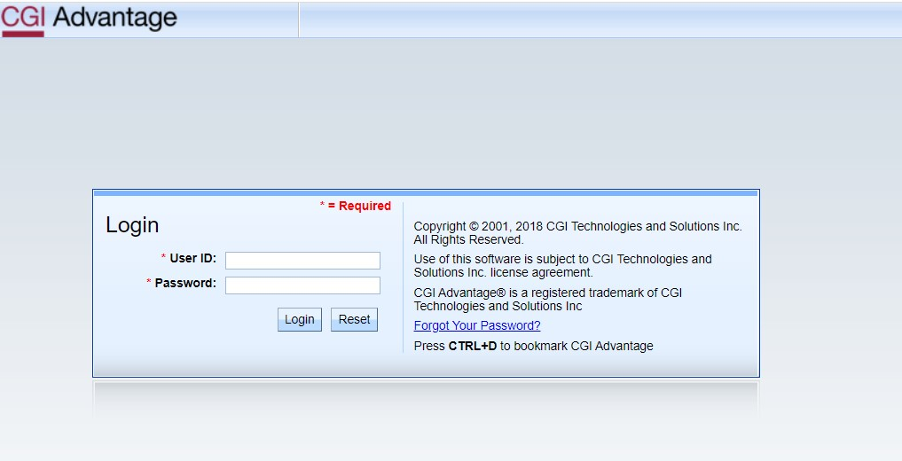

Projects with 10% of Budget Remaining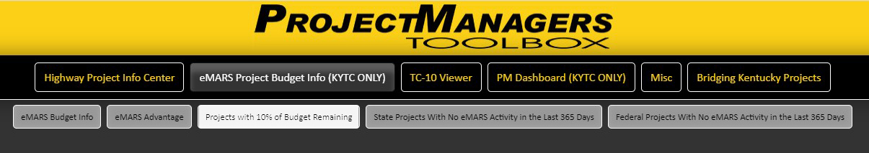
This tab links to a listing of Highway Plan Projects with less than 10% of their budget remaining.
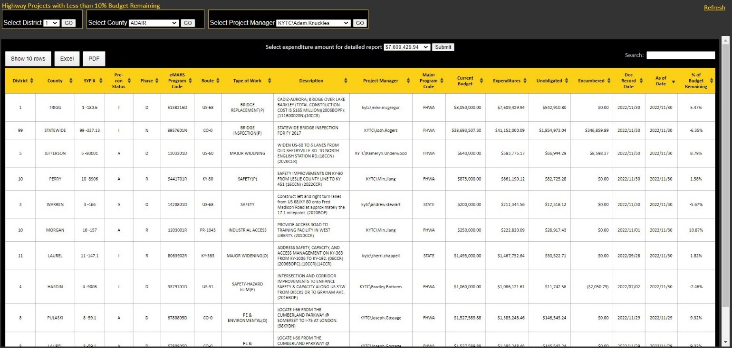
It defaults to showing all projects. However, it can also be filtered by District, County and Project Manager, from the dropdown menus on the top left. To return to all projects simply click refresh on the top right. The table itself can be exported to Excel and contains the following data:
- District  - County  - Highway Plan (SYP) Item  - Precon Status  I = Inactive A = Active  - Project Phase  - eMARS Program Code  - Route  - Type of Work | - Project Description  - Major Program Code  - Current Budget  - Expenditures  - Unobligated Amount (dollars)  - Encumbered Amount (dollars)  - Document Record Date  - As of Date  - % Of Budget Remaining

State/Federal Projects with No Activity in the Last 365 Days
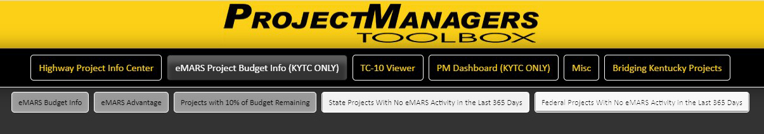These links will display screens that contain a listing of State and Federal Highway Plan projects with no eMARS activity for the last 365 days. The illustration below represents both reports. The only difference between the two is one is filtered by State and the other by Federal projects.
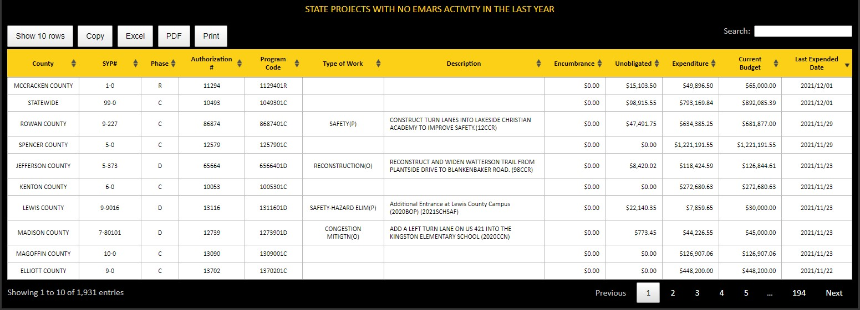
The table can be exported to Excel. The header can also be sorted. The data contains:
- County  - Highway Plan Item Number  - Project Phase  - Authorization Number  - eMARS Program Code  - Type of Work | - Project Description  - Encumbrance (dollars)  - Expenditures (dollars)  - Unobligated Amounts (dollars)  - Current Budget (dollars)  - Last Expended Date

TC-10 Viewer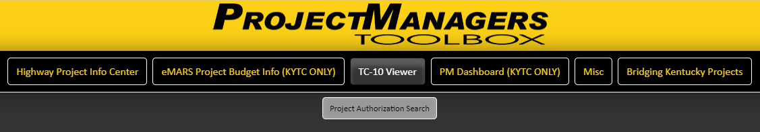The TC-10 viewer will give you online access to all TC-10s issued by the Cabinet since 1978. Page content should be exactly the same as the original TC-10 except for the signature. Please refresh (F5 key) your browser screen if you have used the PM Toolbox previously to make sure you have the latest version.
As shown on the screen shot below, you can search by: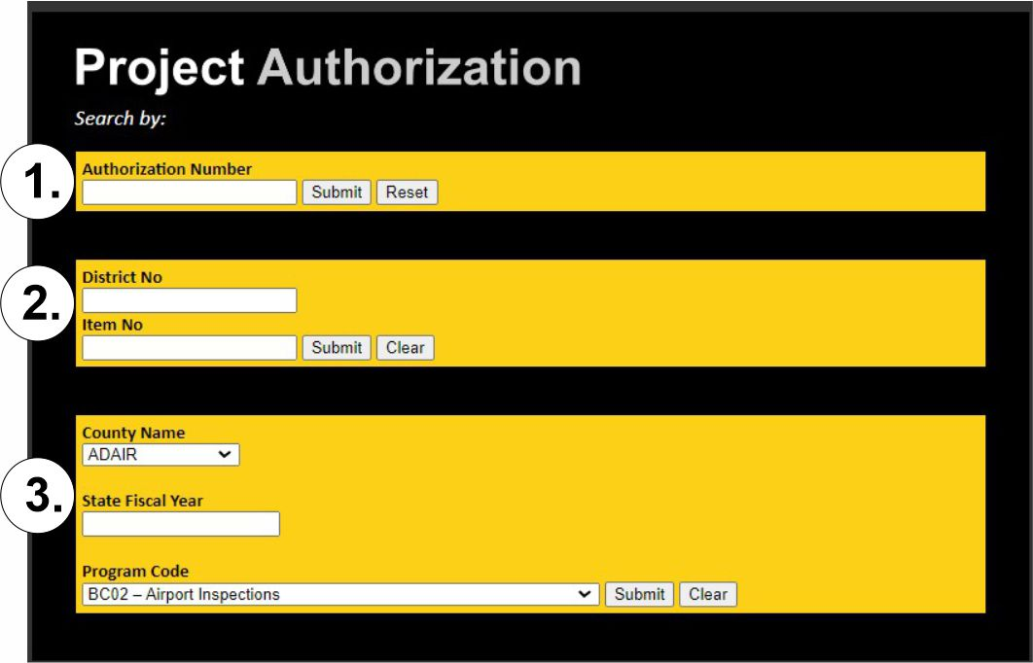
1. Authorization Number
2. District number and Highway Plan Item Number
3. County Name, Fiscal Year and/or Program Code
Drop-down lists for the county name and program code (type of funding) are provided. The program code drop-down list shows all types of funds and corresponding fund descriptions (i.e.: FD04 – state construction funding, FD52 – federal-aid funding). Please note, in order to retrieve a TC-10 you must input valid information.
When selecting, from one of the menus above, it will return similar listings.
The TC-10 list (example below) shows all authorized TC-10s and the current request funding totals associated with the data that was queried.
1. The Authorization Number (TC-10 number) 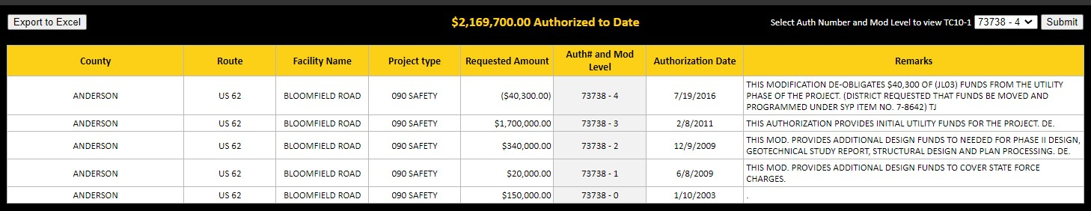
2. The District and Item Number
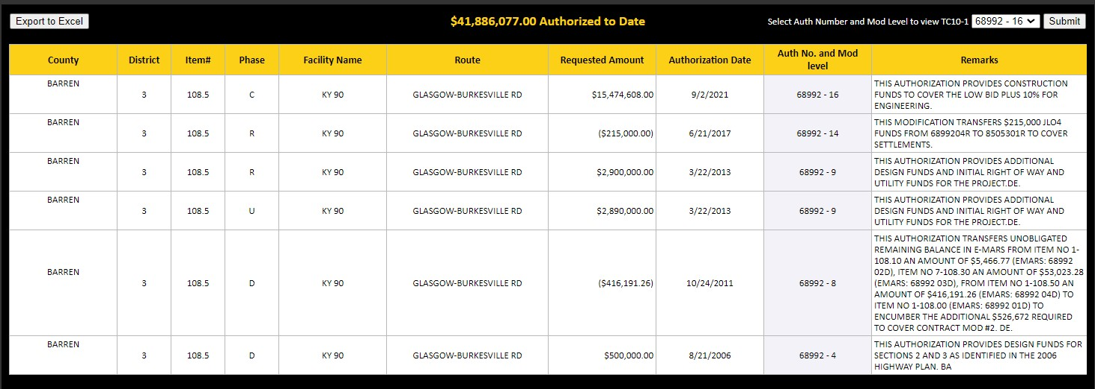

3. County Name, Fiscal Year and/or Program Code
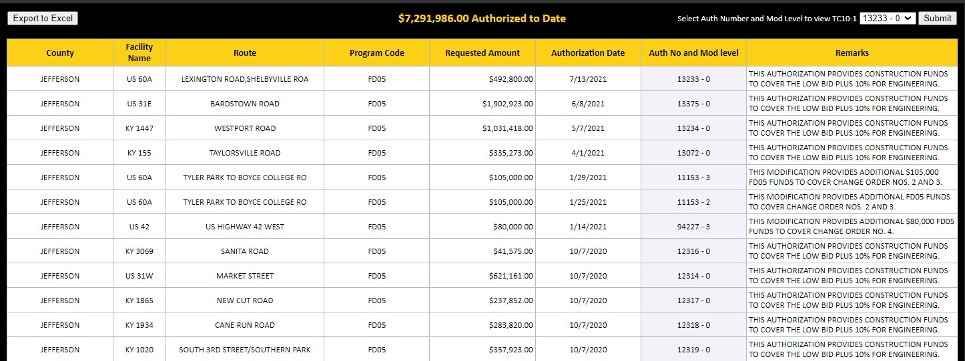

The data on these screens includes:
- County  - District  - Item Number  - Program Code  - Phase  - Facility Name | - Project Type  - Requested Amount (dollars)  - Authorization Date  - Authorization Mod Level  - Remarks  - Route

The menu located at the top of these screens contain a concatenated field. We joined the authorization number with the Modification level (ex: 68992 – 16). The most recent modification level is at the top of the list. After selecting a specific “Auth-Mod number”, you will be taken to the TC-10-1 Project Authorization document.
TC-10-1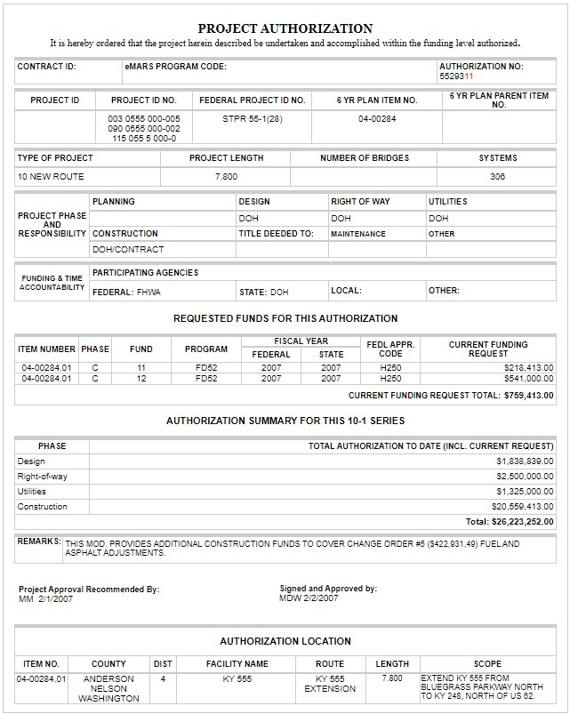
PM Dashboard
The PM Dashboard is a separate companion to the PM Toolbox. It tracks active Pre-con and active Construction Highway Plan Projects as well with more emphasis on certain activities within the project phases. There is information regarding Financial Status, Location Information, Critical Dates, Concerns, Design Milestones, Environmental Permit Mitigation, Right of Way Status, Utility Agreements and Companies, and what Vendors have been assigned. https://dashboard.intranet.kytc.ky.gov/asp/PMDash.html

Both Pre-con and Construction Projects can be tracked by selecting a District, SYP Item Number or Project Manager.If you select a Highway District or a Project Manager (PM) it will return a list of projects filtered by district or PM. The list can be exported to Excel. The SYP Item number will take you directly to the dashboard screen.
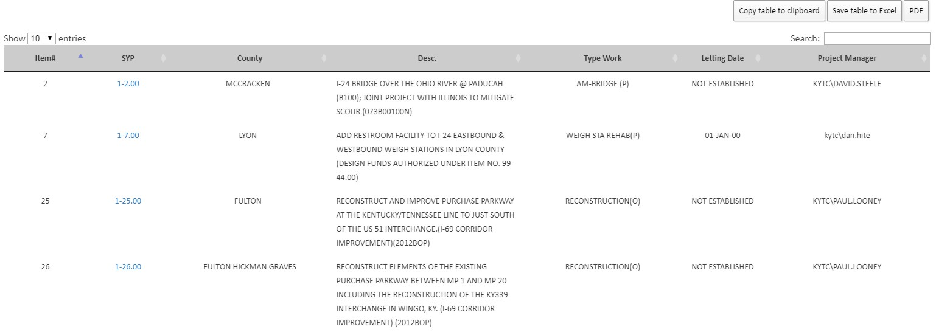
The header on the list are filters. You have the ability to adjust each column alphabetically or numerically. You can copy the table if needed or export it to Excel (csv file) or PDF and there is also a search feature built in.The lookup table will give you a high level listing of SYP projects by District or Project manager. Selecting the Item number will launch the dashboard screen giving you more detailed information about that project.
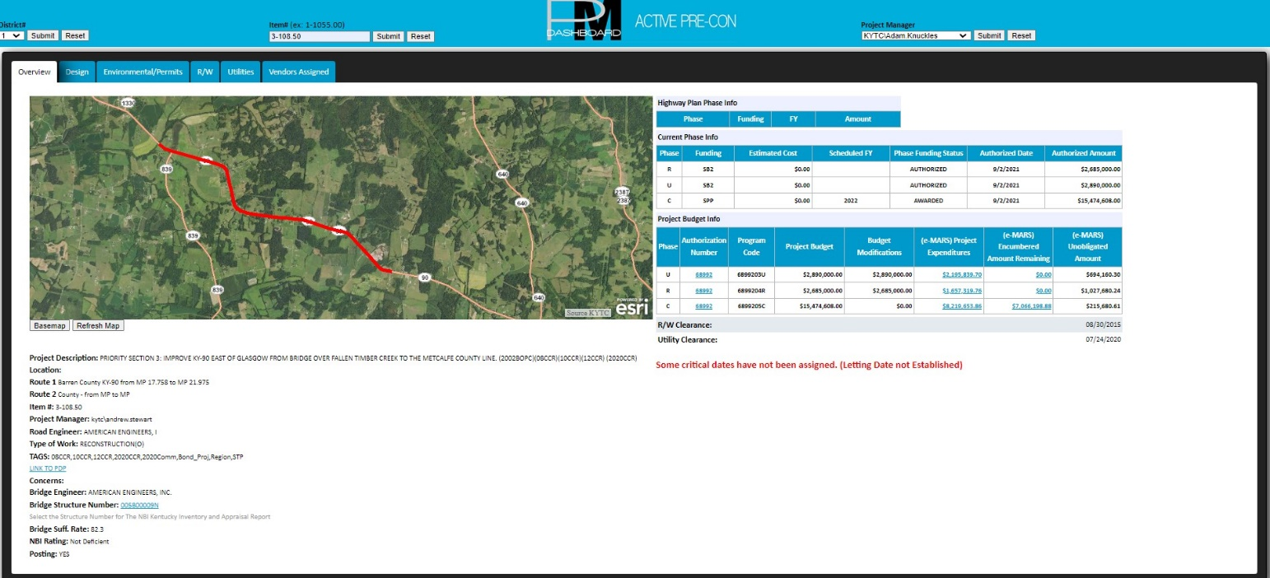
There are six tabs in the Dashboard
- Overview  - Design  - Environmental Permits | - R/W  - Utilities  - Vendors Assigned
Overview tab includes: 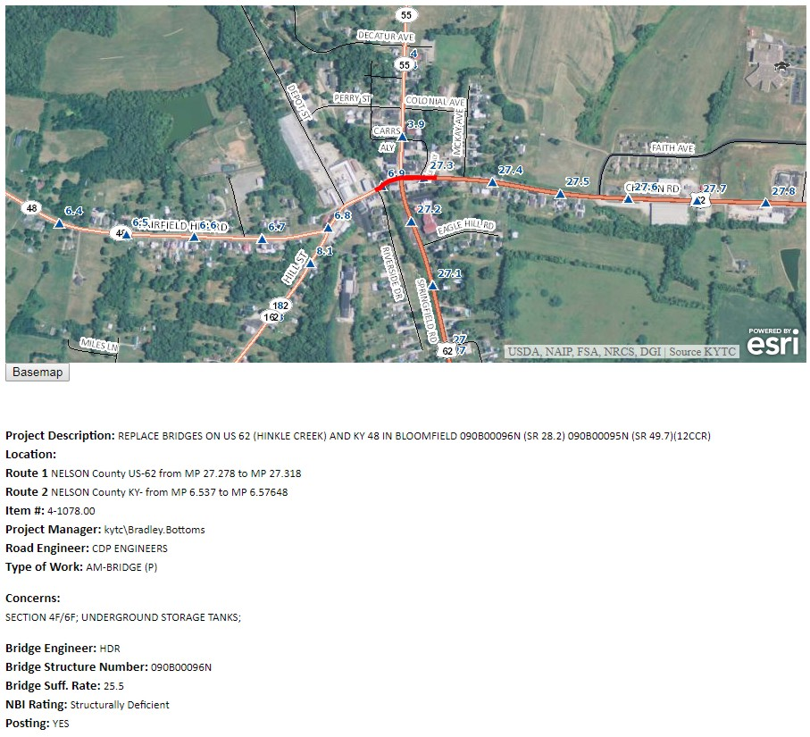
- A GIS location map of the Project. You can zoom in and out as well as toggle the map view from an aerial photo to a base-map view.
- The Project Description, Location, Item number and Type of Work is displayed. It also includes the Project Manager, Road Engineer and Bridge Engineer.
- Project Concerns
- Bridge Structure number
- Sufficiency Rating
- NBI Rating and Posting
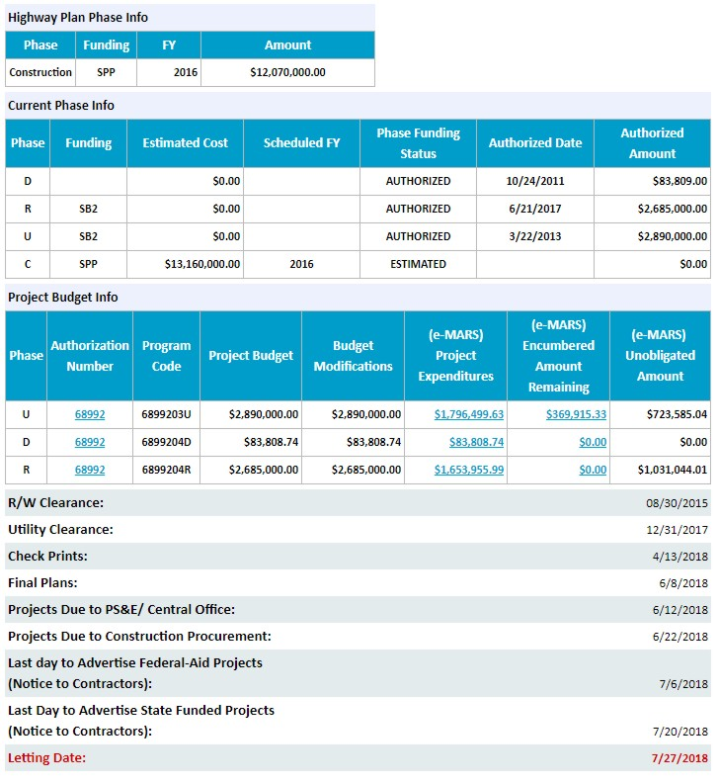
- Phase information from the Highway plan
- Current Phase Information
- Project Budget Information
- Critical Dates including the Letting Date

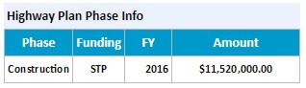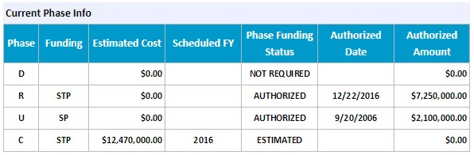
The Highway Plan phase and Current phase information has been duplicated from preconstruction information within the PM Toolbox.
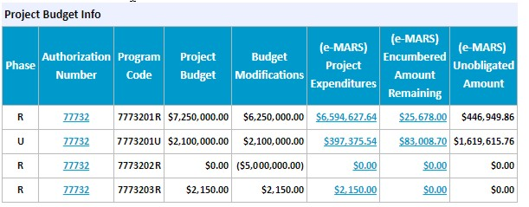
You have the same ability to drill into the Encumbrance and Authorization information as the PM toolbox. The difference here is within the Expenditures.
From the Detailed Expenditure information table, you can filter and search the table as well as copy it, save it to Excel or PDF. From here, you can drilldown from the eMARS Program Code to show its payment activity. 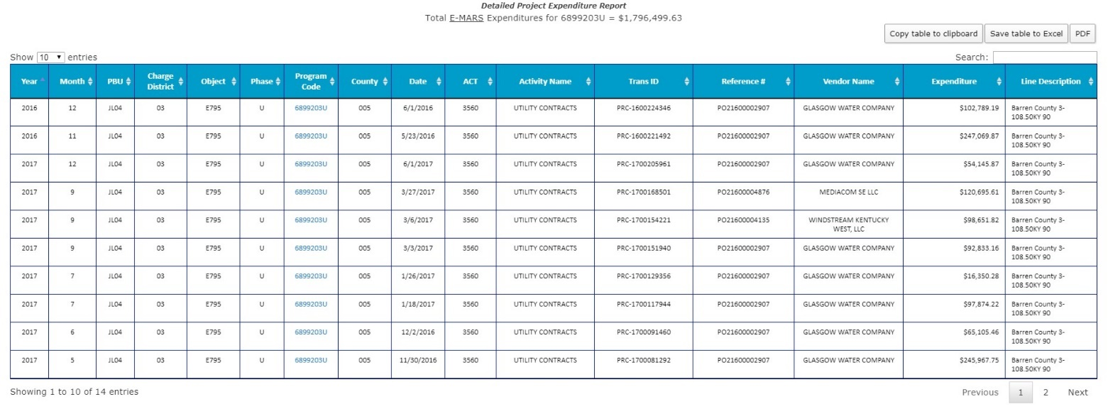
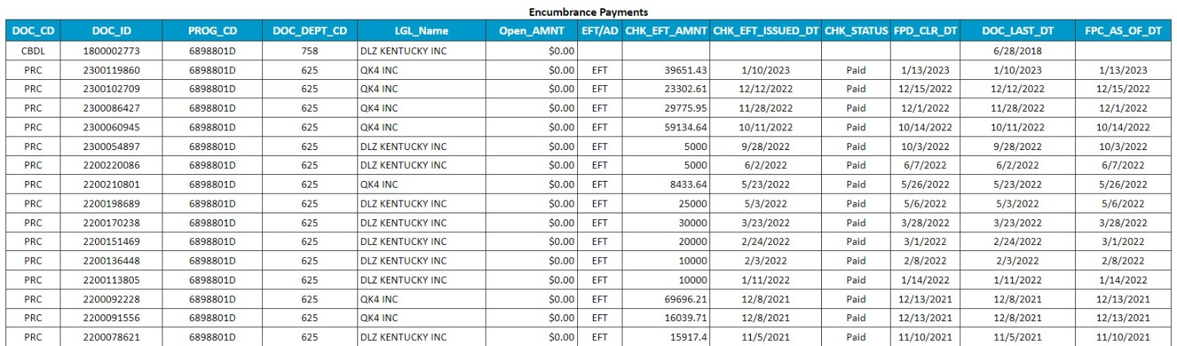
NOTE: This feature is only available in the PM Dashboard.
The data on the payment activity screen includes:
- DOC_CD - Document Code  - DOC_ID – Document ID  - PROG_CD – eMARS Program Code  - DOC_DEPT_CD – Document Department Code  - LGL_Name – Vendor legal name  - Open_AMNT – Open amount (dollars) | - EFT/AD – Transaction type  - FPC_AS_OF_DT – As of date  - CHK_EFT_AMNT – Check amount (dollars)  - CHK_EFT_ISSUED_DT – Date check was issued  - CHK_STATUS – Check Status  - FPD_CLR_DT – Check clear date  - DOC_LAST_DT – Document last date

Design tab includes:
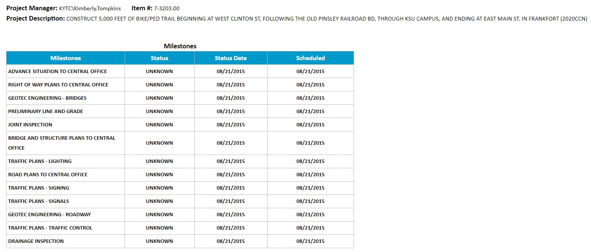
Design Milestones and their status.
Environmental/Permits tab includes:
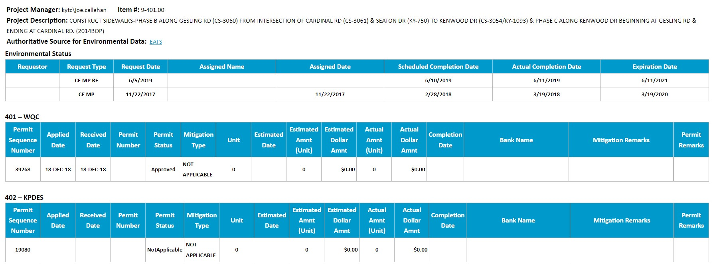
The environmental phase status and Permit Mitigation information. This tab also provides a link to the EATS application, which is the authoritative source for Environmental data. The data in this screen includes.
Environmental Status:
- Requestor  - Request Type  - Request Date  - Assigned Name | - Assigned Date  - Scheduled Completion Date  - Actual Completion Date - Anticipated Completion Date  - Expiration Date
Permit Mitigation Types:
401 – WQC (Water Quality Certification)
402 – KPDES (Kentucky Pollutant Discharge Elimination System)
404 – USACE (US Army Corps of Engineers)
Intergovernmental Review
LOP (Letter of Permission)
TVA (Tennessee Valley Authority)
Data for each permit type includes:
- Permit Sequence Number  - Applied Date  - Received Date  - Permit Number  - Permit Status  - Mitigation Type  - Unit  - Estimated Date | - Estimated Amnt (Unit)  - Estimated Dollar Amnt  - Actual Amnt (Unit)  - Actual Dollar Amnt  - Completion Date  - Bank Name  - Mitigation Remarks  - Permit Remarks
Right of Way tab includes:
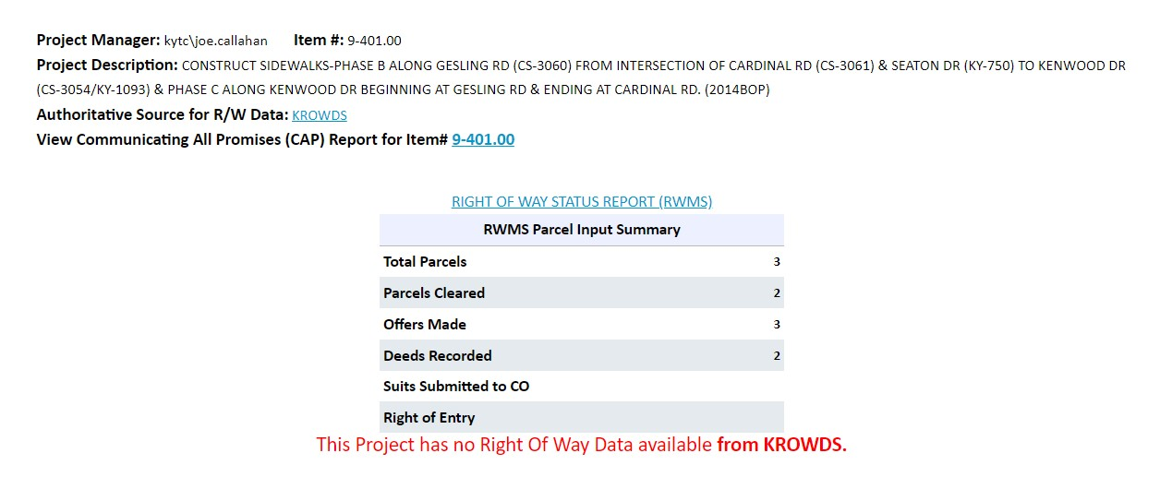
Current Parcel information from both RWMS, if it is an older project and KROWDS, if it is a newer project. It also provides a link to the project’s Right of way Status Report and a link to the CAP (Promises Kept) Report. The R/W tab also provides a link to the KROWDS application, which is the authoritative source for R/W data.
The data on the tab displays:
- Total Parcels
- Parcels Cleared
- Offers Made
- Deeds Recorded
- Suits Submitted
- Right of Entry

The CAP (Promises Kept) Report
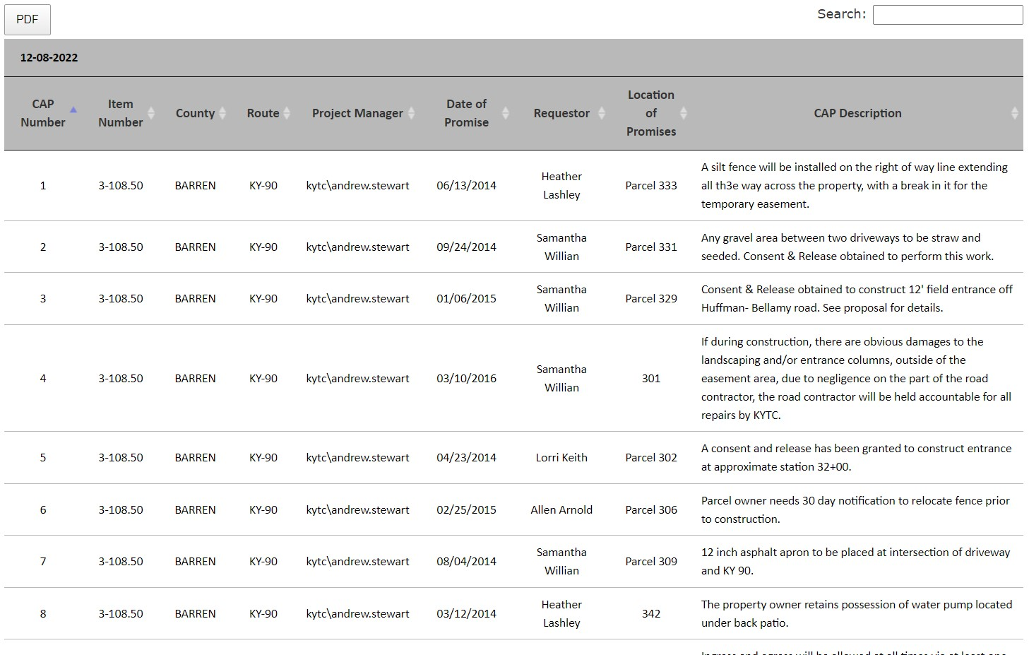
R/W Status report
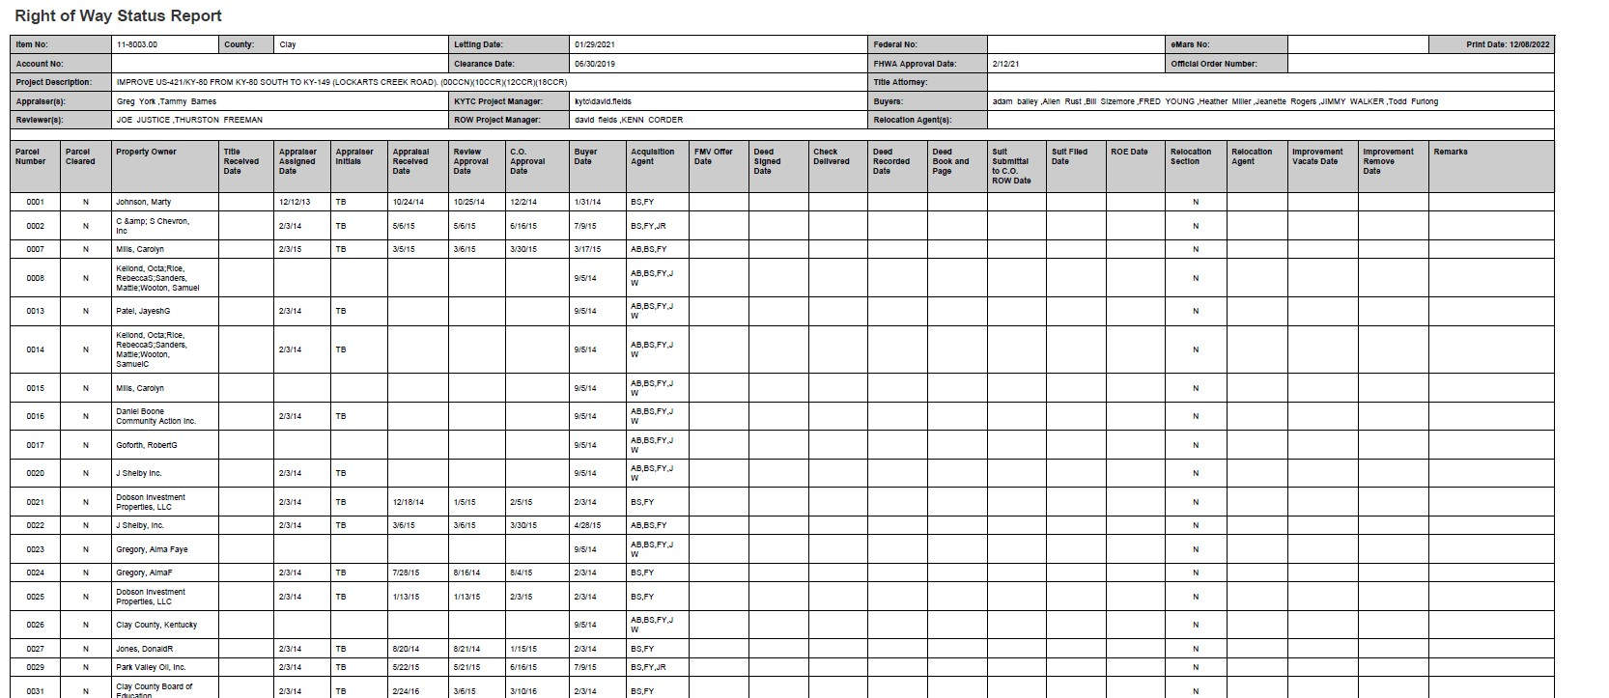
Utilities tab Includes:
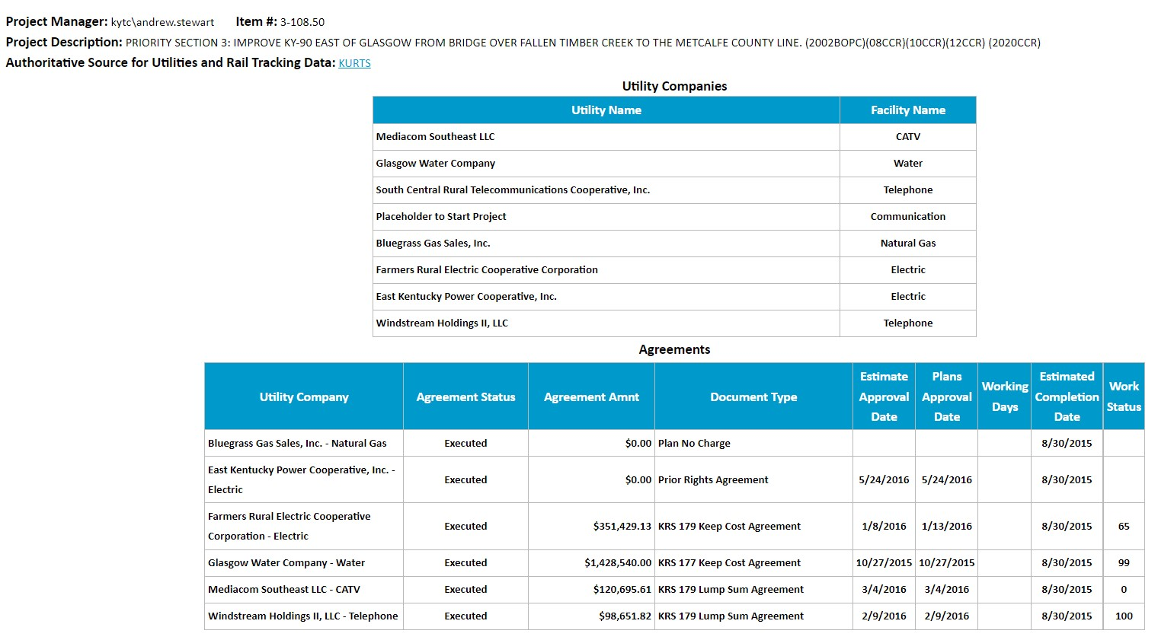
Utility vendor information and agreement status is located here. A link to the project inside the KURTS application is also provided. KURTS is the authoritative source for Utilities data. The data displayed on this tab includes:
Utility Companies
- Utility Name | - Facility Name

Utility Agreements
- Utility Company  - Agreement Status  - Agreement Amount  - Document Type | - Estimate Approval Date  - Plans Approval Date  - Working Days  - Estimated Completion Date  - Work Status (% complete)

Vendors Assigned tab includes:
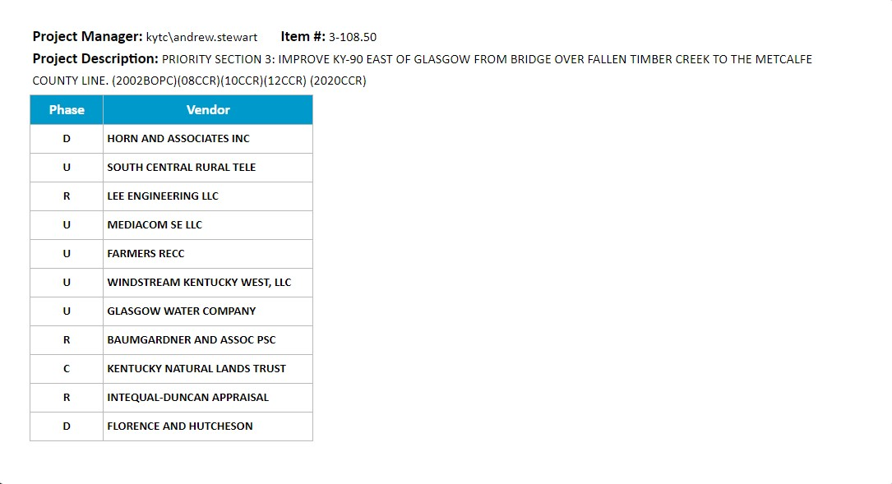
All vendors contracted within the preconstruction phases are included here.

MISC:
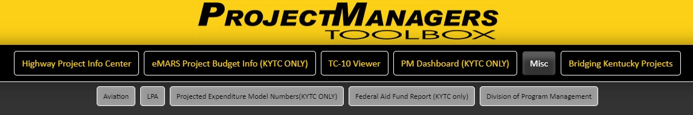
The Miscellaneous tab contains links to various reports including:
- Aviation
- LPA
- Projected Expenditure Numbers (KYTC Only)
- Federal Aid Fund Report (KYTC Only)
- The Division of Program Management (Internet Site)

Aviation
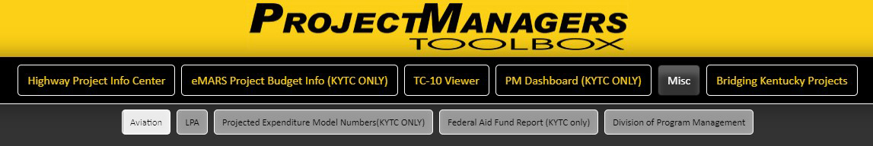
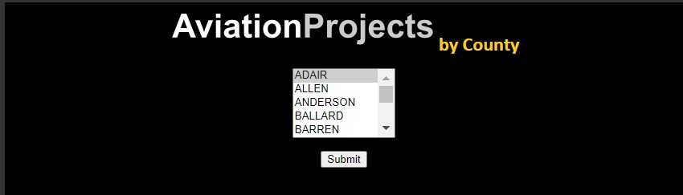
By using the dropdown county listing, you can select Aviation related Highway Projects.
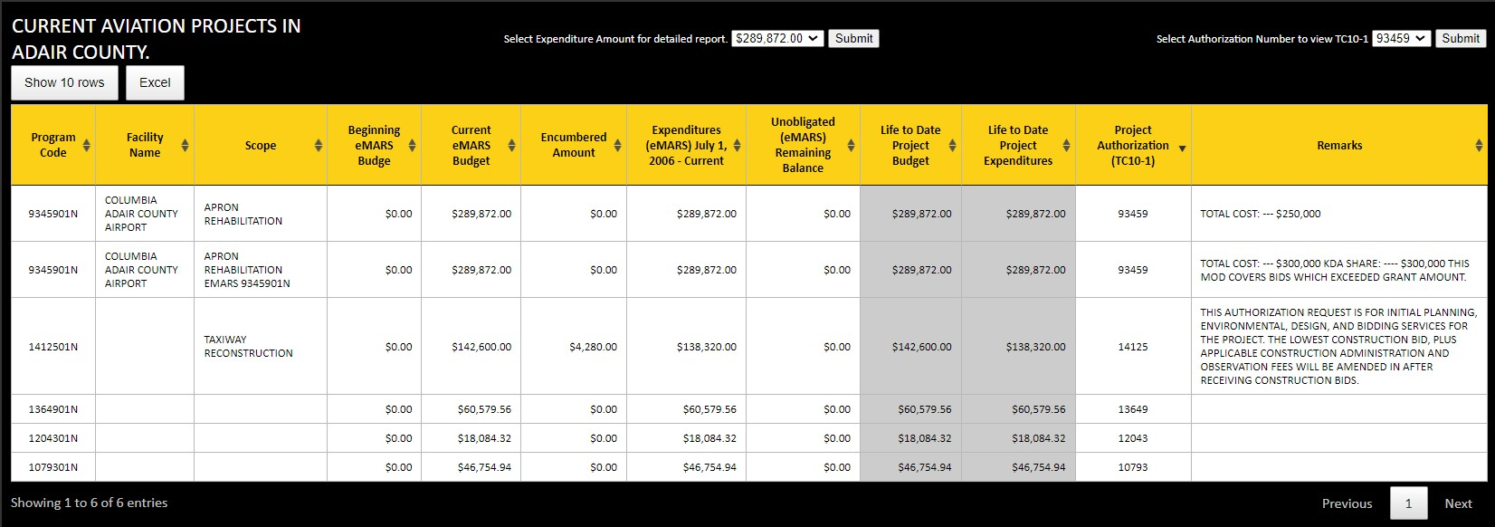
The table on this screen can be exported to Excel. The headers are sortable. There are two menus located at the top. One menu allows you to select a project expenditure that drills down to the Detailed Expenditure report previously mentioned on page… The other menu drills to the authorization and modification information previously mentioned on page…
The data displayed on this screen contains:
- Program Code  - Facility Name  - Scope  - Beginning eMARS Budget  - Current eMARS Budget  - Encumbered Amount | - Expenditures (eMARS) July 1, 2006 - Current  - Unobligated (eMARS) Remaining Balance  - Life to Date Project Budget  - Life to Date Project Expenditures  - Project Authorization (TC10-1) – Authorization Number  - Remarks

LPA
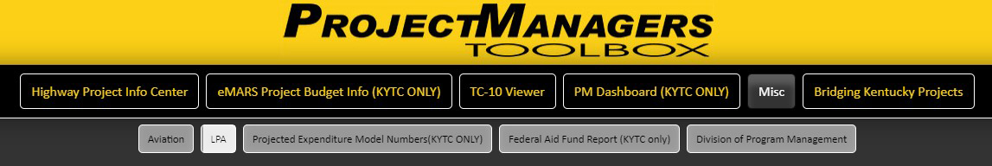
The FHWA, the KYTC, and Local Public Agencies (LPAs) share unique goals and responsibilities to develop and maintain safe and efficient transportation systems using combinations of Federal, state, and local funds. Each type of highway funds has unique funding requirements that have been imposed by Federal, state, and local legislation and regulations.
In 2006, the FHWA completed a national review on the oversight of Federal-aid projects administered by LPAs. The findings suggested that the administration, stewardship, and oversight of these projects lacked a comprehensive approach in some states. This included shortcomings in eligibility determinations and in compliance with established Federal laws and regulations. FHWA Division Offices were directed to review state processes and procedures for LPA-administered projects. In Kentucky, review efforts began in 2006 and have continued in different program areas to date. This reporting application has been designed and implemented to assist project managers in this effort.
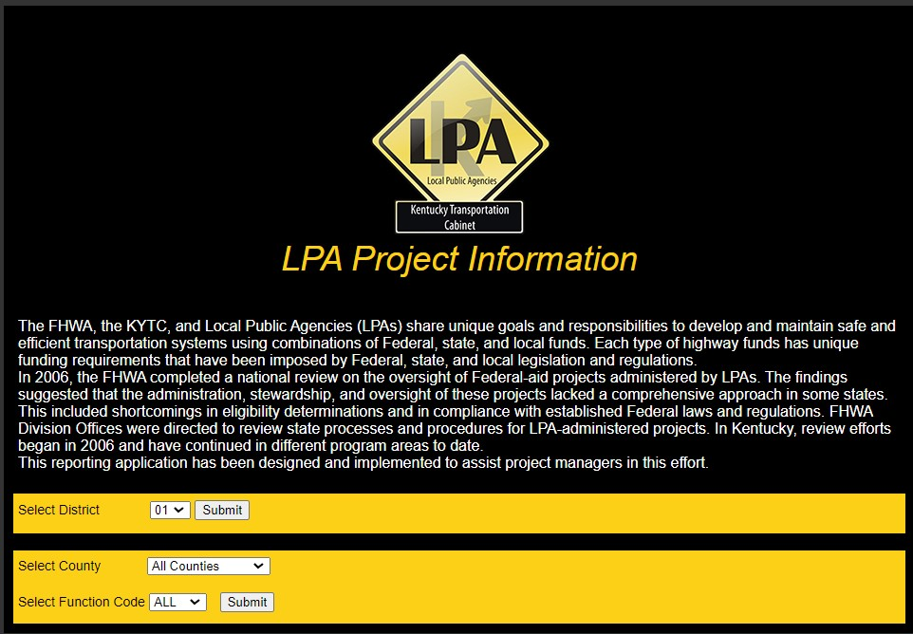Select LPA Projects by Highway District, County along with the Function Code. You have the option to select all counties and all function codes at once or make a more defined selection.
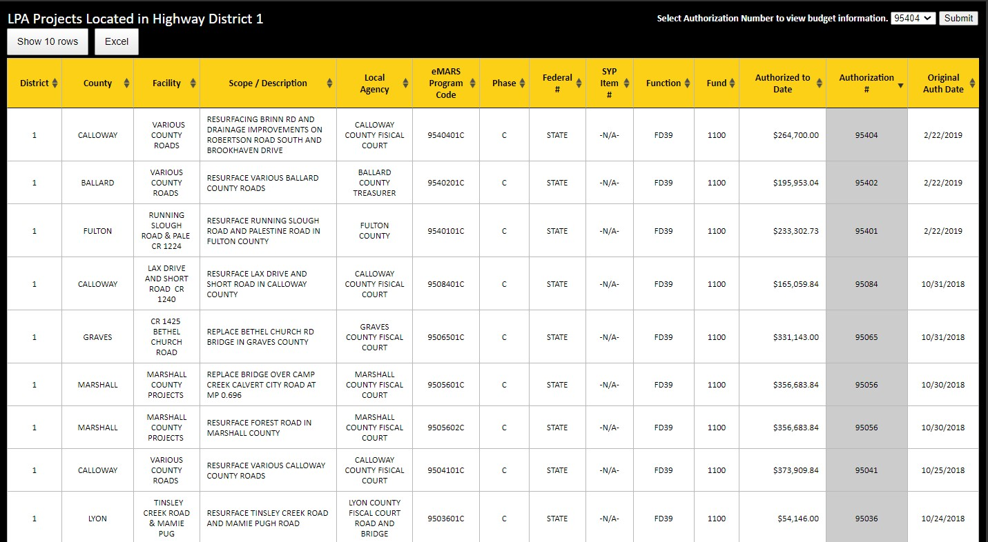
After making your selection, LPA project information will be displayed. The data included in this listing can be sorted and exported to Excel. There is a menu at the top of the screen, containing Authorization numbers, will link you to Authorization Mod listings and the TC-10 report. (see page…)
Data included on this screen:
- District  - County  - Facility  - Scope / Description  - Local Agency  - eMARS Program Code  - Phase | - Federal #  - SYP Item #  - Function  - Fund  - Authorized to Date  - Authorization #  - Original Auth Date

Federal Aid Fund Report (KYTC Only)
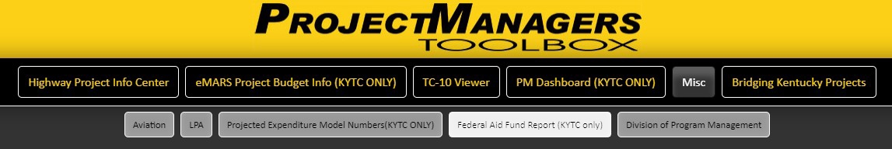
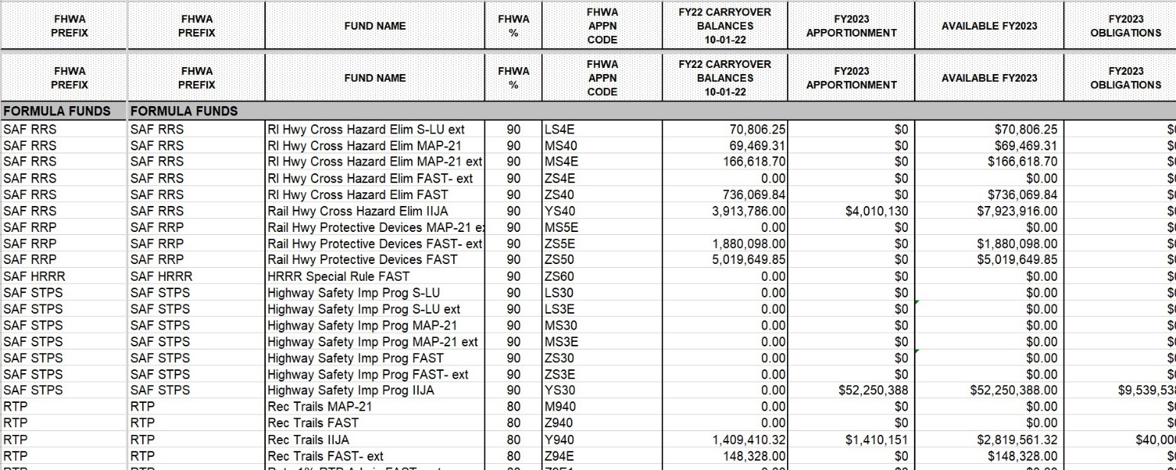
Not all data shown in the illustration. Data includes:
- FHWA PREFIX  - FUND NAME  - FHWA %  - FHWA APPN CODE  - CARRYOVER BALANCES  - FY2023 APPORTIONMENT  - AVAILABLE  - OBLIGATIONS | - RELEASED FUNDS  - UNOBLIGATED APPORTIONMENT BALANCE  - OBLIGATIONAL CEILING/BALANCE  - ESTIMATED RESCISSIONS  - FISCAL YEAR POSSIBLE LAPSE  - POSSIBLE LAPSE  - Pending  - Match W10A

Division of Program Management
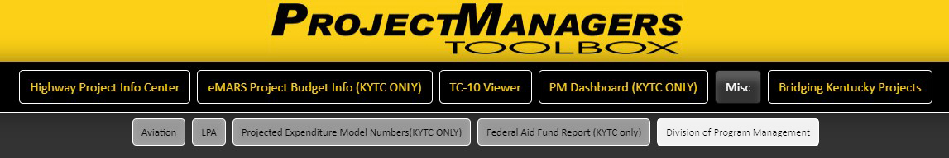
Internet Website link
https://transportation.ky.gov/Program-Management/Pages/default.aspx
Bridging Kentucky Projects:
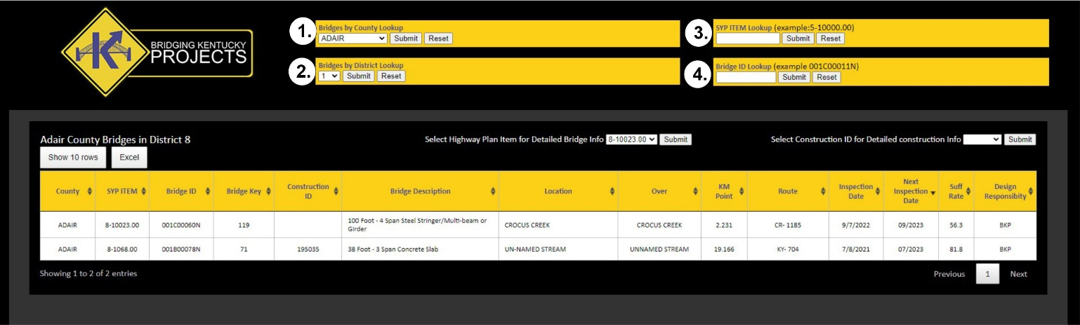
The Bridging Ketucky tab displays bridge projects that are only within the program. The menu at the top queries the bridges by:
1. County
2. District
3. SYP Item Number
4. Bridge ID
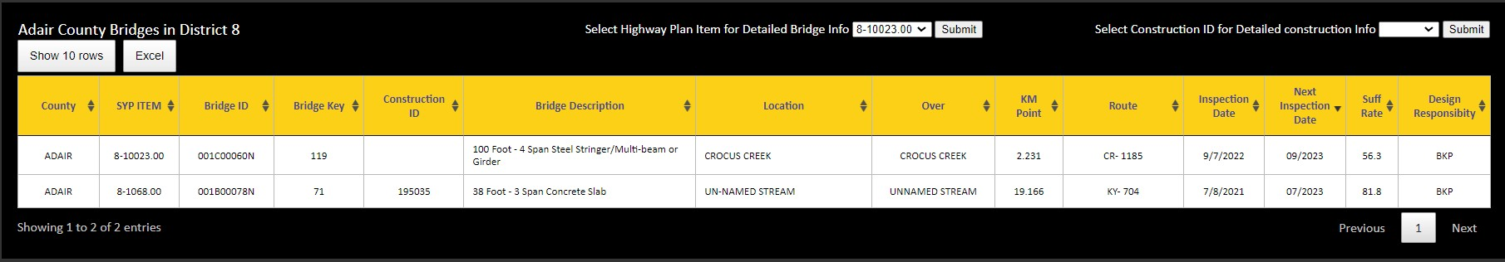
When selecting a value, it will display a listing of bridges based on that value. (ex. If you select a county, it will show you all Bridging Kentucky projects within that county.)
The listing of lookup values contain:
- County  - SYP ITEM  - Bridge ID  - Bridge Key  - Construction ID  - Bridge Description  - Location | - Over  - KM Point  - Route  - Inspection Date  - Next Inspection Date  - Suff Rate  - Design Responsibility
There are two dropdown menus located at the top of the screen lookup listing. The first one that will take you to a detailed bridge information screen by selecting an Item Number. The next one, by selecting a Construction ID, goes to the same detailed construction information, as shown on page….,.
Select an Item Number to view Detailed Bridge Information;
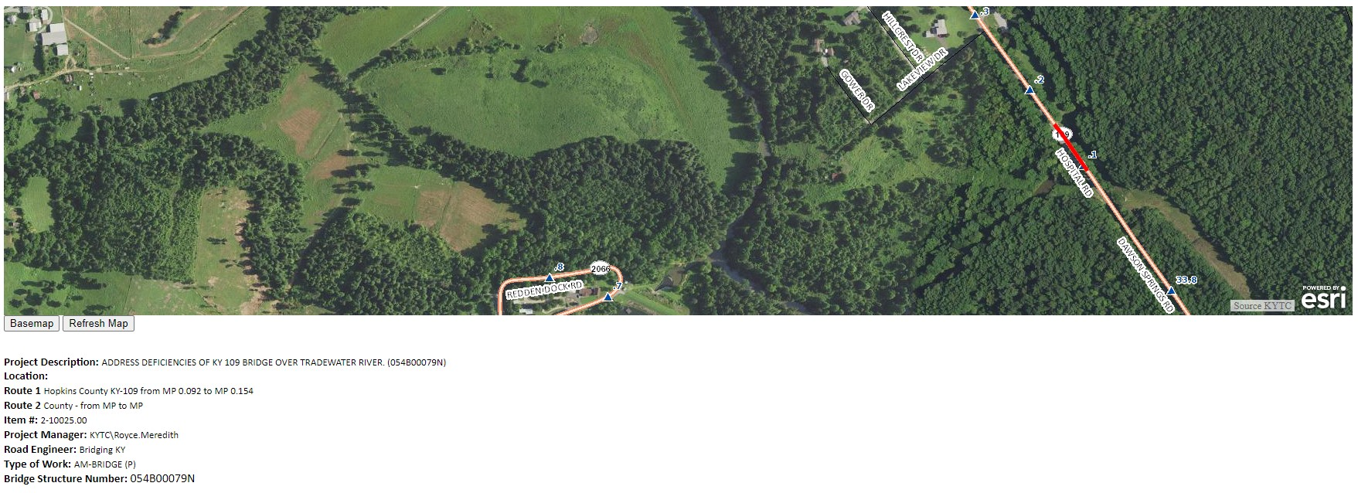
The first section of the details on this screen contains a Project Location Map, Project Description, Project Location, Project Manager, Project Engineer, Type of Work and the Bridge Structure Number.
The next section contains two tables, current project phase and budget Information:
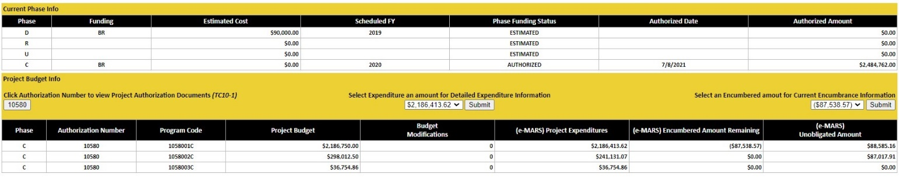
Current Phase Info
- Phase  - Funding  - Estimated Cost  - Scheduled FY | - Phase Funding Status  - Authorized Date  - Authorized Amount
Project Budget Info
- Phase  - Authorization Number  - Program Code  - Project Budget | - Budget Modifications  - (e-MARS) Project Expenditures  - (e-MARS) Encumbered Amount Remaining  - (e-MARS) Unobligated Amount
The next section contains detailed bridge information as shown in the Kentucky Inventory and Appraisal Report
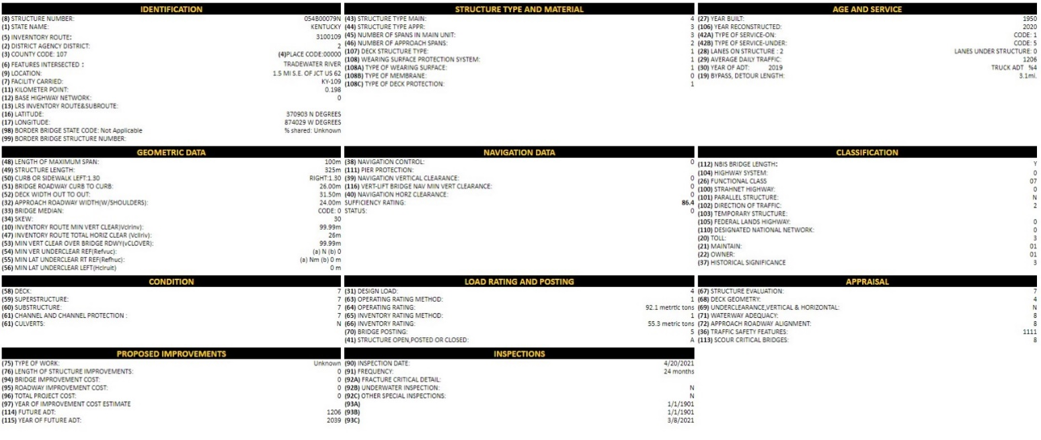
Identification:
- (8) Structure Number  - (1) State Name  - (5) Inventory Route  - (2) District Agency District  - (3) County Code  - (6) Features Intersected  - (9) Location | - (7) Facility Carried  - (11) Kilometer Point  - (12) Base Highway Network  - (13) LRS Inventory Route & Sub-route  - (16) Latitude  - (17) Longitude  - (98) Border Bridge State Code  - (99) Border Bridge Structure Number
Structure Type and Material
- (43) Structure Type Main  - (44) Structure Type Appr  - (45) Number of Spans in Main Unit  - (46) Number of Approach Spans  - (107) Deck Structure Type | - (108) Wearing Surface Protection System  - (108a) Type of Wearing Surface  - (108b) Type of Membrane  - (108c) Type of Deck Protection

Age and Service
- (27) Year Built  - (106) Year Reconstructed  - (42a) Type of Service-On  - (42b) Type of Service-Under | - (28) Lanes on Structure  Lanes Under Structure  - (29) Average Daily Traffic  - (30) Year of ADT  - (19) Bypass, Detour Length
Geometric Data
- (48) Length Of Maximum Span  - (49) Structure Length  - (50) Curb Or Sidewalk Left/Right  - (51) Bridge Roadway Curb to Curb  - (52) Deck Width Out to Out  - (32) Approach Roadway Width(W/Shoulders)  - (33) Bridge Median | - (34) Skew  - (10) Inventory Route Min Vert Clear (Vclrinv)  - (47) Inventory Route Total Horiz Clear (Vcllriv)  - (53) Min Vert Clear Over Bridge Rdwy (vCLOVER)  - (54) Min Ver Underclear Ref(Refvuc)  - (55) Min Lat Underclear Rt Ref(Refhuc)  - (56) Min Lat Underclear Left(Hclruit)

Navigation Data
- (38) Navigation Control  - (111) Pier Protection  - (39) Navigation Vertical Clearance  - (116) Vert-Lift Bridge Nav Min Vert Clearance | - (40) Navigation Horz Clearance  - Sufficiency Rating  - Status

Classification
- (112) Nbis Bridge Length  - (104) Highway System  - (26) Functional Class  - (100) Strahnet Highway  - (101) Parallel Structure  - (102) Direction Of Traffic  - (103) Temporary Structure | - (105) Federal Lands Highway  - (110) Designated National Network  - (20) Toll  - (21) Maintain  - (22) Owner  - (37) Historical Significance
Condition
- (58) Deck  - (59) Superstructure  - (60) Substructure | - (61) Channel And Channel Protection  - (62) Culverts

Load Rating and Posting
- (31) Design Load  - (63) Operating Rating Method  - (64) Operating Rating  - (65) Inventory Rating Method | - (66) Inventory Rating  - (70) Bridge Posting  - (41) Structure Open, Posted or Closed
Appraisal
- (67) Structure Evaluation  - (68) Deck Geometry  - (69) Underclearance, Vertical & Horizontal  - (71) Waterway Adequacy | - (72) Approach Roadway Alignment  - (36) Traffic Safety Features  - (113) Scour Critical Bridges

Proposed Improvements
- (75) Type Of Work  - (76) Length Of Structure Improvements  - (94) Bridge Improvement Cost  - (95) Roadway Improvement Cost | - (96) Total Project Cost  - (97) Year Of Improvement Cost Estimate  - (114) Future Adt  - (115) Year Of Future Adt
Inspections
- (90) Inspection Date  - (91) Frequency  - (92a) Fracture Critical Detail  - (92b) Underwater Inspection  - (92c) Other Special Inspections | - (93a)  - (93b)  - (93c)

GLOSSERY OF TERMS

A
Act Fl (Activity Flag), Project Active Flag
- indicates if a project is active or inactive in eMARS 0 = Inactive 1 = Active
Activity, (ACT) Code
- Activity code is 4 characters long and is required on expense transactions. This provides a more complete explanation regarding the work activity associated with the project. To view the listing of activity codes, go to Activity Codes
Activity Name
- The name of the activity on expense transactions. It is identified by the Activity Code. To view the listing of activity codes, go to Activity Codes
Actual Amnt (Unit)
- In mitigation information for the SYP Environmental Permits, this Column contains the Actual AMUs (from permit once its approved)
Actual Completion Date
- The date when the work was actually completed.
Actual Dollar Amnt
- Regarding mitigation information for the SYP Environmental Permits. This value represents the Actual mitigation amount required for payment.
Agreement Amount
- Regarding Utility agreements. This value represents the actual dollar amount agreed to pay for a specific utility contract.
Agreement Status
- Regarding Utility agreements. This value represents the position of where the contract currently stands. (Approved, Executed, Signed, N/A)
Amount
- Regarding Change Orders and Pending Change Orders, this field represents the dollars given to a specific Change Order or Pending Change Order. This is based on the Change Order or Pending Change Order number.
Amount Paid to date
- Regarding construction contracts. The current dollar amount that has been paid of the total contract amount.

Amount Remaining
- Regarding construction contracts. The dollar amount of the contract that has not been expended.
Applied Date
- Regarding Environmental Permit Mitigation. This value represents the date in which a permit was applied for.
Apportionment
- Regarding the Federal Aid Fund Report, (ex:FY2023 Apportionment) This field represents the new funds received in current fiscal year
Approval Date
- The Date the amount of the Change Order was approved by Central Office
As Of Date
- Only applies to eMARS. The current date which a budget mod has been approved.
Assigned Date
- Regarding Environmental Status. This value represents the date was the project assigned to an employee.
Assigned Name
- Regarding Environmental Status this value represents who is updating the status.
Auth. No, Authorization #, Authorization Number (TC-10 Number, PDP-FA Number)
- The identification number from the PDP-FA system that identifies authorized funds for specific project phase activities.
Authorization Date
- The date which specific phase activities have been authorized.
Authorization Mod Level
- Regarding the TC-10 viewer, this code was created for the PMtoolbox joining the PDP-FA number with the Authorization Modification level number (ex: 68992 – 16) to return the correct TC-10-1 document.
Authorized Amount, C Authorized Amount, C Phase Authorized Amount, D Authorized Amount, D Phase Authorized Amount
- The authorized dollar amount for the start of the identified phase.
Authorized Date
- The date in which an authorized funds for a project phase have been established.
Authorized to Date
- The current dollar amount that has been authorized to use for a specific project phase.
Available
- Regarding the Federal aid fund report, (ex: Available FY2023) this field represents sum of carryover and new apportionment
Award Amount
- For Construction, the dollar amount of accepted bid from contractor through the letting process.
Award Date
- For construction, actual date the project was awarded to contractor.

B
Bank, Bank Name
- Name of financial institution that administers the EFT funds for contract payments.
Beginning eMARS Budget
- Original budget set up in eMARS.
Bid Amount
- The dollar amount that contractor is willing to do work for.
BMP / EMP
- Beginning Mile Point and Ending Mile Point along a specified route.
Bridge Description
- Description of all parts of a bridge.
Bridge Engineer
- This is used to identify who is responsible for bridge design activities. (ie; Department or Consultant)

Bridge ID
- Bridge Identifier
Bridge Key
- Originally setup to be the unique identifier of a bridge.
Bridge Plan Status
- Structure and Bridge plans required and not required
Bridge Plans Status Date
- Structure and Bridge plan status update date
Bridge Plans Status Remarks
- Notes written about status
Bridge Structure number
- Unique Identifier assigned to bridge from BRM
Budget
- Money, funded by State and Federal sources, set up to operate Highway projects.
Budget Modifications
- Alterations to existing budget

C
C Fund
- Regarding the Active Projects Report, this field represents the type for funding used for the Construction Phase of a Highway Project.
C Phase Funds Expended
- Regarding the Active Projects Report, this field represents the current amount of funding spent on the Construction Phase of Highway Project.
C Precon Escalated Cost
- Regarding the Active Projects Report, equation to adjust Construction cost for inflation in future years.

C Precon FY
- Scheduled Authorization Year for the Construction Phase
C Proj Auth Date
- Regarding the Active Projects Report, this field represents the date funds were authorized for the Construction Phase of a Highway Project
C Year
- Regarding the Active Projects Report, this field represents the current fiscal year shown where the Construction Phase will be authorized.
CARRYOVER BALANCES
- Regarding the Federal Aid Fund Report, this field represents the remaining funds from previous fiscal year
Change Order Number
- Identifies a specific Change Order made on a Construction contract
Change Order Status
- This field identifies if a Change Order is still pending approval.
Charge District
- Within the Cabinet payroll system this reflects the location assignment of the person charging the project. This could be central office or a district location.
Check Prints Due Date
- When Check prints are due to plan processing. Due 105 days before the letting date.
CHK_EFT_AMNT
- Electronic Funds Transfer dollar amount
CHK_EFT_ISSUED_DT
- Date EFT was issued
CHK_STATUS
- Check Status, EFT Status
Completion Date
- Definition of date varies depending on the phase and completion of activity.

Conditions
- Regarding Environmental Permits. This value represents the condition of the permit status.
Construction ID
- Construction Contract identifier
Contractor Name
- Legal name used to identify construction contractor
Contractor Name and Address
- Legal name and address used to identify construction contractor
County, Syp Loc Countyname
- Name of County where Highway project activity is located.
County Code, County No.
- Number assigned to county from 001(Adair) to 120 (Woodford)
Created Date
- Regarding Document Information. It is the date that the document was created.
Current Budget, Current Budget Amount, Current eMARS Budget
- An up-to-date account of money funded by State and Federal sources, set up to operate Highway projects.

D
Date
Regarding Expenditures, this is field represents the date the transaction occurred in e-mars
D Fund
- Regarding the Active Projects Report, this field represents the type for funding used for the Design Phase of a project.
D Phase Funds Expended
- Regarding the Active Projects Report, this field represents the current amount of funding spent on the Design Phase of a project.
D Precon Escalated Cost
- Regarding the Active Projects Report, equation to adjust Design cost for inflation in future years.
D Precon FY
- Regarding the Active Projects Report, this field represents the scheduled Authorization Year for the Design Phase
D Proj Auth Date
- Regarding the Active Projects Report, this field represents the date funds were authorized for the Design Phase of a project
D Year
- Regarding the Active Projects Report, this field represents the current fiscal year shown where the Design Phase will be authorized.
Date of Expenditure
- The date the transaction occurred in eMARS.
Deeds Recorded
- The number of R/W deed that have been recorded on a project.
Department Code
- Identifies specific KYTC departments
DES Approval Date
- Date the Environmental activity completion.
Description, Desc
- Description of activity.
- The description of the project as identified within the Six Year Highway Plan. As the project makes its way through the Preconstruction process, the description may be amended to clarify the project location and activities.
Design Responsibility
- Defines if Design activity is done internally of externally.
District Item No.
- Combined Highway District and SYP item number

Doc Code, DOC_CD, Document Code
- eMARS code that indicates type of transaction
Doc DeptCd, DOC_DEPT_CD – Document Department Code
- The department code assigned to this document.
Doc Rec Dt – Document Recorded Date
- Indicates the transaction date
Doc Received Date
- The date the document was received
DOC_ID, Document ID
- Unique identifier for an eMARS agreement
DOC_LAST_DT , Last Date – Document last date
- Most current date related to document
Document Actual Amount
- The dollar amount of the Transaction
Document Closed Amount
- The dollar amount of the actual executed transaction
Document Description
- Describes the document contents
Document Record Date
- Date of transaction
Document Status
- Indicates the contract “status” within eMARS. This will illustrate if a document is still open or if it has been closed in eMARS.
Document Type
- eMARS code that indicates type of transaction
Document Unit Code
- Indicates the KYTC area responsible

Document Version Number
- Sequential number of document revisions

E
E Curr Bud Am (eMARS Current Budget Amount)
- The current amount of dollars budgeted and reported in eMARS 3.11
E Exp Am (eMARS Expended Amount), (e-MARS) Project Expenditures, Expenditure, Expenditure Amount, Expenditures, Expenditures (eMARS) July 1, 2006 – Current
- The portion of the budget reported in eMARS that was spent.
E Uoblg Am (eMARS Unobligated Amount), (e-MARS) Unobligated Amount
- The portion of the budget reported in eMARS was not encumbered or spent.
Effective End Date
- Represents the date that the program will end
EFT/AD
- Fund transaction types
eMARS Program Code, Program Code, Prog Cd
- The first five digits indicate the eMARS Authorization number (TC-10 number), the next two digits indicate the sequence number and the last character indicates the phase of the project.
(ex. 9241601U)
Encumbered Amount, Encumbrance, Encumbrance Amount, E Enc Am (eMARS Encumbered Amount)
- An encumbrance is a portion of a budget set aside for spending required but is not actually physically paid out yet.
Encumbered Amount Remaining, (e-MARS) Encumbered Amount Remaining
- Encumbered Amount minus the sum of all Expenditures from Encumbrances that reference the encumbering document = Remaining Balance. When a contract with an unexpended encumbered amount has been closed in eMARS any remaining encumbered amount is then liquidated reflecting the document open amount in eMARS as zero. However, when this happens, the PMToolbox will indicate the contract has been closed but will show a “Remaining Balance”, which represents the encumbrance balance remaining when the contract was closed. The Remaining Balance is the amount that was not expended.

Environmental Actual Completion Date
- Date the environmental activity has been completed
Environmental Request Type
- The type of Environmental activity being requested
Environmental Schedule Completion Date
- Date the environmental activity is scheduled to be complete
Estimate Approval Date
- Regarding construction phase. Date bi-weekly estimate sent to central office for approval.
Estimated Amnt (Unit)
- Regarding Environmental Permit Mitigation, this field represents Estimated AMUs
Estimated Completion Date
- Regarding Utility Agreements, this is the projected date of completing said agreement
Estimated Cost
- Regarding current phase information, this is the most recent estimated amount for completing a project phase
Estimated Dollar Amnt
- Regarding Environmental Permit Mitigation, this field represents the estimated dollar amount for the mitigation
Estimated Date
- Regarding Environmental Permit Mitigation, this field Represents when the mitigation be needs to be paid.
Estimated Rescissions
- Regarding the Federal Aid Fund Report, this field is only populated if we the current bill has an amount identified that will be rescinded. It will be populated if rescissions are taken. Rescissions are amounts dictated by the bill or Dot that will be taken from available apportionment
Expenditures from Encumbrance
- This is the amount of the charge, correction, P.O., etc.
Expensed
- Regarding the Federal Projects End Dates report, the amount spent on specific program
Expiration Date
- Regarding Environmental Analysis, this field represents the date when work expires.
- EA (An EA is not a final document; it simply assesses the magnitude of environmental impacts expected.)
- FONSI (An actual environmental finding, approved by FHWA; Good for 1 year from approval date.)
- EIS (An actual environmental finding, approved by FHWA; Good for 1 year from approval date.)
- CE (An actual environmental finding, approved by FHWA; Good for 2 years from approval date.)
ExpiresSoon
- FHWA project expiration date within 90 days

F
Facility, Facility Name
- Regarding highway projects this field represents the route a Highway project located is on
- Regarding Utilities, this field represents the type of Utility

Fed Approp
- Amount of federal dollars allocated
Federal #
- Unique identifier for Federal project
Federal Aid Project Number
- Unique identifier for Federal project as referred to in eMARS
FHWA %
- Regarding the Federal Aid Fund Report, this field represents the minimum percentage required.
FHWA APPN CODE
- Regarding the Federal Aid Fund Report, this field represents A four-character alphanumeric code for a federal program Appropriation Code from FMIS. Program Funds Program Code is the name given by FHWA in FMIS. We receive new codes with each federal funding bill authorization.

FHWA PREFIX
- Regarding the Federal Aid Funding Report, this field represents codes that were assigned in FEMIS that identify and segregate different types of Federal Funding.
Final Plans Due Date
- The date final plans are due to plan processing. This date is always 7 weeks before letting date.
Fiscal Year (FY), Year
- The fiscal year that the charge was accepted against the project (FY is July 01 20XX – June 30 20XX).
Fiscal Year Month, Month
- FY month is July 01 20XX – June 30 20XX
- This is the fiscal month (based on the state fiscal year) that the expenditure was accepted against the project (July = 01, August = 02 etc.
FISCAL YEAR POSSIBLE LAPSE
- Regarding the Federal Aid Funding Report, this is that amount of funds that will not carry over into new fiscal year based on fund availability. Most codes it is 3 years plus the current year that can be carried over into the next fiscal year.
Formal Acceptance Date
- Date that KYTC and Federal Government says a construction project is completed
FPC_AS_OF_DT – As of Date
- Regarding encumbrance payments, this field represents the current status of the transaction. All steps needed to complete the transaction has been done and checked by this date.
FPD_CLR_DT – Check clear date
- Date check was cleared
Function
- KYTC program identifier (funds)
Fund, Fund Code
- The type of funds scheduled to be utilized for funding the identified project phase. (ie; IM, NH, STP, BRO, SP)
Fund Name
- Regarding the Federal aid fund report, this field corresponds to the name of the appropriation in FMIS
Fund Type
- Equivalent to the Major Program Code which is used to segregate funds in eMARS
Funding
- Regarding current phase information this field is a KYTC code used to segregate the different funding types

H
Highway District, District
- Department of Highway districts are divided into 12 areas across the state their purpose is to locally oversee the various phases of highway projects, to inspect and maintain state roadways bridges.
- District 1 includes: Ballard, Calloway, Carlisle, Crittenden, Fulton, Graves, Hickman, Livingston, Lyon, Marshall, McCracken, & Trigg counties
- District 2 includes: Caldwell, Christian, Daviess, Hancock, Henderson, Hopkins, McLean, Muhlenberg, Ohio, Union, & Webster counties
- District 3 includes: Allen, Barren, Butler, Edmonson, Logan, Metcalfe, Monroe, Simpson, Todd and Warren counties.
- District 4 includes: Grayson, Green, Hardin, Hart, LaRue, Marion, Meade, Nelson, Taylor, and Washington counties
- District 5 includes: Bullitt, Franklin, Henry, Jefferson, Oldham, Shelby, Spencer, and Trimble counties.
- District 6 includes: Boone, Bracken, Campbell, Carroll, Gallatin, Grant, Harrison, Kenton, Owen, Pendleton, and Robertson counties.
- District 7 includes: Anderson, Bourbon, Boyle, Clark, Fayette, Garrard, Jessamine, Madison, Mercer, Montgomery, Scott, and Woodford counties.
- District 8 includes: Adair, Casey, Clinton, Cumberland, Lincoln, McCreary, Pulaski, Rockcastle, Russell, and Wayne counties.
- District 9 includes: Bath, Boyd, Carter, Elliott, Fleming, Greenup, Lewis, Mason, Nicholas, and Rowan counties.
- District 10 includes: Breathitt, Estill, Lee, Magoffin, Menifee, Morgan, Owsley, Perry, Powell, and Wolfe counties.
- District 11 includes: Bell, Clay, Harlan, Jackson, Knox, Laurel, Leslie, and Whitley counties.
- District 12 includes: Floyd, Johnson, Knott, Lawrence, Letcher, Martin and Pike counties.

I
Indian Reservation, Indian Reserve, Indn Rsrv
- Field used to identify certain programs ex: DB10, DB8, DB9, LPA, ROW, SPP
Individual Expiration Date
- Expiration date of Individual Permit
Individual Permit Applied Date
- Date that the permit applications was submitted to the Army CORPS of engineers
Individual Permit Received Date
- Date that the permit is authorized for impacts to water resources
Inspection Date
- Date of bridge inspection
Item No., Item Number, Highway Plan Item No., Highway Plan Item Number, Highway Plan (SYP) Item, SYP Item, SYP Item Number
- Unique identifying code used on all Highway Plan projects

J
Joint Inspection Status
- Status identifier related to joint inspection details (Required, Not Required, Unknown)
Joint Inspection Status Date
- Date status of Joint inspection milestone was updated within PDP application
Joint Inspection Status Remarks
- Additional remarks about Joint Inspection status

K
KM Point
- Kilometer Point
L
Last Expended Date, Last Expenditure Date
- Date of most current expenditure
Length, Project Length
- The length of the proposed project in miles
Letting Date
- This is the scheduled date for the project to be let to construction.
LGL_Name
- Vendor legal name
Life to Date Project Budget
- Total amount of funds set up for project
Life to Date Project Expenditures
- Total amount of funds expended to date
Lighting Status
- The status identifier related to traffic signals plans (Required, Not Required, Unknown)
Lighting Status Date
- The date status of traffic signal milestone updated within PDP application
Lighting Status Remarks
- Remarks/notes related to traffic lighting status update
Line Description
- Free form description fields for PD (procurement desktop) transactions, usually an identifier to reference an account number. For system-generated transactions this describes what the charge is for or the location and crew who made the charge.
Local Agency
- Local municipality KYTC partners with on local projects
Location Engineer
- Liaison for project teams through all stages of design and plan development. The location engineer provides technical expertise & support, oversight and works on behalf of project managers and project teams
Location (Road Name)
- The local name given to a road or route

M
Major Program, Major Program Code, Mjr Prog Cd
- eMARS code used for segregating funding sources State and Federal
Match W10A
- Regarding the Federal Aid Fund Report, this field represents how funds are matched up to the W10A report.
Mitigation Actual Dollar Amount
- The total amount that KYTC paid for water resources permitted for impact
Mitigation Actual Unit
- The measured units of stream or wetland mitigated for. AMU (adjusted mitigation units) or EIU (ecological integrity units)
Mitigation Completion Date
- The date that mitigation was paid (credits debited or receipt provided)
Mitigation Remarks
- Additional remarks about the mitigation process
Mitigation Type
- Describes what type of mitigation will be used

N
National Bridge Inventory (NBI) Kentucky Inventory and Appraisal Report
(1) State Name
- FIPS Code for the State who owns the bridge

(2) District Agency District
- The highway agency district (State or Federal) in which the bridge is located represented by a 2-digit code.
(3) County Code
- Number assigned to county from 001(Adair) to 120 (Woodford)
(5) Inventory Route
- The inventory route is a 9-digit code composed of 5 segments.
Length Segment Description
1 digit 5A Record Type
1 digit 5B Route Signing Prefix
1 digit 5C Designated level of service
5 digit 5D Route Number
1 digit 5E Directional Suffix
(6) Features Intersected
- These items contain the description of the features intersected by the structure and a critical facility indicator ( no longer coded ).
- What a bridge intersects with and is and what it is built to pass traffic over.
(7) Facility Carried
- The facility being carried by the structure. In all situations this item describes the use "on" the structure.
(8) Structure Number
- A 15 digit structure number unique for each bridge within the state.
(9) Location
- A narrative description of the bridge location.
(10) Inventory Route Min Vert Clear (Vclrinv)
- The minimum vertical clearance over the inventory route identified in Item 5, whether the route is "on" the structure or "under" the structure. Measured in meters.

(11) Kilometer Point
- The linear referencing system (LRS) kilometerpoint is used to establish the location of the bridge on the Base Highway Network(Item 12).

(12) Base Highway Network
- The Base Highway Network includes the through lane(mainline) portions of the NHS, rural/urban principal arterial system and rural minor arterial system. Ramps, frontage roads and other roadways are not included in the Base Network.
Code Description
0 Inventory route is not on the Base Network
1 Inventory route is on the Base Network
99 Miscoded data
(13) LRS Inventory Route & Sub-route
- If Item 12 - Base Highway Network has been coded 1, the information to be recorded for this item is inventory route for the State's linear referencing system(LRS). If Item 12 has been coded 0, this entire item is left blank.
(16) Latitude
- The angular distance of a point north or south of the earth's equator usually expressed in degrees and minutes.
(17) Longitude
- The angular distance of a place east or west of the meridian at Greenwich, England, usually expressed in degrees and minutes.
(19) Bypass, Detour Length
- The actual length to the nearest kilometer of the detour length. It is the total additional travel for a vehicle which would result from closing of the bridge.
(20) Toll
- Code Description
1 Toll bridge. Tolls are paid specifically to use the structure.
2 On toll road. The structure carries a toll road, i.e. tolls are paid to the facility, which
includes both the highway and the structure.
3 On free road. The structure is toll-free and carries a toll-free highway.
4 On Interstate toll segment under Secretarial Agreement. Structure functions as a
part of the toll segment.
5 Toll bridge is a segment under Secretarial Agreement. Structure is separate
agreement from highway segment.
99 Miscoded data

(21) Maintain, (22) Owner
- Code Description
01 State Highway Agency
02 County Highway Agency
03 Town or Township Highway Agency
04 City or Municipal Highway Agency
11 State Park, Forest, or Reservation Agency
12 Local Park, Forest, or Reservation Agency
21 Other State Agencies
25 Other Local Agencies
26 Private (other than railroad)
27 Railroad 31 State Toll Authority
32 Local Toll Authority
60 Other Federal Agencies (not listed below)
61 Indian Tribal Government
62 Bureau of Indian Affairs
63 Bureau of Fish and Wildlife
64 U.S. Forest Service
66 National Park Service
67 Tennessee Valley Authority
68 Bureau of Land Management
69 Bureau of Reclamation
70 Corps of Engineers (Civil)
71 Corps of Engineers (Military)
72 Air Force
73 Navy/Marines
74 Army
75 NASA
76 Metropolitan Washington Airports Service
80 Unknown
99 Miscoded data
(26) Functional Class
- Code Description
Rural
01 Principal Arterial – Interstate
02 Principal Arterial – Other
06 Minor Arterial
07 Major Collector
08 Minor Collector
09 Local
Urban
11 Principal Arterial – Interstate
12 Principal Arterial - Other Freeways or Expressways
14 Other Principal Arterial
16 Minor Arterial
17 Collector
19 Local
99 Miscoded data
(27) Year Built
- Year of construction of the structure.
(28) Lanes on Structure/Lanes Under Structure
- Number of lanes being carried by the structure and being crossed over by the structure.
(29) Average Daily Traffic
- Average daily traffic volume for the inventory route identified in Item 5.
(30) Year of ADT
- Year represented by the ADT (Item 29).
(31) Design Load
- Code Metric / English Description
1 M 9 / H 10
2 M 13.5 / H 15
3 MS 13.5 / HS 15
4 M 18 / H 20
5 MS 18 / HS 20
6 MS 18+Mod / HS 20+Mod
7 Pedestrian
8 Railroad
9 MS 22.5 / HS 25
0 Other or Unknown
99 Miscoded data
(32) Approach Roadway Width(W/Shoulders)
- Normal width of usable roadway approaching the structure measured in meters.
(33) Bridge Median
- Code Description
0 No median
1 Open median
2 Closed median (no barriers)
3 Closed median with non-mountable barrier
99 Miscoded data
(34) Skew
- The skew angle is the angle between the centerline of a pier and a line normal to the roadway centerline. Major variation in skews of substructure units is indicated with 99.
(36) Traffic Safety Features
- Bridge inspection shall include the recording of information on the following traffic safety features so that the evaluation of their adequacy can be made.
Segment Description
36A Bridge railings
36B Transitions
36C Approach guardrail
36D Approach guardrail endsThe reporting of these features shall be as follows:
Code Description
0 Inspected feature does not meet currently acceptable stds. or a safety feature is
required and none is provided.*
1 Inpected peature meets currently acceptable standards.*
N Not applicable or a safety feature is not required.*
99 Miscoded data
* For structures on the NHS, national standards are set by regulation. For those not on the NHS, it shall be the responsibility of the highway agency (state, county, local or federal) to set standards.
(37) Historical Significance
- Code Description
1 Bridge is on the National Register of Historic Places(NRHP).
2 Bridge is eligible for the NRHP.
3 Bridge is possibly eligible for the NRHP(requires further investigation before
determination can be made) or bridge is on a State or local historic register.
4 Historical significance is not determinable at this time.
5 Bridge is not eligible for the NRHP.
99 Miscoded data
(38) Navigation Control
- Code Description
N Not applicable, no waterway.
0 No navigation control on waterway(bridge permit not required).
1 Navigation control on waterway(bridge permit required).
99 Miscoded data
(39) Navigation Vertical Clearance
- If Item 38 - Navigation Control has been coded 1, clearance is the minimum vertical clearance imposed at the site as measured above a datum that is specified on a navigation permit issued by a control agency. Measured in meters.
(40) Navigation Horz Clearance
- If Item 38 - Navigation Control has been coded 1, clearance is the horizontal clearance imposed at the site that is shown on the navigation permit. Measured in meters.
(41) Structure Open, Posted or Closed
- Code Description
A Open, no restriction
B Open, posting recommended but not legally implemented (all signs not in place or
not correctly implemented)
D Open, would be posted or closed except for temporary shoring, etc. to allow for
unrestricted traffic
E Open, temporary structure in place to carry legal loads while original structure is
closed and awaiting replacement or rehabilitation
G New structure not yet open to traffic
K Bridge closed to all traffic
P Posted for load (may include other restrictions such a temporary bridges which are
load posted)
R Posted for other load-capacity restriction (speed, number of vehicles on bridge, etc.)
99 Miscoded data
(42a) Type of Service-On
- Code Description
1 Highway
2 Railroad
3 Pedestrian-bicycle
4 Highway-railroad
5 Highway-pedestrian
6 Overpass structure at an interchange or second level of a multilevel interchange
7 Third level (Interchange)
8 Fourth level (Interchange)
9 Building of plaza
0 Other
99 Miscoded data
(42b) Type of Service-Under
- Type of Service under Bridge
Code Description
1 Highway, with or without pedestrian
2 Railroad
3 Pedestrian-bicycle
4 Highway-railroad
5 Waterway
6 Highway-waterway
7 Railroad-waterway
8 Highway-waterway-railroad
9 Relief for waterway
0 Other
99 Miscoded data
(43) Structure Type Main
- Code Description
1 Concrete
2 Concrete continuous
3 Steel
4 Steel continuous
5 Prestressed concrete *
6 Prestressed concrete continuous *
7 Wood or timber
8 Masonry
9 Aluminum, Wrought Iron or Cast Iron
0** Other
99 Miscoded data
* Post-tensioned concrete coded as prestressed concrete
** Not applicable for Item 44
(44) Structure Type Appr
- Code Description
01 Slab
02 Stringer/Multi-beam or girder
03 Girder and floorbeam system
04 Tee beam
05 Box beam or girders – Multiple
06 Box Beam or girders - Single or Spread
07 Frame
08 Orthotropic
09 Truss – Deck
10 Truss – Thru
11 Arch – Deck
12 Arch – Thru
13 Suspension
14 Stayed girder
15 Movable – Lift
16 Movable – Bascule
17 Movable – Swing
18 Tunnel
19 Culvert
20* Mixed types
21 Segmental box girder
22 Channel beam
00** Other
99 Miscoded data
* Applicable to only approach spans - Item 44.
** Not applicable for Item 44
(45) Number of Spans in Main Unit
- Number of spans in the main or major unit.
(46) Number of Approach Spans
- Number of spans in the approach spans to the major bridge, or the number of spans of material different from that of the major bridge.
(47) Inventory Route Total Horiz Clear (Vcllriv)
- The total horizontal clearance for the inventory route identified in Item 5 measured in meters. It is the available clearance measured between the restrictive features -- curbs, rails, walls, piers or other structural features limiting the roadway (surface and shoulders). When the restriction is 100 meters or greater, code could be 999.
(48) Length Of Maximum Span
- The length of maximum span. It shall be noted whether the measurement is center of bearing points or clear open distance between piers, bents or abutments. The measurement shall be along the centerline of the bridge. Measured in meters.
(49) Structure Length
- The length of the structure measured in meters. This shall be the length of roadway which is supported on the bridge structure. The length is measured back to back of backwalls of abutments or from paving notch to paving notch. Culvert lengths are measured along the center line of roadway regardless of their depth below grade. Measurement is made between inside faces of exterior walls. Tunnel length is measured along the centerline of the roadway.
(50) Curb Or Sidewalk Left
- The widths of the left and right curbs or sidewalks measured in meters. "Left" and "Right" is determined on the basis of direction of the inventory.

(51) Bridge Roadway Curb to Curb
- The most restrictive minimum distance between curbs or rails on the structure roadway measured in meters.
(52) Deck Width Out to Out
- The out-to-out width measured in meters.
(53) Min Vert Clear Over Bridge Rdwy (vCLOVER)
- The actual minimum vertical clearance over the bridge roadway, including shoulders, to any superstructure restriction, measured in meters. When no superstructure restriction exists above the bridge roadway, or when a restriction is 30 meters or greater, indicated as 99.99.
(54) Min Ver Underclear Ref(Refvuc)
- The reference feature from which the clearance measurement is taken:
Code Description
H Highway beneath structure
R Railroad beneath structure
N Feature not a highway or railroad
99 Miscoded data
(55) Min Lat Underclear Rt Ref(Refhuc)
- The reference feature from which the clearance measurement is taken:
Code Description
H Highway beneath structure
R Railroad beneath structure
N Feature not a highway or railroad
99 Miscoded data
(56) Min Lat Underclear Left(Hclruit)
- The minimum lateral underclearance on the left measured in meters.
(58) Deck, (59) Superstructure, (60) Substructure
- Code Description
N NOT APPLICABLE
9 EXCELLENT CONDITION
8 VERY GOOD CONDITION - no problems noted.
7 GOOD CONDITION - some minor problems.
6 SATISFACTORY CONDITION - structural elements show some minor deterioration.
5 FAIR CONDITION - all primary structural elements are sound but may have minor
section loss, cracking, spalling or scour.
4 POOR CONDITION - advanced section loss, deterioration, spalling or scour.
3 SERIOUS CONDITION - loss of section, deterioration of primary structural elements.
Fatigue cracks in steel or shear cracks in concrete may be present.
2 CRITICAL CONDITION - advanced deterioration of primary structural elements.
Fatigue cracks in steel or shear cracks in concrete may be present or scour may have
removed substructure support. Unless closely monitored it may be necessary to
close the bridge until corrective action is taken.
1 "IMMINANT" FAILURE CONDITION - major deterioration or section loss present in
critical sructural components or obvious vertical or horizontal movement affecting
structure stability. Bridge is closed to traffic but corrective action may put it back in
light service.
0 FAILED CONDITION - out of service; beyond corrective action.
99 Miscoded data
(61) Channel And Channel Protection
- Code Description
N Not applicable.
9 There are no noticeable or noteworthy deficiencies which affect the condition of
the channel.
8 Banks are protected or well vegetated. River control devices such as spur dikes and
embankment protection are not required or are in a stable condition.
7 Bank protection is in need of minor repairs. River control devices and embankment
protection have a little minor damage. Banks and/or channel have minor amounts
of drift.
6 Bank is beginning to slump. River control devices and embankment protection have
widespread minor damage. There is minor stream bed movement evident. Debris is
restricting the channel slightly.
5 Bank protection is being eroded. River control devices and/or embankment have
major damage. Trees and brush restrict the channel.
4 Bank and embankment protection is severely undermined. River control devices
have severe damage. Large deposits of debris are in the channel.
3 Bank protection has failed. River control devices have been destroyed. Stream bed
aggradation, degradation or lateral movement has changed the channel to now
threaten the bridge and/or approach roadway.
2 The channel has changed to the extent the bridge is near a state of collapse.
1 Bridge closed because of channel failure. Corrective action may put back in light
service.
0 Bridge closed because of channel failure. Replacement necessary.
99 Miscoded data
(62) Culverts
- Code Description
N Not applicable. Used if structure is not a culvert.
9 No defeciencies
8 No noticeable or noteworthy deficiencies which affect the condition of the culvert.
Insignificant scrape marks caused by drift.
7 Shrinkage cracks, light scaling and insignificant spalling which does not expose
reinforcing steel. Insignificant damage caused by drift with no misalignment and
not requiring corrective action. Some minor scouring has occurred near curtain
walls, wingwalls or pipes. Metal culverts have a smooth symmetrical curvature with
superficial corrosion and no pitting.
6 Deterioration or initial disintegration, minor chloride contamination, cracking with
some leaching, or spalls on concrete or masonry walls and slabs. Local minor
scouring at curtain walls, wingwalls or pipes. Metal culverts have a smooth
curvature, non-symmetrical shape, significant corrosion or moderate pitting.
5 Moderate to major deterioration or disintegration, extensive cracking and leaching
or spalls on concrete or masonry walls and slabs. Minor settlement or
misalignment. Noticeable scouring or erosion at curtain walls, wingwalls or pipes.
Metal culverts have significant distortion and deflection in one section, significant
corrosion or deep pitting.
4 Large spalls, heavy scaling, wide cracks, considerable efflorescence or opened
construction joint permitting loss of backfill. Considerable settlement or
misalignment. Considerable scouring or erosion at curtain walls, wingwalls or
pipes. Metal culverts have significant distortion and deflection throughout,
extensive corrosion or deep pitting.
3 Any condition described in Code 4 but which is excessive in scope. Severe
movement or differential settlement of the segments or loss of fill. Holes may exist
in walls or slabs. Integral wingwalls nearly severed from culvert. Severe scour or
erosion at curtain walls, wingwalls or pipes. Metal culverts have extreme distortion
and deflection in one section, extensive corrosion, or deep pitting with scattered
perforations.
2 Integral wingwalls collapsed, severe settlement of roadway due to loss of fill.
Section of culvert may have failed and can no longer support embankment.
Complete undermining at curtain walls and pipes. Corrective action required to
maintain traffic. Metal culverts have extreme distortion and deflection and
deflection throughout with extensive perforations due to corrosion.
1 Bridge closed. Corrective action may put back in light service.
0 Bridge closed. Replacement necessary.
99 Miscoded data
(63) Operating Rating Method, (65) Inventory Rating Method
- Code Description
1 Load Factor(LF)
2 Allowable Stress(AS)
3 Load and Resistance Factor(LRFR)
4 Load Testing
5 No rating analysis performed
99 Miscoded data
(64) Operating Rating
- This capacity rating referred to as the operating rating, will result in the absolute maximum permissible load level to which the structure may be subjected for the vehicle type used in the rating. Represents the total mass of the entire vehicle measured in metric tons. If the bridge will not carry a minimum of 2.7 metric tons of live load, the operating rating is 0 metric tons.
(66) Inventory Rating
- This capacity rating referred to as the inventory rating, will result in a load level which can safely utilize an existing structure for an indefinite period of time. Coded as '999' for a structure under sufficient fill such that, according to AASHTO design, the live load is insignificant in the structure load capacity.
(67) Structure Evaluation, (68) Deck Geometry, (69) Underclearance,Vertical & Horizontal, (71)
Waterway Adequacy, (72) Approach Roadway Alignment
- Code Description
N N/A
9 Superior to present desirable criteria
8 Equal to present desirable criteria
7 Better than present minimum criteria
6 Equal to present minimum criteria
5 Somewhat better than minimum adequacy to tolerate being left in place as is
4 Meets minimum tolerable limits to be left in place as is
3 Basically intolerable requiring high priority of corrrective action
2 Basically intolerable requiring high priority of replacement
1 This value of rating code not used
0 Bridge closed
99 Miscoded data
(70) Bridge Posting
- Code Description
5 Equal to or above legal loads
4 00.1 - 09.9 % below
3 10.0 - 19.9 % below
2 20.0 - 29.9 % below
1 30.0 - 39.9 % below
0 > 39.9% below
99 Miscoded data
(75) Type Of Work
- Code Description
31 Replacement of bridge or other structure because of substandard load carrying
capacity or substantial bridge roadway geometry.
32 Replacement of bridge or other structure because of relocation of road.
33 Widening of existing bridge or other major structure without deck rehabilitation
or replacement; includes culvert lengthening.
34 Widening of existing bridge with deck rehabilitation or replacement.
35 Bridge rehabilitation because of general structure deterioration or inadequate
strength.
36 Bridge deck rehabilitation with only incidental widening.
37 Bridge deck replacement with only incidental widening.
38 Other structural work, including hydraulic replacements.
99 Miscoded data
(76) Length Of Structure Improvements
- This is the length of the proposed bridge improvement measured in meters.
(90) Inspection Date
- This is the month(2-digits) and year(4-digits) of the last routine inspection of the structure performed.
(91) Frequency
- This is the number of months between designated inspections of the structure.
(92a) Fracture Critical Detail, (92b) Underwater Inspection, (92c) Other Special Inspections
- 1st digit
Code Description
Y Special inspection or emphasis needed
N Not needed
2nd and 3rd digit
2 - digit number to indicate the number of months between inspections only if the first digit is coded 'Y'.
(93a), (93b), (93c) - Critical Feature Inspection Date
- If the first digit of Item 92 is coded 'Y' then the first 2 - digits represent the month and last 2 - digits represent the year that the last inspection of the denoted critical feature was performed.
(94) Bridge Improvement Cost
- Estimated cost of the proposed bridge or major structure improvements in thousands of dollars. This cost shall include only bridge construction costs, excluding roadway, right of way, detour, demolition, preliminary engineering, etc.
(95) Roadway Improvement Cost
- Estimated cost of the proposed roadway improvement in thousands of dollars. This shall include only roadway construction costs, excluding bridge, right-of-way, detour, extensive roadway realignment costs, preliminary engineering, etc.
(96) Total Project Cost
- Estimated total project costs associated with the proposed bridge improvement project in thousands of dollars, including incidental costs not included in Items 94 and 95. The total project cost will therefore be greater than the sum of Items 94 and 95.
(97) Year Of Improvement Cost Estimate
- The 4 - digit year that the costs of work estimated in Items 94, 95 and 96 were based upon.
(98) Border Bridge State Code
- This item indicates structures crossing borders of States.
Segment Description
98A Neighboring State Code[ 3 digits ]
98B Percent Responsibility*[ 2 digits ]
* - Percentage of total deck area of the existing bridge that the neighboring State is responsible for funding. If the structure is not on a border, left blank.
(99) Border Bridge Structure Number
- This item indicates neighboring State's 15-Digit NBI structure number for any structure noted in Item 98. Blank if Item 98 is blank.
(100) Strahnet Highway
- Code Description
1 The inventory route is not a STRAHNET route.
2 The inventory route is on a Interstate STRAHNET route.
3 The inventory route is on a Non-Interstate STRAHNET route
4 The inventory route is on a STRAHNET connector route.
99 Miscoded data
(101) Parallel Structure
- Code Description
R The right structure of parallel bridges carrying the roadway in the direction of the
inventory. (For a STRAHNET highway, this is west to east and south to north.)
L The left structure of parallel bridges. This structure carries traffic in the opposite
direction.
N No parallel structure exists.
99 Miscoded data
(102) Direction Of Traffic
- Code Description
0 Highway traffic not carried
1 1 - way traffic
2 2 - way traffic
3 One lane bridge for 2 - way traffic
99 Miscoded data

(103) Temporary Structure
- Code Description
T Temporary structure(s) or conditions exist.
99 Miscoded data
Blank if not applicable.
(104) Highway System
- Code Description
0 Inventory Route is not on the NHS.
1 Inventory Route is on the NHS.
99 Miscoded data
(105) Federal Lands Highway
- Code Description
0 N/A
1 Indian Reservation Road (IRR)
2 Forest Highway (FH)
3 Land Management Highway System (LMHS)
4 Both IRR and FH
5 Both IRR and LMHS
6 Both FH and LMHS
9 Combined IRR, FH and LMHS
99 Miscoded data
(106) Year Reconstructed
- 4 - digit year of most recent reconstruction of the structure. If there has been no reconstruction, year is 0.
(107) Deck Structure Type
- Code Description
1 Concrete Cast-in-Place
2 Concrete Precast Panels
3 Open Grating
4 Closed Grating
5 Steel plate (includes orthotropic)
6 Corrugated Steel
7 Aluminum
8 Wood or Timber
9 Other
N Not applicable
99 Miscoded data

(108) Wearing Surface Protection System
- Information on the wearing surface and protective system of the bridge deck is composed of 3 segments.
Length Segment Description
1 digit 108A Type of Wearing Surface
1 digit 108B Type of Membrane
1 digit 108C Deck Protection
(108a) Type of Wearing Surface
- Code Description
1 Monolithic Concrete (concurrently placed with structural deck)
2 Integral Concrete (separate non-modified layer of concrete added to structural
deck)
3 Latex Concrete or similar additive
4 Low slump Concrete
5 Epoxy Overlay
6 Bituminous
7 Wood or Timber
8 Gravel
9 Other
0 None (no additional concrete thickness or wearing surface is included in the bridge
deck)
N Not applicable (applies only to structures with no deck)
99 Miscoded data
(108b) Type of Membrane
- Code Description
1 Built-up
2 Preformed Fabric
3 Epoxy
8 Unknown
9 Other
0 None
N Not applicable (applies only to structures with no deck)
99 Miscoded data
(108c) Type of Deck Protection
- Code Description
1 Epoxy Coated Reinforcing
2 Galvanized Reinforcing
3 Other Coated Reinforcing
4 Cathodic Protected
6 Polymer Impregnated
7 Internally Sealed
8 Unknown
9 Other
0 None
N Not applicable (applies only to structures with no deck)
99 Miscoded data
(110) Designated National Network
- Code Description
0 The inventory route is not part of the national network for trucks.
1 The inventory route is part of the national network for trucks
99 Miscoded data
(111) Pier Protection
- Code Description
1 Navigation protection not required
2 In place and functioning
3 In place but in a deteriorated condition
4 In place but re-evaluation of design suggested
5 None present but re-evaluation suggested
99 Miscoded data
(112) Nbis Bridge Length
- Does this structure meet or exceed the minimum length specified to be designated as a bridge for National Bridge Inspection Standards purposes?
Code Description
Y Yes
N No
99 Miscoded data
(113) Scour Critical Bridges
- Code Description
N Bridge not over waterway.
U Bridge with "unknown" foundation that has not been evaluated for scour. Until risk
can be determined, a plan of action should be developed and implemented to
reduce the risk to users from abridge failure during and immediately after a flood
event (see HEC 23)
T Bridge over "tidal" waters that has not been evaluated for scour but considered low
risk. Bridge will be monitored with regular inspection cycle and with appropriate
underwater inspections until an evaluation is performed ("Unknown" foundations in
"tidal" waters should be coded U.)
9 Bridge foundations (including piles) on dry land well above flood water elevations.
8 Bridge foundations determined to be stable for the assessed or calculated scour
condition. Scour is determined to be above top of footing (Example A) by
assessment (i.e., bridge foundations are on rock formations that have been
determined to resist scour within the service life of the bridge4), by calculation or
by installation of properly designed countermeasures (see HEC 23).
7 Countermeasures have been installed to mitigate an existing problem with scour
and to reduce the risk of bridge failure during a flood event. Instructions contained
in a plan of action have been implemented to reduce the risk to users from a bridge
failure during or immediately after a flood event.
6 Scour calculation/evaluation has not been made. (Use only to describe case where
bridge has not yet been evaluated for scour potential.)
5 Bridge foundations determined to be stable for assessed or calculated scour
condition. Scour is determined to be within the limits of footing or piles (Example B)
by assessment (i.e.,bridge foundations are on rock formations that have been
determined to resist scour within the service life of the bridge), by calculations or by
installation of properly designed countermeasures (see HEC 23).
4 Bridge foundations determined to be stable for assessed or calculated scour
conditions; field review indicates action is required to protect exposed foundations
(see HEC 23).
3 Bridge is scour critical; bridge foundations determined to be unstable for assessed or
calculated scour conditions:
- Scour within limits of footing or piles. (Example B)
- Scour below spread-footing base or pile tips. (Example C)
2 Bridge is scour critical; field review indicates that extensive scour has occurred at
bridge foundations, which are determined to be unstable by:
- a comparison of calculated scour and observed scour during the bridge
inspection, or
- an engineering evaluation of the observed scour condition reported by the bridge
inspector in Item 60.
1 Bridge is scour critical; field review indicates that failure of piers/abutments is
imminent. Bridge is closed to traffic. Failure is imminent based on:
- a comparison of calculated and observed scour during the bridge inspection, or
- an engineering evaluation of the observed scour condition reported by the bridge
inspector in Item 60.
0 Bridge is scour critical. Bridge has failed and is closed to traffic.
99 Miscoded data
(114) Future Adt
- The forecasted average daily traffic (ADT) for the inventory route identfied in Item 5.
(115) Year Of Future Adt
- Year represented by the future ADT in Item 114.
(116) Vert-Lift Bridge Nav Min Vert Clearance
- The minimum vertical clearance imposed at the site as measured above a datum that is specified on a navigation permit issued by a control agency. Measured in meters.
Sufficiency Rating
- The sufficiency is a method of evaluating highway bridge data by calculating four separate factors to obtain a numeric value which is indicative of bridge sufficiency to remain in service. The result of this method is a percentage in which 100 percent would represent an entirely sufficient bridge and zero percent would represent an entirely insufficient or deficient bridge.
Status
- Code Description
0 Not deficient
1 Structurally deficient
2 Functionally obsolete
N Not applicable
-End NBI Report-
Nationwide Expiration Date
- Expiration date of Individual Permit
Nationwide Permit Applied Date
- Date that the permit applications was submitted to the Army CORPS of engineers

Nationwide Permit Received Date
- Date that the permit is authorized
NBI Rating and Posting
- The sufficiency is a method of evaluating highway bridge data by calculating four separate factors to obtain a numeric value which is indicative of bridge sufficiency to remain in service. The result of this method is a percentage in which 100 percent would represent a entirely sufficient bridge and zero percent would represent an entirely insufficient or deficient bridge.
Next Inspection Date
- The next date a bridge will be inspected
No. of Lanes
- The number of lanes included on a roadway
Notice to Proceed (date)
- The date KYTC gives construction contractor permission to start work.

O
Object Code
- Four-digit code of the commodity or service purchased.
Obligational Ceiling/Balance
- Regarding the Federal Aid Fund Report, this field represents the amount obligation authority we are given to spend for the apportionment
OBLIGATIONS
- Regarding the Federal Aid Fund Report, (ex: FY2023 OBLIGATIONS) this field represents funds obligated to projects.
Offers Made
- KYTC has made an offer to buy parcel from property owner
Open_AMNT – Open amount (dollars)
- The dollar amount on an eMARS contract or agreement
Original Auth Date
- The first date that funds were authorized (Mod 0)
Over (Features Intersected)
- This field represents what a bridge is built to pass traffic over

P
Parcels Cleared
- The number of the total identified parcels, that the department has completed the R/W acquisition process.
Parent No.
- The project number that the current identified project originated from within the Six Year Highway Plan. When a new project enters the Six Year Plan, the Project Number and Parent Number are the same.
PBU
- Shows the budget at the division or work area level; State Construction Program (FD04), Federal Highway Program (FD52), Highway Contingency Program (FD39), Statewide Resurfacing Program (FD05), Bond Fund Project Program (J accounts), etc.
PDP-FA Program Code
- The state / federal programming code for the authorized fund type of the identified phase. (ie; FD52, FD04, FD39)
Pending
- Regarding the Federal Aid Fund report, this field represents the total amount of appropriated funds that that are pending FHWA approval.
(Pending) Change Order Number
- Identifies a specific Change Order pending approval on a Construction contract.
Percent of Budget Remaining
- Calculated percentage of the remaining budget on an eMARS program
Percent of contract amount spent
- Calculated percentage of the remaining budget of a construction contract
Permit Number
- The number given to ID a permit, assigned by the Army Corps of Engineers
Permit Remarks, Individual Permit Remarks, Nationwide Permit Remarks
- Additional remarks about the permit process
Permit Sequence Number
- Unique identifying number for Permit data
Permit Status, Nationwide Permit Status, Individual Permit Status
- Defines the status of a permit (Submitted, Approved)
Permit Type
- A type of Mitigation Permit
Phase, Project Phase
- Separate controlled activities within a Highway project
Acceptable phases for eMARS:
C = Construction
D = Design
E = Emergency Projects – Reimbursable
M = Maintenance and Traffic used on maintenance and traffic projects
N = Non-Highway used on TC-10-1 Projects and Info Tech Projects
P = Planning
R = Right of Way
U = Utility
Z = Federal Grant (non-construction) Capital Projects
Phase Funding Status
- Indicates if funds were authorized or still estimated
PL&G Inspection Status
- Indicates the status of the Preliminary Line and Grade inspection. (Inspection Held, Inspection Report Approved, DES Submitted, Completed)
PL&G Inspection Status Date
- Indicates the date the PL&G status was entered into the system
PL&G Status Remarks
- Additional remarks about the PL&G status
Plans Approval Date
- The date utility relocation plans approved by central office.
Precon Flag, preconflag, Precon Status, Syp Pro Preconflag
- Indicates the Preconstruction status I = Inactive A = Active
Prefix, Syp Loc Prefix – Route Location Prefix
- Regarding Route Location, this field represents the type of route indicated followed by the route number (ex. I-75, “I” represents Interstate)
Program, Program Name
- Indicates the description of the state/federal programming code for the authorized fund type of the identified phase.
Project Agreement Number
- Unique identifier in eMARS for project agreements
Project Authorization (TC10-1)
- A legal document that depicts, describes and authorizes specific activities and related funding
Project Concerns
- Identified items throughout the development of the project plans.
Project Description, Syp Pro Desc
- Project Description
Project Location Map
- A GIS map showing the location point of a highway project
Project No.
- The project number identified within the Six Year Highway Plan, or it is the number of a project that is broken out of a project identified with the Six Year Highway Plan (See Parent Number).
Project Manager
- The contact name of the District’s preconstruction engineer assigned to monitor the project.
Project Type, Syp Pro Typework
- Indicates the type of work being done on a Highway project.
POSSIBLE LAPSE
- The unspent obligation from the previous Federal FY that may be applied to the current Federal FY

R
R Authorized Amount
- Regarding the Active Projects Report, this field represents the dollar amount of funds authorized for the Right of Way phase of a Highway Project
R Fund
- Regarding the Active Projects Report, this field represents the type for funding used for the Right of Way phase of a Highway Project
R Precon Escalated Cost
- Regarding the Active Projects Report, equation to adjust Right of Way costs for inflation in future years.
R Precon FY
- Regarding the Active Projects Report, this field represents the scheduled Authorization Year for the Right of Way Phase of a Highway Project
R Proj Auth Date
- Regarding the Active Projects Report, this field represents the date funds were authorized for the Right of Way Phase of a Highway Project
R Year
- Regarding the Active Projects Report, this field represents the current fiscal year shown where the Right of Way Phase will be authorized.
Received Date
- The dated when DEA received the permit from the resource agency.
Reference #
- If the transaction is system generated or a user generated correction, this number refers back to the originating transaction. If this is a pay voucher against a purchase order then this refers back to the contract, master agreement or delivery order.
RELEASED FUNDS
- From The Federal Aid Fund Report, (ex: FY2023 RELEASED FUNDS) this field represents the funds that are released from projects
Remaining Balance
- The amount that not expended
Remarks
- Additional comments made
Request Date
- Regarding Permit Mitigation, this field represents the date that was requested by the Requestor.

Request Type
- Regarding Permit Mitigation, this field represents the work asked to be completed by Requestor.
Requested Amount (dollars)
- Regarding Project Authorization, this field represents the dollar amount project managers request for phase activities
Requestor
- Regarding Permit mitigation, this field represents who in the Cabinet requested the work (District EC or EPM)
Right of Entry
- The number of the “Suits Filed” that the department has possession of property, but the final determination of cost is yet to be determined. The completion date is the projected date where the department will have possession of property on all suits.
Road Engineer
- This field is used to identify who is responsible for roadway design activities. (ie; Department or Consultant)
Road Plans Status
- Identifies the status of the final roadway plans submittal
Road Plans Status Date
- The date the roadway plans status was updated in the PDP application.
Road Plans Status Remarks
- Additional comments about the Road Plans Status
Route, Route No., Syp Loc Routeno – Route Location Number
- The federal, state, or local route number where the project is located (ie; US 60; I-75; or KY 80)
ROW Authorized Date
- Date when TC-10 was approved
ROW Phase Authorized Amount
- The dollar amount in which the TC- 10 was approved
ROW Phase Funds Expended
- The dollar amount of R/W costs to date

ROW Relocations Complete
- The number of property owners relocated
ROW Total Parcels
- The number of parcels involved within a Highway project

S
Scheduled Completion Date
- The date expected for the identified type of environmental analysis work to be complete.
Scheduled FY
- The Fiscal Year the project phase is anticipated
Scope
- The planned activities of a specific Highway project
Scope / Description
- The description of planned activities of a specific Highway project
Signal Status
- Identifies the status of the traffic signal plans if required.
Signal Status Date
- The date the traffic signal plans was updated in the PDP application.
Signal Status Remarks
- Additional comments about the Signal Status
Signing Status
- The date the traffic signal plans was updated in the PDP application.
Signing Status Date
- Identifies the status of the traffic signing plans if required.
Signing Status Remarks
- The date the traffic signing plans milestone was updated in the PDP application.
Suff Rate, Sufficiency Rating
- The calculated sufficiency rating for the identified bridge number, based upon the sufficiency calculation formula required by FHWA.
Suits Submitted
- The total number of parcels where condemnation is necessary to obtain possession.
SYP Dist
- Highway district where project is located

T
TAGS
- Unique Identifiers that segregate projects in PDP
Total Amount
- Regarding Change Orders and Pending Change Orders, this field represents the total amount of funds used on all Change Orders or Pending Change orders made on a single Highway Project.
Total Change Order amount (dollars)
- The current total dollar amount spent on a Change Order
Total Contract amount (dollars)
- The accepted bid amount + Change Orders on a construction project
Total Parcels
- The number of the identified parcels affected by the proposed project.
Transaction ID, Trans ID
- Represents the type of eMARS transaction.
Type of Work
- The type of work to be conducted as per the project description

U
U Authorized Amount
- Regarding the Active Projects Report, this field represents the dollar amount of funds authorized for the Utilities Phase of a Highway Project
U Fund
- Regarding the Active Projects Report, this field represents the type for funding used for the Utilities Phase of a Highway Project
U Phase Authorized Amount
- Regarding the Active Projects Report, this field represents the dollar amount of funds authorized for the Utilities Phase of a Highway Project
U Phase Funds Expended
- Regarding the Active Projects Report, this field represents the dollar amount of funds spent on the Utilities Phase of a Highway Project
U Precon Escalated Cost
- Regarding the Active Projects Report, equation to adjust Utilities cost for inflation in future years.
U Precon FY
- Regarding the Active Projects Report, this field represents the scheduled Authorization Year for the Utilities Phase of a Highway Project
U Proj Auth Date
- Regarding the Active Projects Report, this field represents the date funds were authorized for the Utilities Phase of a Highway Project
U Year
- Regarding the Active Projects Report, this field represents the current fiscal year shown where the Utilities Phase will be authorized
Unit
- Regarding Environmental Permit Mitigation, field represents how many AMUs are associated with permit.
Unobligated (eMARS) Remaining Balance
- The amount of budgeted funds that have not been encumbered or expended

UNOBLIGATED APPORTIONMENT BALANCE
- Regarding the Federal Aid Fund report, this is how much apportionment funding, approved by KYTC, is remaining that has not been approved by FHWA.
Uspent Balance (Unspent)
- Regarding the Federal Projects End Dates report this field represents the remaining budget amount
Utility Agreements Initiated
- The number of agreements on a Highway project that KYTC has contracted with Utility companies
Utility Company, Utility Name
- The legal name used with responsible entity for Utility relocation activities
Utility Relocations Initiated
- The number of agreements started on a Highway project

V
Vendor, Vendor Legal Name, Vendor Name
- Name of the vendor providing the goods or service.

W
Water Quality Certification Applied Date
- Date that the application for WQC was submitted to KY Division of Water
Water Quality Certification Expiration Date
- The date that the Water Quality Certification expires after which the impacts to water resources Are no longer permitted
Water Quality Certification Received Date
- The date that the KY Division of Water issues the WQC
Water Quality Certification Remarks
- Additional Comments made about the Certification
Water Quality Certification Status
- The status of the application/requirement. This could be required/not required, submitted, or approved (received)
Work Begin Date, Work Begins (date)
- The date in which the contractor actually begins work on a construction project
Work Completion Date, Work Complete (date)
- The date the construction contractor says they have completed the work
Work Order Date
- The date the design consultant can officially begin work.
Work Status (% complete)
- The percentage of the Utility relocation that have been completed based upon inspection
Working Days
- The agreed upon contract days that the work will be completed in

APPENDIX

This document provides a listing of eMARS document types used by the Transportation Cabinet and is presented as an aid to Transportation Cabinet eMARS users. Required changes\updates to the table below should be reported to Jessica Scott in the Office of Budget and Fiscal Management.
DOCUMENT SEARCH INFORMATION
The eMARS document catalog is the on-line source of information for all pending and final documents created in eMARS. The document catalog provides excellent search capabilities that permit a user to conduct a search for a document or documents based on either very general or very specific information. Search help is available by right clicking your mouse on the document catalog page and selecting page help from the menu. Once a document is located very detailed information can be obtained. Additional search capabilities about backward and forward document references are available using the Lifecycle Inquiry (page code LINQ) or the Lifecycle Document Search (page code LFDOCSCH). Search help is available for either of these pages by right clicking your mouse on the page and selecting page help from the menu.
SORTED BY DOCUMENT PREFIX:
Doc Prefix | Document Title | Document Number | Business Area | Accounting Action | Additional Comments:
AD | Automated Disbursement | (13 positions)  1-2 = AD  3-13 = system assigned number | Payment | Expenditure | Records the issuance of the vendor payment. The AD document ID is the check number for the vendor payment.  Backward reference to the related payment request.
CA | Cost Allocation – labor cost distribution | (19 positions)  1-2 = document prefix “XR” indicating a regular payroll cycle or “XS” indicating a supplemental payroll cycle  3-4 = calendar month  5 = pay period indicator “1” for first payroll cycle of month, “2” for second payroll cycle of month  6 = calendar year “9” for 2009, “A” for 2010, “B” for 2011, etc.  7-9 = interface ID “106”  10-11 = calendar year  12-14 = julian day  15-19 = unique document ID | Payroll | Expenditure | Records the labor costs charges to overhead, operating accounts, highway projects and grants.  CA transactions for payroll are created through an interface between the KHRIS payroll system and eMARS.
CR | Revenue Deposit | (10 positions)  1- 2 = fiscal year  3-10 = eMARS assigned document number | Receipts | Revenue | Records revenue related to receipts or refunds of prior year expenditure refunds.
CT | Contract for a one-time purchase of goods or services | (10 positions)  1- 2 = fiscal year  3-10 = eMARS assigned document number | Procurement | Encumbrance, if selected (recommended) | One-time contracts for goods or services issued by Transportation or the Finance Cabinet.  Previously, in eMARS 3.10, a CT2 or CTT2 was used for one-time service contracts and a CTT1 was used for one-time contracts for goods.
CT | Contracts for Services – Highways Construction Contracts | (20 positions)  1-6 = constant “XCONST”  7-9 = interface ID “092”  10-15 = PCN contract identification  16-19 = Unique document version (contracts converted from MARS will have “CV” in positions 16-17)  20 = “K” | Procurement | Encumbrance | Highway construction and maintenance contracts interfaced to eMARS through Site Manager.  Previously, in eMARS 3.10, a PO2 was used for highways construction contracts.  CT documents are created by the Division of Purchases or the Division of Construction.
CTRP1 | Real Property Contract | (10 positions)  1- 2 = fiscal year  3-10 = eMARS assigned document number | Procurement | Encumbrance, if selected (recommended) | Used for the procurement of real property.  Previously, in eMARS 3.10, a PO2 was used for real property procurement.  CTRP1 documents are created by KYTC Division of Support Services or Finance.
DO | Delivery Order | (10 positions)  1- 2 = fiscal year  3-10 = eMARS assigned document number | Procurement | Encumbrance, if selected (recommended) | Records the order of goods and\or services from Master Agreements.  Previously, in eMARS 3.10, a DO2 was used for services from Master Agreements.
DO3 | Delivery Order – PunchOut with ProCard | (10 positions)  1- 2 = fiscal year  3-10 = eMARS assigned document number | Procurement | Encumbrance, if selected (recommended) | Used to purchase goods from PunchOut contract using a ProCard.
DO4 | Delivery Order – PunchOut without ProCard | (10 positions)  1- 2 = fiscal year  3-10 = eMARS assigned document number | Procurement | Encumbrance, if selected (recommended) | Used to purchase goods from PunchOut contract without using a ProCard.
EFT | Electronic Funds Transfer | (13 positions)  1-2 = EF  3-13 = system assigned number | Payment | Expenditure | Records the electronic funds transfer to the vendor’s bank.  -Backward reference to the related payment request
EV | Bid Evaluation | (10 positions)  1- 2 = fiscal year  3-10 = eMARS assigned document number | Procurement | None | Documents the results of the evaluation of bids.  EV documents are created by the Division of Purchases.
GAX | Payment request | (10 positions)  1- 2 = fiscal year  3-10 = eMARS assigned document number | Payment | Expenditure & encumbrance liquidation | Used for Road Fund disbursements, Board of Claims payments, court fees, ROW acquisition or relocation, nd utility services (e.g. electric, water, gas, sewer, etc.)  - Forward reference to the related payment issuance document (AD or EFT)
IET | Inter-agency transaction – OMS interface for Monthly Minimum Fleet | (20 positions)  1 = constant “X”  2-5 = “E12B”  7-9 = “750” seller department  10-11 = calendar year  12-14 = julian date (day interface runs)  15-19 = unique document number  20 = constant “0” | Payment | Expenditure | Records the minimum accessed rental for fleet vehicles permanently assigned to Transportation budget units. Offsetting credits are recorded to fleet revenues.
IET | Inter-agency transaction – OMS interface for Weekly Equipment Usage for Equipment and Fleet | (20 positions)  1 = constant “X”  2-5 = “E13A”  7-9 = “625” seller department  10-11 = calendar year  12-14 = julian date (day interface runs)  15-19 = unique document number  20 = constant “0” | Payment | Expenditure | Records charges to benefits operating accounts, projects or grants for the actual usage of permanently assigned equipment and fleet vehicles to Transportation budget units. Offsetting credits are recorded to assigned equipment and fleet vehicle administrative units.
IET | Inter-agency transaction – OMS interface for Monthly Fleet Excess Usage | (20 positions)  1 = constant “X”  2-5 = “E13B”  7-9 = “750” seller department  10-11 = calendar year  12-14 = julian date (day interface runs)  15-19 = unique document number  20 = constant “0” | Payment | Expenditure | Records additional rental for permanently assigned fleet vehicle actual usage that exceeds the monthly minimum allowable usage. Offsetting credits are recorded to Fleet revenues.
IET | Inter-agency transaction – OMS interface for Fleet Reservation System Charges | (20 positions)  1 = constant “X”  2-5 = “E018”  7-9 = “750” seller department  10-11 = calendar year  12-14 = julian date  15-19 = unique document number  20 = constant “0” | Payment | Expenditure | Records fleet vehicle charges resulting from the use of motor pool vehicles. Offsetting credits are recorded to Fleet revenues.
IET | Inter-agency transaction – OMS interface for Material Usage Charges | (20 positions)  1 = constant “X”  2-5 = “M005”  7-9 = “625” seller department  10-11 = calendar year  12-14 = julian date  15-19 = unique document number  20 = constant “0” | Payment | Expenditure | Records charges to benefits operating accounts and work activities for the materials used on OMS work orders. Offsetting credits are recorded to material stockpile administrative units.
IET | Inter-agency transaction – OMS interface for Monthly Minimum Equipment | (20 positions)  1 = constant “X”  2-5 = “E12A”  7-9 = “625” seller department  10-11 = calendar year  12-14 = julian date  15-19 = unique document number  20 = constant “0” | Payment & Revenue | Expenditure & Revenue | Records the minimum accessed rental for equipment permanently assigned to Transportation budget units. Offsetting credits are recorded to equipment revenues.
IET | Inter-agency transaction – Other Agencies | Varies by Agencies | Payment | Expenditure | Records the charges that are billed from other departments through a single document. This is created by the seller and processed by the seller. The buyer is not involved unless there is an error on the buyer’s accounting line.  - Most commonly used for State Park Lodging
ITA | Inter-agency transaction – buyer side | (13 positions)  1-3 = seller’s department  4-5 = fiscal year  6-13 = eMARS assigned document number | Inter- account | Expenditure | The ITA is created by the buyer from the related ITI document created by the seller. Both the ITA and the related ITI must be validated and approved before either document is finalized.  -Backward reference to the related seller inter-agency document (ITI)
ITI | Inter-agency transaction – seller side | (13 positions)  1-3 = buyer’s department  4-5 = fiscal year  6-13 = eMARS assigned document number | Inter-account | Expenditure or revenue | Created by the seller, the ITI is recorded as either revenues or expenditure credits depending on the seller’s business practices. The seller is responsible for coordinating with the buyer so that the related ITA is created. Both the ITI and the related ITA must be validated and approved before either document is finalized.  -Forward reference to the related buyer inter-agency document (ITA)
JVC | Journal Voucher Correction – Program Costs | (10 positions)  1- 2 = fiscal year  3-10 = eMARS assigned document number | Programs (Projects) | Expenditure & Revenue | Correct expenditures and revenues related to “Programs” that have a front-end split.  -Requires a cash line entry.
JV2E | Journal Voucher Correction - Expenditure | (10 positions)  1- 2 = fiscal year  3-10 = eMARS assigned document number | General Accounting | Expenditure | Correct expenditures posted to the wrong funding.
JV2R | Journal Voucher Correction – Revenue | (10 positions)  1- 2 = fiscal year  3-10 = eMARS assigned document number | General Accounting | Revenue | Correct revenues posted to the wrong funding.
JV2T | Journal Voucher Transfer | (10 positions)  1- 2 = fiscal year  3-10 = eMARS assigned document number | General Accounting | Cash | Moves cash between funds – On/Off budget.
MA | Master Agreement | (10 positions)  1- 2 = fiscal year  3-10 = eMARS assigned document number  Contracts converted from eMARS 3.10 will use the originally assigned eMARS document number | Procurement | None | Contract with a supplier for a purchase of goods or services that will be purchased to meet recurring needs, or purchased as needed.  MA documents are created by the Division of Purchases.
PO | Purchases order award | (10 positions)  1- 2 = fiscal year  3-10 = eMARS assigned document number  Contracts converted from eMARS 3.10 will use the originally assigned document number | Procurement | None | Used for one-time purchase of goods and services that fall below the small purchase limit of $5,000. Also, used for competitive exceptions.  Previously, in eMARS 3.10, a PO2 was used for services contracts.
PON2 | Proof of Necessity Agreement | 10 positions)  1- 2 = fiscal year  3-10 = eMARS assigned document number  Contracts converted from eMARS 3.10 will use the originally assigned eMARS document number | Procurement | Encumbrance, if chosen | Personal service contracts and MOAs. These are reviewed by LRC Government Contract Review Committee.  PON2 documents are created by the Division of Purchases or the Division of Professional Services.
PRC | Payment request – stand alone invoice or linked to an award (contract) document | (10 positions)  1- 2 = fiscal year  3-10 = eMARS assigned document number | Payment | Expenditure & encumbrance liquidation | Forward reference to the related payment issuance document (AD or EFT).  Backward reference to the award (contract) document, if referenced.
PRCC | Payment Request – pro-card | (13 positions)  1-3 = “PRO”  4-5 = fiscal year  1-13 = eMARS assigned document number | Payments – pro-card | Expenditure | Records expenses associated with pro-card purchases.  Previously, in eMARS 3.10, a PRC2 was used for pro-card payments.
PRCI | Payment Request for Internal Vendors | (10 positions)  1- 2 = fiscal year  3-10 = eMARS assigned document number | Payment | Expenditure | Payment request to another state agency that is setup in eMARS as an internal vendor. The PRCI user created Payment is made by charging the buyers account and crediting a designated account for the internal vendor.
RC | Receiving Report | (10 positions)  1- 2 = fiscal year  3-10 = eMARS assigned document number | Procurement | None | Records the receipt of goods.
RE | Receivable | (10 positions)  1- 2 = fiscal year  3-10 = eMARS assigned document number | Receipts | Receivable | Records accounts receivable related to invoices.
RFB | Request for Bid Solicitation | (10 positions)  1- 2 = fiscal year  3-10 = eMARS assigned document number | Procurement | None | Requests bids from vendors based on the purchase requisition requirements.  RFB documents are created by the Division of Purchases.
RFP | Request for Proposal Solicitation | (10 positions)  1- 2 = fiscal year  3-10 = eMARS assigned document number | Procurement | None | Requests proposals from vendors based on the purchase requisition requirements.  RFP documents are created by the Division of Purchases.
RQS | Standard Purchase Requisition | (10 positions)  1- 2 = fiscal year  3-10 = eMARS assigned document number | Procurement | None | Notifies Division of Purchases of the need to make a purchase that exceeds the user’s small purchase limit.
SC | Service Contract | (10 positions)  1- 2 = fiscal year  3-10 = eMARS assigned document number | Procurement | Encumbrance, if chosen | Used for grants, MOAs exempt from the LRC contract review.  Previously, in eMARS 3.10, a PO2 was used for service contracts.
SPR1 | Strategic Procurement Request | (11 positions)  1- 2 = fiscal year  3-10 = eMARS assigned document number | Procurement | None | Request permission to procure certain goods and services. Required on all IT procurements exceeding $1,000.
SR | Solicitation Response | (10 positions)  1- 2 = fiscal year  3-10 = eMARS assigned document number | Procurement | None | Records the vendors’ response to request for bids or request for proposals.  SR documents are created by the Division of Purchases.
TE | Travel Authorization | (10 positions)  1- 2 = fiscal year  3-10 = eMARS assigned document number | Travel | None | Used to authorize out-of-state and out-of-county travel.
TP | Travel Payment | (10 positions)  1- 2 = fiscal year  3-10 = eMARS assigned document number | Travel | Expenditure | Records the travel expense reimbursement to employees.  -Backward reference to the related travel authorization (TE) if applicable  - Forward reference to the related payment issuance document (AD or EFT)
UR | Universal Requestor | (10 positions)  1- 2 = fiscal year  3-10 = eMARS assigned document number | Procurement | None | Market Basket for orders resulting from catalog or master agreement searches.

